Contents

Analysis 3

Introduction 3

Current System 3

The Problems 8

Perspective Users and Objectives 9

Perspective Users 9

The User Needs 9

Objectives 11

Data 13

Data Dictionary 13

Data Flow Diagram 14

UML Class Diagram 15

Chosen Solution 15

Design 16

General Design 16

Modular Structure 16

System Flow Chart 17

UML Diagram 18

Validation Required 18

Interface 18

Record Structure 21

Library 22

Algorithm 22

Deal Card 22

Decide First Player 23

Remove Card 23

Check Validity 24

Start Turn 25

Play Card 26

Hint 27

Gather Data 27

AI Find Solution 29

AI Make Decision 35

AI Decide Wild Colour 37

Testing 39

Testing Form 39

FormGameMenu 39

FormRules 42

FormChooseAI 45

FormChooseWildColour 47

FormPlayAgainstPlayer 49

FormPlayAgainstAI 64

Appraisal 78

Comparison of Actual Performances against Objectives 78

Appendix 83

Bibliography 83

Survey 83

Coding 86

FormGameMenu.vb 86

FormRules.vb 87

FormChooseWildColour.vb 89

FormChooseAI.vb 90

FormPlayAgainstPlayer.vb 90

FormPlayAgainstAI.vb 94

Game.vb 98

# Analysis

## Introduction

### Current System

#### Card Video Games

Recently, turn-based card video games such as Hearthstone: Heroes of Warcraft and Shadowverse are extremely popular among game players and have become highly successful. This kind of card video games is usually between two opponents, with self-constructed deck for each player. Random cards are dealt to players, while each card has different functionality to summon minions to attack the opponent, deal damage to the minions or the opponent directly, draw extra cards and so on. The purpose of the game is to reduce the opponent’s health to zero. [1] Except for online matches between players, most of the games also provide offline game mode, in which player can play against a challenging AI player.

Some of these games would also provide game mode against extremely challenging AI, and the players can gain rewards after successfully defeating them. For instance, the Hearthstone supports a XXXX mode in which players can challenge different kinds of AI in a weekly rotation and solo adventure mode where players play against AI of increasing difficulties.

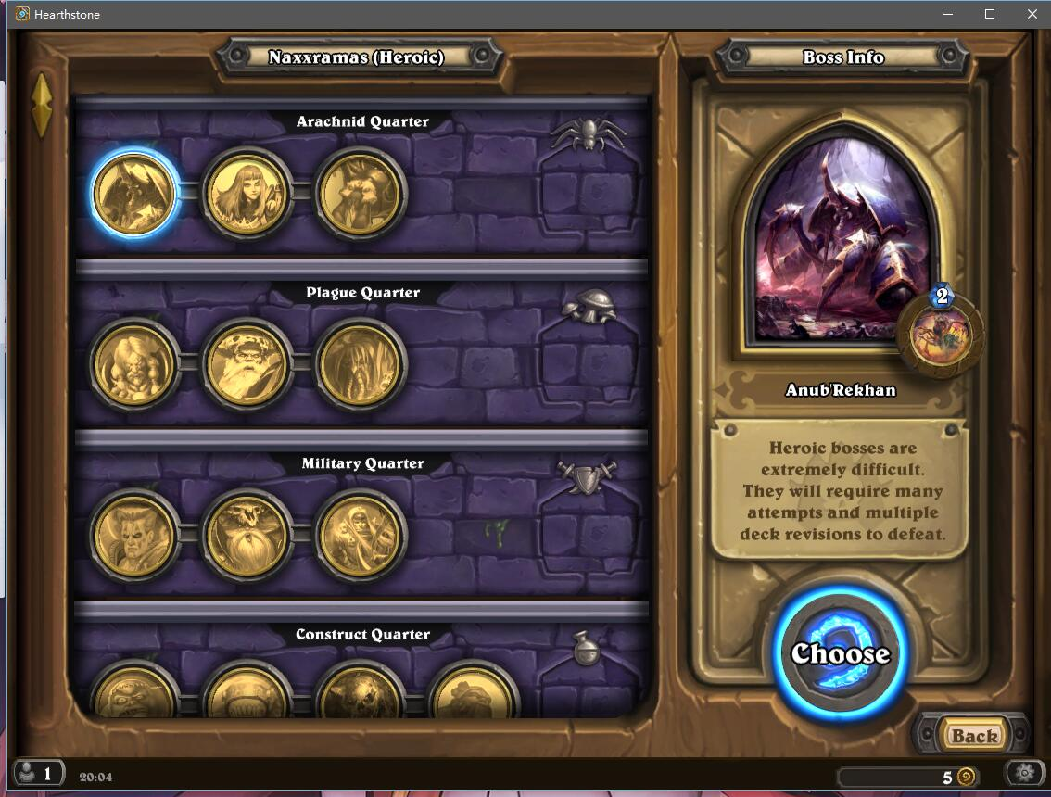

(A heroic AI player in Hearthstone)

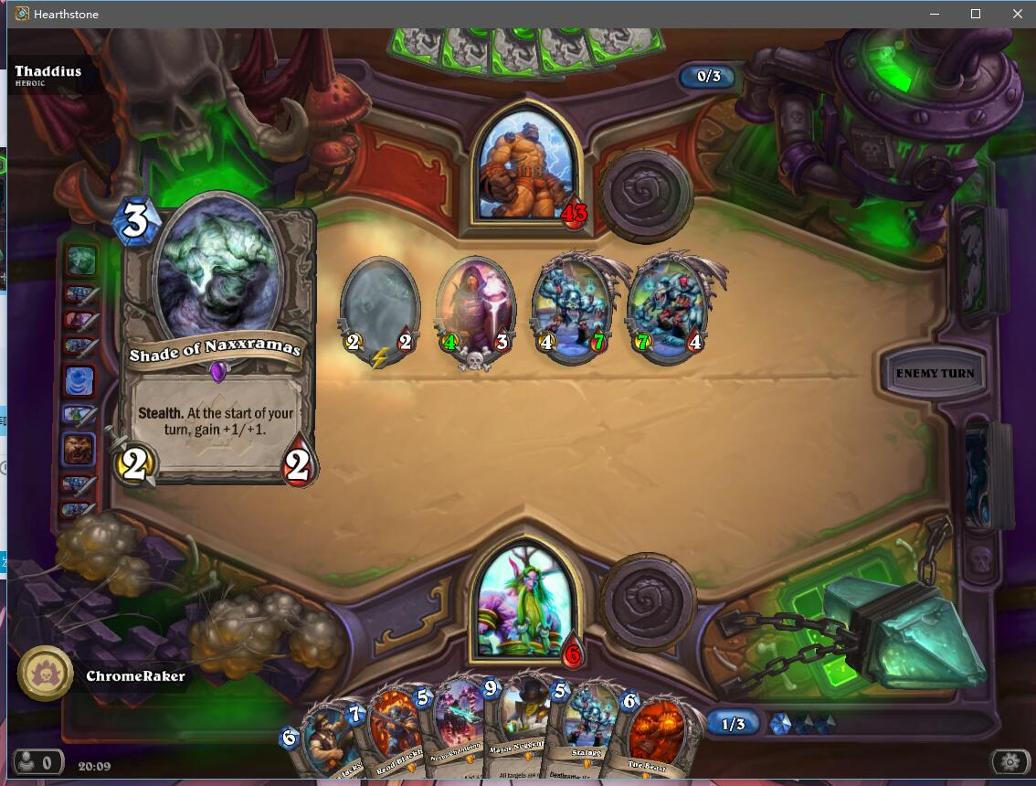

(Minions with different powers can be summoned using mana)

#### Uno

Uno is a traditional shedding-type card game from America and has been popular among people of all age group. [2] The game was initially developed as a card game, and after it became famous, the video game version of Uno was developed and spread over the Internet.

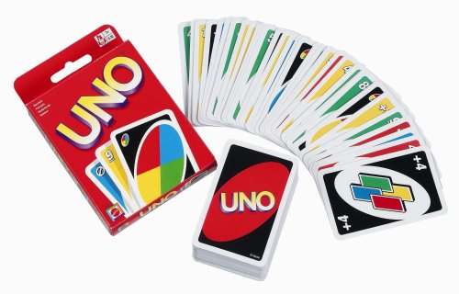

(A standard deck of Uno cards)

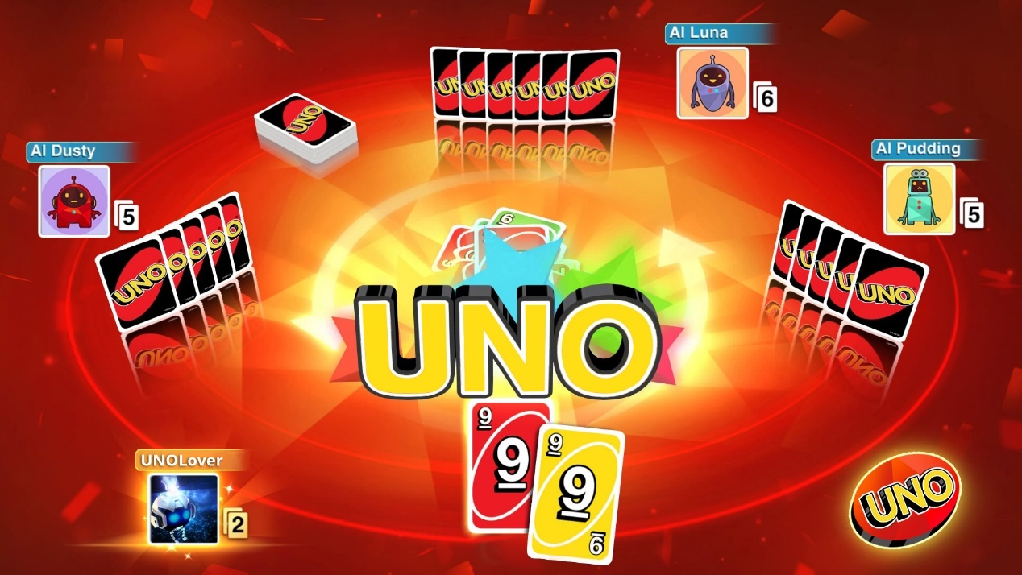

(A video game version of Uno)

An Uno game usually has 2 to 10 players. At the beginning of a game, each player would be dealt a card randomly from the deck, and their numbers would be compared to decide which player plays first. In the case of non-number card or cards with same number, new cards will be dealt until one player holds a card with larger number.

Random cards from deck are dealt to players, and the purpose of the game is to play all the cards and reduce the number of hand to zero. However, a card can only be played when it matches the previously played card. A basic non-word card matches another card only if they have the same colour or number. Besides this, cards with special abilities called word card are also added into the deck. This includes:

* Skip: Can match non-word card of the same colour; next player in sequence misses a turn
* +2: Can match non-word card of the same colour; next player in sequence draws two cards
* Reverse: Can match non-word card of the same colour; order of play switches directions (when there are only two players, this is equivalent to Skip)
* Wild: Can match non-word cards of any colour; player declares next colour to be matched
* Wild +4: Can match any card except for card with skip ability (Skip, Reverse or Wild +4); player declares next colour to be matched; next player in sequence draws four cards and misses a turn.

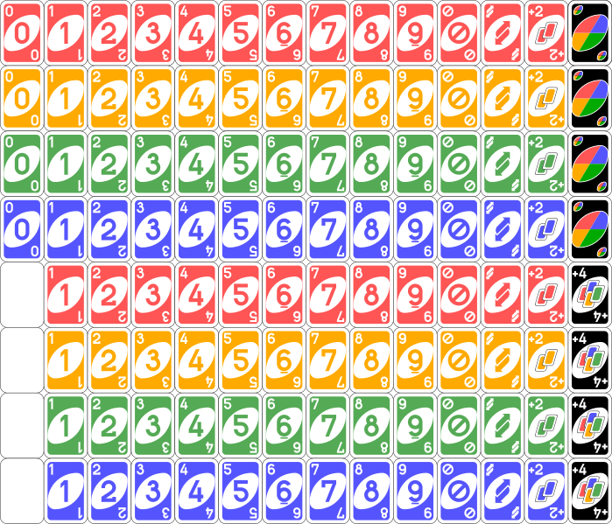

(Cards in a standard Uno deck)

On a player’s turn, he/she must do one of the following:

* Play a card matching the last played card
* Draw an extra card as penalty.

If the player chooses to draw an extra card, he/she still has a chance to play a matching card, otherwise, the turn would pass to the next player in order.

In a party game, player must say “Uno” immediately when they only have one card in hand, failed to do so might cause punishments. However, in video game version this function would usually be removed.

The game proceeds until one player has reduced his/her hand to zero. This player then wins and the rest lose the game.

Random factors are involved in both games, restricting the performance of analysing and optimising algorithms of the AI player in a fair game. However, if AI player is authorised to cheat in the game and become capable of accessing the hand of human player and the placement order of deck, it will become impossible to defeat.

#### AI

According to Wikipedia [3], AI, or Artificial Intelligence, is generally referred to any device that reads information and tries to maximise its chance of success to achieve a goal. To be exact, this word is more frequently used when describing a machine which is able to execute cognitive functions, for instance, machine learning.

In terms of video games, AI is used to generate human-like behaviours for non-player characters (NPC). The main purpose of AI’s algorithm is to mimic human players and to provide good gameplay experience. Due to certain restrictions, it might be very different from a traditional AI. For example, cheats are sometimes allowed to provide more challenge, or the computer abilities are restricted so it does not affect the performance of the game.

Cheating usually refers to the programmer authorising AI player to access the information that would be inaccessible to the player in the same situation. Particularly in games where creative strategic is needed, cheats are implemented to give player a greater challenge.

In most of the cases, cheating is considered to be acceptable as long as its effect is not obvious to players. [4]

#### Random Number Generator

The random number generator provided by programming software (Visual Basic 2010) will be used to simulate the random factors in dealing cards and arranging the order of deck.

In Visual Basic 2010, random number generator is used through function Rnd, which returns random number less than 1 but larger than or equal to zero.

For the same given initial seed value, same random number sequence is generated, since Rnd function uses the last generated random number as new seed and generates next value in the list. Therefore, the random numbers generated may not appear to be very random, if the sequence is not initialized using statement Randomize, which gives a new value based on system timer as initial seed.

Because both Rnd and Randomize use certain algorithm and a seed value to generate a random number within a finite range, the random numbers generated might be predictable, especially for people who knows the algorithm. This would result in problems in security and thus, Rnd and Randomize should not be used in encryption. [5]

### The Problems

After coming to UK, I realised that the game of Uno is less popular than I expected. Some of my friends and teachers in the college have not played Uno before. As Uno is a very interesting and enjoyable game, particularly in some college events, I would like to introduce this game to them using a simple Uno program.

Except for that, many fans of turn-based card games such as Hearthstone and Shadowverse are interested in the AI players provided in the game. Due to the restrictions on performance of AI algorithm by random factors, they believe it is extremely hard for AI players to become very powerful in a fair game, they, therefore, want to figure out the working mechanism of AI player, and some even suspect that developers have authorised the AI to cheat to prevent players from getting awards easily.

However, as the software is encrypted and protected by copyright, it is illegal to research the mechanism of the game directly, resulting in great difficulties in judging whether the AI player is able to cheat or not.

Meanwhile, there are some other games that are involved with random factors. Although they have different rules and game mechanisms, problems that need to be overcome when developing an AI player is similar. If a cheater AI player can be built in such game, for instance, the game of Uno, then it might provide some valuable data.

## Perspective Users and Objectives

### Perspective Users

The students and teachers are the main perspective users of this program. Besides, this game is supposed to be enjoyed easily by anyone, no matter (s)he has played the game of Uno before or not. For those who do not know the rules, a simple demonstration along with a tutorial will be provided so they can learn all the rules very easily, whilst for those who have played the game before, they can play a 1 VS 1 Uno game with their friends using this software, or challenge a series of AI with different difficulties.

People who are interested in cheater AI are also part of perspective users. Through this program, they can play games with a Cheater AI and get a good understanding about how will the cheater AI act in a video card game.

### The User Needs

Hsin, a fan of video card game Hearthstone, was interested in the cheater AI and accepted a brief interview about his needs of the cheater AI as well as general AI players. Useful information was recorded:

1. All the AI players should simulate a time of thinking and reaction to reduce the pressure given to the human player and preventing the pace of game being too fast.
2. However, the AI player should react within a reasonable time, otherwise, the human player needs to wait for a long time.
3. When playing against AI, it is reasonable to display the player’s hand all the time during the game. On the other hand, the hands of AI should be displayed as the back of cards.
4. The AI player, of course, should also obey the rules of game.
5. The fair AI players should only use legal information to make decisions and are not allowed to use information about player’s hand or next card in the deck.
6. Although the cheater AI is allowed to cheat in the game, it should not be too obvious. For example, the AI maybe can look at its opponent’s hand and the deck, but it shouldn’t change the order of deck or even change the card in its hand, and it should also leave some possibilities for player to win the game.

A web-based survey has also been done on Survey Monkey (<https://www.surveymonkey.co.uk/r/H3KLXGQ>) to investigate the general needs of an Uno program. The main respondents are the students and teachers in the college. And the results are:

The results are shown below:

|  |  |  |
| --- | --- | --- |
|  | Yes | No |
| Have you ever played Uno before? | 10 | 4 |
| If not, do you think highlighting the playable card is helpful in learning the rules of Uno? (Respondents who have played Uno are not shown) | 8 | 0 |
| Do you think a proper user interface is necessary for an Uno game? | 14 | 0 |
| As Uno games tend to have different versions and rules in different regions, do you think it will be helpful if the rules are displayed in the program? | 13 | 1 |
| Do you think it will be better if the AI has a variety of difficulties? | 13 | 1 |
| Except for an AI player, would you like the game to support player against player mode as well? | 10 | 4 |

The main requirements are included below:

1. Highlighting or an arrow should be used to indicate the cards that can be played on this turn.
2. A proper user interface is necessary for an Uno game, which means the images of Uno cards must be found from free-sharing website.
3. Users should be able to check the rules before the game.
4. AI player should have a variety of difficulties for player to challenge.
5. Player against player might not be necessary, but it will be better if there is one.

### Objectives

The general purpose of this application is to:

1. Provide a game menu containing different choices.
2. Provide a basic Uno game which enables two players.
3. Provide different game modes, including player against player and player against AI (with hints).
4. Provide a cheater AI player.
5. Provide a debug mode.
6. Provide a Help menu which displays all the rules in this Uno game in detail

#### Objective 1: Game Menu

* 1. A simple game menu with different choices will be displayed when the application is run.
  2. The game menu should contain different game modes including tutorial, player against player and player against AI, as well as an Exit option.

#### Objective 2: Uno Game

Specific Objectives:

* 1. Simulate a standard 108-card Uno deck, which consists of 25 of each colour (Blue, Golden, Green and Red) and each colour has two of each type except for type zero, of which each colour only has one. The types including number type 1 to 9, “Skip”, “Reverse” and “+2”. Besides this, the deck also contains 4 “Wild” cards and 4 “Wild +4” cards (2017 Wikipedia).
  2. The game can be started by clicking on the picture of deck displayed in the middle of the screen.
  3. The Uno game should start with dealing each player one card to decide which player to play first. The player who holds the card of larger number can play first. If one player is dealt with a non-number card or their numbers are the same, another two cards would be dealt until the play sequence is decided.
  4. On the player’s turn, player should be able to play a card that fits the rules (see description above) or draw a card from deck by clicking either the picture of card or deck. If the player chooses to draw an extra card, (s)he still has a chance to play a card, otherwise, the turn would be passed to next player.
  5. If player tries to play a card that does not meet the rules, an error message would show and ask player to choose another card to play.
  6. The functions of word card (Skip, Reverse, +2, Wild and Wild +4) should all be enabled as the description above.
  7. When a wild card is played by a player, a new window will be open to ask for a colour for that wild card.
  8. A player can hold no more than 20 cards. If more cards are dealt to player’s hand, an error message would be displayed and the dealing would be prevented.
  9. The game lasts until a player has zero cards in hand. The winning message will be shown and all cards in the opponent’s hand will be displayed. Player then can start another match by clicking the deck again.
  10. A simple scoreboard would display the win counter of each player. If the game window is closed, the scores will be reset to zero.

#### Objective 3: Player against Player Mode

Specific Objectives:

* 1. This game mode supports an Uno game between two players.
  2. Since two players should not see each other’s hand, when it’s on Player1’s turn, Player1 will have to move the mouse over P1’s hand and the cards will be displayed. After the mouse leaves the image of deck, its image will be changed to the back of card again. When it’s on a player’s turn, then only that player’s hand will be displayed in this way. Moving mouse over the opponent’s hand will not cause the cards to be displayed.
  3. Player can only click the picture of a hand and play this card on his/her turn.

#### Objective 4: Player against AI Mode

Specific Objectives:

* 1. This game mode supports an Uno game between a human player and an AI player of different difficulties.
  2. Before the game starts, a difficulty window would be open and ask the player to choose a difficulty for AI.
  3. Fair AI players are not allowed to cheat, but only make decisions based on its own hand and discards.
  4. A hint button should be displayed on the game window, and all hands that can be played on this turn will be indicated by arrows when clicked. Considering the game should be fair in PvP mode, this function will not be supported on the player against player game.

#### Objective 5: Cheater AI

Specific Objectives:

5.1 The cheater is allowed to look at cards in the deck and its opponent’s hand, but nothing further than that.

#### Objective 6: Debug Mode

Specific Objectives:

6.1 A debug mode should be supported to make the future testing easier.

6.2 The debug mode includes a “Reveal All” button, which will display both players’ hand after clicked.

6.3 The debug mode can be open by some special operations on Game Menu (e.g. right click on the game button rather left click)

#### Objective 7: Help Menu

7.1 The Help menu should divide the rules into parts and display them individually.

## Data

The whole program will work by clicking on the images of Uno cards or colours. So the only data input is the picturebox user clicked.

### Data Dictionary

|  |  |  |  |
| --- | --- | --- | --- |
| Data Name | Data Type | Destination and Process | Description |
| FormGame.sender | System.Object | The data of sender will be sent to FormGame. The information of the number of picturebox clicked will be extracted and send to Class Game for further procedure. | The object representing picturebox clicked by user. |
| FormDecideWildColour.sender | System.Object | The data of colour decided by player will be extracted and sent to FormGameMenu for further use. | The object representing picturebox clicked by user. |

### Data Flow Diagram

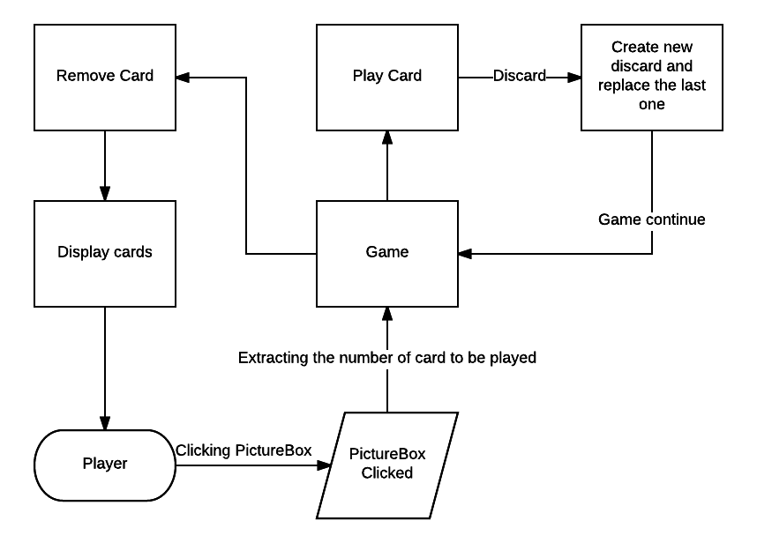

## UML Class Diagram

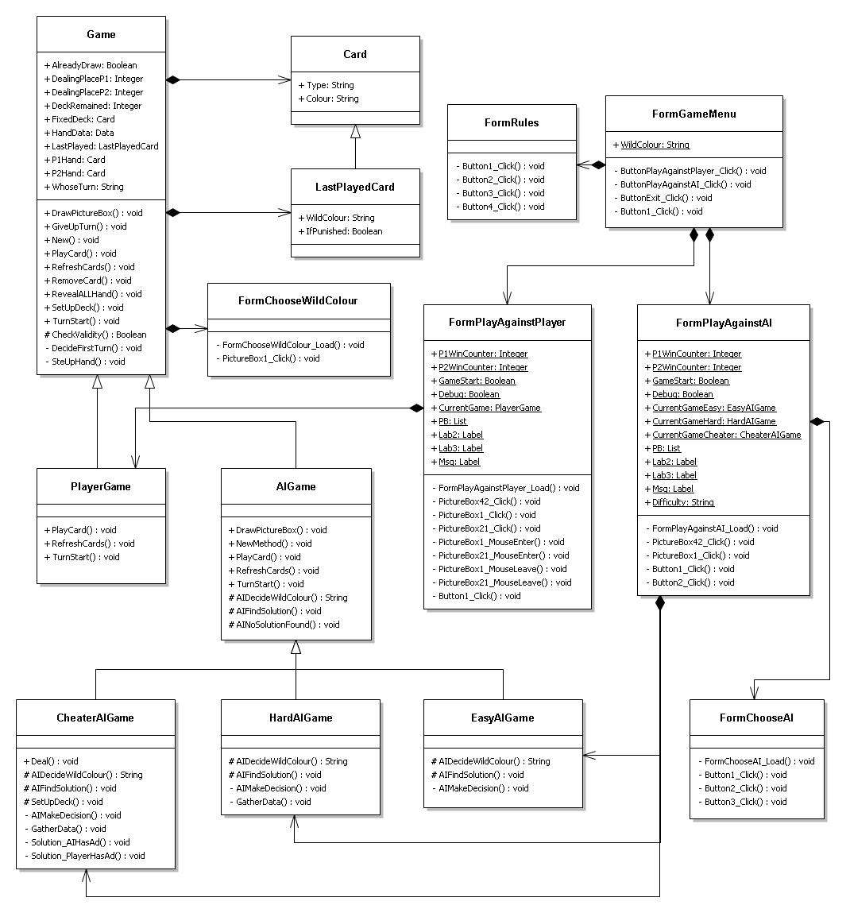

## Chosen Solution

Before learning how to program using visual basic 2010, I learnt to code based on a console programming language called Free Pascal. Therefore, I’m more familiar with console-based programming rather than windows application form programming.

On visual basic 2010, both types of programming are provided. Initially, I tended to program the Uno game on a console-based program where all the cards would be displayed as words or numbers and player would need to type in a number to play the card. However, after a series of research, a proper user interface is found to be essential for an Uno game. Thus, I decided to program the game as a windows application and try to find some free resources of the images of Uno cards online, despite the difficulties I might come across during the windows application programming.

# Design

## General Design

This project will be programmed using visual basic 2010 window forms application. The program will be heavily object-oriented and different forms will be designed as user interface. The program should be less than 20 megabytes in volume including the image resources. The program will load and unload images from resources to the pictureboxes defined. In terms of storage, no data will be permanently stored as files on the computer.

## Modular Structure

Six forms in total will be designed in this program.

|  |  |  |
| --- | --- | --- |
| Form Name | Linkage | Description |
| FormGameMenu | Can call the FormPlayAgainstAI, FormPlayAgainstPlayer and FormRules. | The general game menu which will be open as the program is running. User can click on buttons to open different game modes or read instructions. |
| FormRules | Can be called from FormGameMenu. | A form which displays the rules and instructions of Uno. |
| FormPlayAgainstAI | Can be called from FormGameMenu. Can call the FormChooseAI and FormChooseWildColour. | Form for AI mode game. A new form will be displayed to ask for the AI difficulty when the form is loading, and when a wild card is played during the game, a form will be called to ask for a colour. |
| FormPlayAgainstPlayer | Can be called from FormGameMenu. Can call the FormChooseWildColour. | Form for PvP mode game. When a wild card is played during the game, a form will be called to ask for a colour. |
| FormChooseAI | Can be called from FormPlayAgainstAI. | Form for choosing AI difficulty. |
| FormChooseWildColour | Can be called from FormPlayAgainstAI and FormPlayAgainstPlayer. | Form for choosing wild colour. |

## System Flow Chart

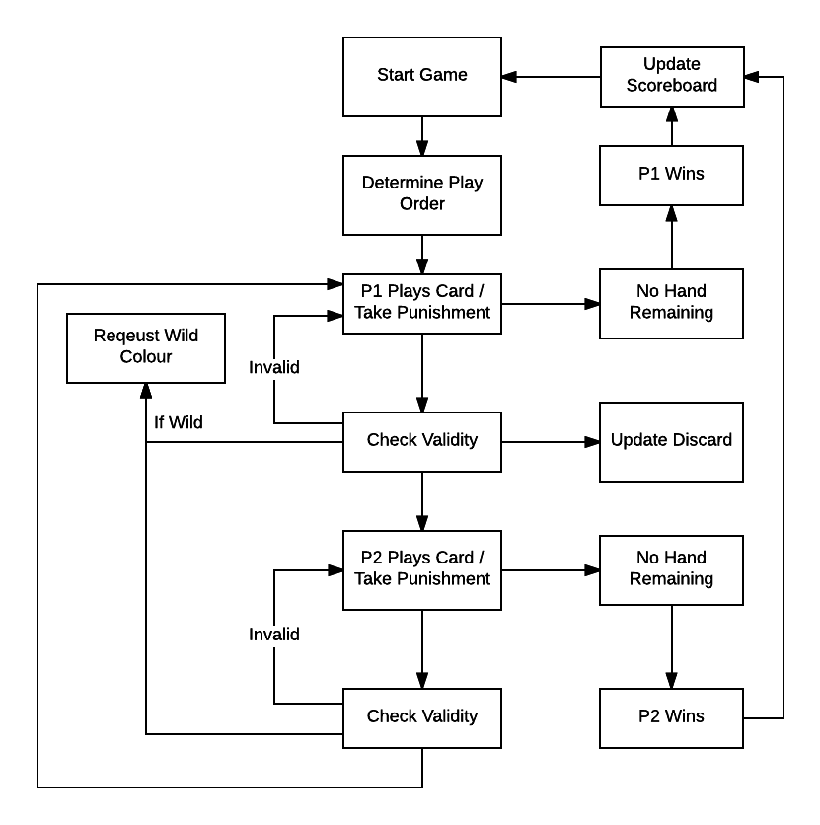

## UML Diagram

See Analysis.

## Validation Required

The only data input by user would be the picturebox or button clicked. Therefore, the validation is only required under following situations:

1. During an Uno game, after the user has clicked on a hand to play, the program will first check if the player is doing a legal move. If it was not the player’s turn then card will not be played. If the card selected does not fit the rules and cannot be played on this turn, a message will be displayed to ask player to choose another card to play. Cards meeting any of the following four requirements are valid to play.

* Whether the selected card has same number or colour with discard, or the selected card is a Wild or Wild +4 card, when the discard is a non-word card.
* Whether the selected card is Wild +4 card, when the discard is a +2 card.
* Whether the selected card has same colour with the discard, when the discard is a Wild or Wild +4 card.
* Whether the selected card has same colour with the discard, when the discard is a word card and the punishment has already been applied once.

1. When selecting AI difficulty or wild colour, closing the window without choosing any option will cause the return value to be “Unselected”, and the same window will be opened again until the user has selected an option.

## Interface

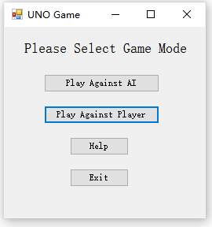

(FormGameMenu)

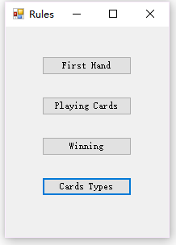

(FormRules)

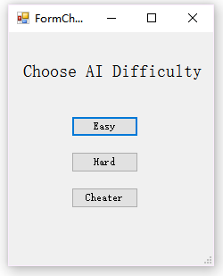

(FormChooseAI)

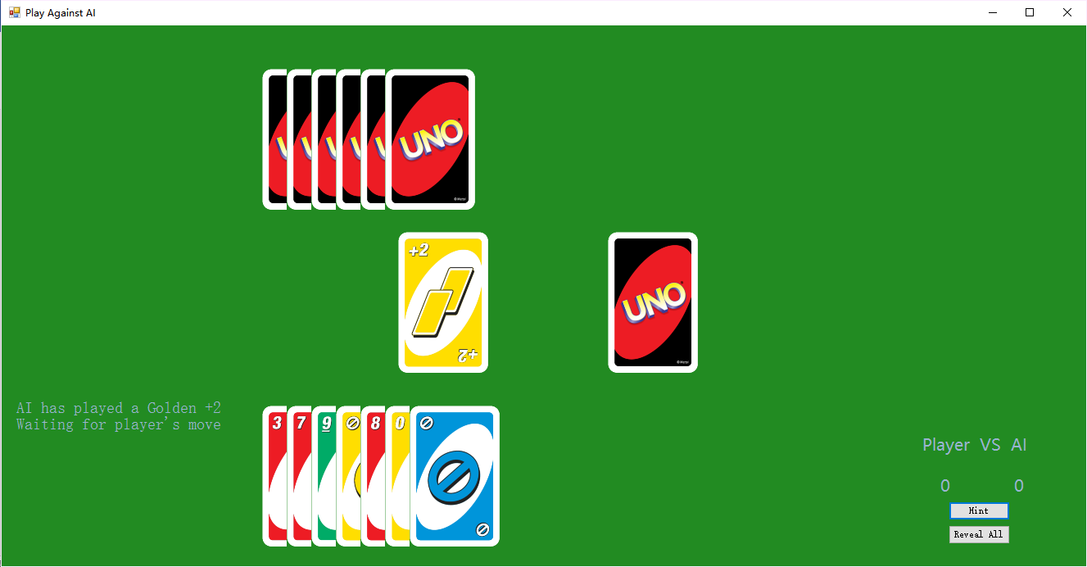

⑦

⑥

⑤

④

③

②

①

FormGame:

1. Uno card deck: the deck of Uno cards. Player can click here to start the game, draw card, and skip the turn.
2. Discard: this area will display the image of card played last time, and is refreshed every a new card has been played.
3. Wild colour displacement: when the discard is a wild card, this area will indicate the chosen colour of wild card.
4. Player1’s Hand: this area displays the hand of P1 up to a maximum of 20.
5. Player2’s Hand: this area displays the hand of P2 up to a maximum of 20.
6. Message box: instructions are displayed here to help understanding the game.
7. Scoreboard, hint button and debug button: scoreboard shows the scores of each player, and will be reset every time the game window is closed. Hint button only exists in Play against AI mode, and will give instructions of next legal cards when clicked. Debug button will only be displayed when the debug mode is on, and will reveal hands of both players when clicked.

Although two game windows, PlayAgainstAI and PlayAgainstPlayer, use distinguish interface design, their characteristics are highly similar and thus are not introduced individually.

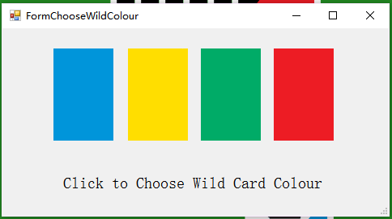

(FormChooseWildColour)

The wild colour is selected by simply left-clicking the image of colours.

## Record Structure

Only one structure will be used in this program: Structure Data.

This structure is used to store the data of Player and AI’s hand and purely for making the coding tidy.

Only one parameter HandData will use this structure.

The parameters included in this structure are:

P1Blue As Integer

P1Golden As Integer

P1Green As Integer

P1Red As Integer

P1NonWild As Integer

P1MinColour As String

P2Blue As Integer

P2Golden As Integer

P2Green As Integer

P2Red As Integer

P2NonWild As Integer

P2MaxColour As String

P2NonWord As Integer

## Library

The main library used in this program is the Visual Basic Runtime Library.

This library is used to provide some special constant, such as vbCrLf, as well as data type conversion methods and random number generator.

## Algorithm

### Deal Card

This procedure deals a random card from the deck to player’s hand.

When a card is dealt from the deck, it will be deleted from the deck and indicated as “None”.

The procedure won’t deal a deleted card to player. If a “None” card is selected from the deck, the selection will run again to choose another card from the deck.

Because player cannot hold more than 20 cards in hand, if the player’s hand is going to be beyond the limit, an error message will show and the card won’t be dealt.

If there’s no more valid card in the deck, the game will be a draw and end immediately.

If DeckRemained <> 0 Then

If DealingPlace <= 19 Then

Randomize()

Do

indicator = Int(Rnd() * 108)

Loop Until Deck(indicator).Type <> "None"

PlayerHand(DealingPlace).Type = Deck(indicator).Type

PlayerHand(DealingPlace).Colour = Deck(indicator).Colour

Deck(indicator).Type = "None"

Deck(indicator).Colour = ""

DealingPlace += 1

DeckRemained -= 1

Else

MsgBox("Can't hold more than 20 cards in hand!")

End If

Else

MsgBox("No more card in the deck!")

GameEnd()

End If

### Decide First Player

This algorithm will determine which player will play in the first round.

The random number generator is used in this algorithm.

Two random numbers are generated. The cards with that number will be dealt to players. If any of them is not a number card or they have the same number, another two cards will be dealt.

The player with the card of the larger number will play first.

Randomize()

Do

p1 = Int(Rnd() * 108)

p2 = Int(Rnd() * 108)

Loop Until Len(Deck(p1).Type) = 1 And Len(Deck(p2).Type) = 1 And Deck(p1).Type <> Deck(p2).Type

If CInt(Deck(p1).Type) > CInt(Deck(p2).Type) Then

P1PlayFirst()

Else

P2PlayFirst()

End If

### Remove Card

This algorithm removes a card from a player’s hand and forwards all the cards behind the empty space.

It is done by assigning the data of the following hands to their previous hand place, starting from the hand that was played on this turn.

Afterwards, the last hand is assigned with empty value.

The dealing place, which is used to record the place where next card would be dealt to, also decreases by one.

For counter = CardNumber To DealingPlace - 2

PlayerHand(counter).Type = PlayerHand(counter + 1).Type

PlayerHand(counter).Colour = PlayerHand(counter + 1).Colour

Next

PlayerHand(DealingPlace - 1).Type = "None"

PlayerHand(DealingPlace - 1).Colour = ""

DealingPlace = DealingPlace - 1

### Check Validity

This function will be given two cards and it checks whether the first card can be played when the second card is discard. The information of whether the discard has been punished and its wild colour will also be given.

The rules of word cards are discussed and given in the previous section.

The algorithm first check if the card and discard have same number or colour, or if the card is a wild card, when the discard is a number card. The algorithm justifies it by taking the length of its type, since only number cards have types of single characters.

Then it checks if the card is a Wild +4 card, when the discard is a +2 card.

Afterwards, it considers the situation when the discard is Wild. In such case the data stored in WildColour would be the colour selected, and the card needs to have same colour with WildColour.

After a word card is punished, this information will be stored in IfPunished. The algorithm will check if the card has same colour with discard, when the discard is a word card and has been punished.

In the last place, when the discard is none, which only happens in the beginning of the game, any card is allowed to play.

If ((Type = DISCARD.Type Or Colour = DISCARD.Colour Or Colour = "Wild") And (Len(DISCARD.Type) = 1)) Then

'a non-word card followed by a card with same number or colour or wild card

Return True

ElseIf (DISCARD.Type = "+2" And Type = "+4") Then

'a +2 card overided by a wild +4 card

Return True

ElseIf (DISCARD.Colour = "Wild" And (Colour = DISCARD.WildColour Or Colour = "Wild")) Then

'a wild card with colour only

Return True

ElseIf (DISCARD.IfPunished = True And (Colour = DISCARD.Colour Or Colour = "Wild")) Then

'a punished word card

Return True

ElseIf DISCARD.Type = "None" Then

'no previous played card

Return True

Else

Return False

End If

### Start Turn

This procedure starts a new turn.

The Turn will be passed in the beginning of the procedure. (P1 to P2, P2 to P1)

If the discard was a word card, the algorithm will check if the punishment needs to be applied. Otherwise, the program will wait until AI or player has made a decision.

When the discard is an unpunished Skip, current player’s turn will be skipped and related information will be displayed.

When the discard is an unpunished Reverse, current play order will be reversed and related information will be displayed.

When the discard is an unpunished Wild +4, current player will draw four extra cards and its turn will be skipped, and related information will be displayed.

The punishment of +2 is not included in this algorithm, since player is able to override +2 using a Wild +4.

If WhoseTurn = "P1" Then

WhoseTurn = "P2"

ElseIf WhoseTurn = "P2" Then

WhoseTurn = "P1"

End If

AlreadyDraw = False

If LastPlayed.IfPunished = False Then

If LastPlayed.Type = "Skip" Then

LastPlayed.IfPunished = True

PunishSkip()

ElseIf LastPlayed.Type = "Reverse" Then

LastPlayed.IfPunished = True

PunishReverse()

ElseIf LastPlayed.Type = "+4" Then

LastPlayed.IfPunished = True

PunishWildDrawFour()

End If

End If

If WhoseTurn = "P1" and GameType = "AI" Then

AIFindSolution()

End If

### Play Card

When player has clicked on an image of card, the ordinal number of card clicked will be passed to this algorithm and it will try to play this card.

If this is not a valid card to be played, an error message will show.

If the card is valid, the card will be removed from the player’s hand using the algorithm Remove Card, and the discard information will be updated to this card.

If the card is a wild card, the form ChooseWildColour will be open and player will be asked for a wild colour.

After playing the card, the remained hand of the player will be checked. If the player has 0 cards in hand, then the game ends and that player wins the game. Otherwise, the game will continue to next turn.

If CheckValidity(PlayerHand(HandCardNumber).Colour, PlayerHand(HandCardNumber).Type, LastPlayed) Then

LastPlayed = PlayerHand(HandCardNumber)

RemoveCard(PlayerHand, HandCardNumber, DealingPlace)

If LastPlayed.Colour = "Wild" Then 'Request wild colour

AskForWildColour()

End If

If DealingPlace <> 0 Then

TurnStart()

ElseIf WhoseTurn = "P1" Then

P1Wins()

ElseIf WhoseTurn = "P2" Then

P2Wins()

End If

Else

Msgbox("You can't play this card!" + vbCrLf + "Choose another card to play")

End If

### Hint

This algorithm determines the cards that can be played on this turn and indicates them using pre-set arrows.

Determining whether the card can be played or not will use the procedure CheckValidity.

This also shows what will happen if the deck is clicked (Draw a card / Pass the turn), using the information stored in AlreadyDraw

For i = 0 To DealingPlaceP1 - 1

If CheckValidity(P1Hand(i).Colour, P1Hand(i).Type, LastPlayed) Then

Arrow(i).Show()

End If

Next

If AlreadyDraw Then

Msgbox("Click deck to pass the turn")

Else

Msgbox("Click deck to draw a card")

End If

### Gather Data

This algorithm will gather the data needed by HardAI and CheaterAI.

The data including the number of cards in different colours in P1 and P2’s hand. The number of non-wild cards in P1 and P2’s hand, the number of non-word cards in P2’s hand.

Then it will find which colour P1 has the least number of, as well as the colour P2 has the largest number of.

It is done by reading all the cards first. The number counter of cards of each type will be increased if certain kind of card is read.

After that, the numbers of cards in each category are compared with each other to give the maximum value and minimum value.

HandData.P1Blue = 0

HandData.P1Golden = 0

HandData.P1Green = 0

HandData.P1Red = 0

HandData.P1NonWild = 0

HandData.P2Blue = 0

HandData.P2Golden = 0

HandData.P2Green = 0

HandData.P2Red = 0

HandData.P2NonWild = 0

HandData.P2NonWord = 0

For i = 0 To DealingPlaceP1 - 1

Select Case P1Hand(i).Colour

Case "Blue"

HandData.P1Blue += 1

Case "Golden"

HandData.P1Golden += 1

Case "Green"

HandData.P1Green += 1

Case "Red"

HandData.P1Red += 1

End Select

Next

For i = 0 To DealingPlaceP2 - 1

Select Case P2Hand(i).Colour

Case "Blue"

HandData.P2Blue += 1

Case "Golden"

HandData.P2Golden += 1

Case "Green"

HandData.P2Green += 1

Case "Red"

HandData.P2Red += 1

End Select

If Len(P2Hand(i).Type) = 1 Then

HandData.P2NonWord += 1

End If

Next

HandData.P1NonWild = HandData.P1Blue + HandData.P1Golden + HandData.P1Green + HandData.P1Red

HandData.P2NonWild = HandData.P2Blue + HandData.P2Golden + HandData.P2Green + HandData.P2Red

'determining P1Min and P2Max

P1MinNum = HandData.P1Blue

HandData.P1MinColour = "Blue"

If P1MinNum > HandData.P1Golden Then

P1MinNum = HandData.P1Golden

HandData.P1MinColour = "Golden"

End If

If P1MinNum > HandData.P1Green Then

P1MinNum = HandData.P1Green

HandData.P1MinColour = "Green"

End If

If P1MinNum > HandData.P1Red Then

P1MinNum = HandData.P1Red

HandData.P1MinColour = "Red"

End If

P2MaxNum = HandData.P2Blue

HandData.P2MaxColour = "Blue"

If P2MaxNum < HandData.P2Golden Then

P2MaxNum = HandData.P2Golden

HandData.P2MaxColour = "Golden"

End If

If P2MaxNum < HandData.P2Green Then

P2MaxNum = HandData.P2Green

HandData.P2MaxColour = "Green"

End If

If P2MaxNum < HandData.P2Red Then

P2MaxNum = HandData.P2Red

HandData.P2MaxColour = "Red"

End If

### AI Find Solution

This algorithm will find the best solutions for AI player. AI of different difficulties will use different methods to find the solutions.

#### Easy AI

Easy AI will add all the legal solutions to the solution list.

This is done by using the Check Validity algorithm.

For i = 0 To DealingPlaceP2 - 1

If CheckValidity(P2Hand(i).Colour, P2Hand(i).Type, LastPlayed) Then

PossibleSolutions.Add(i)

End If

Next

#### Hard AI

Hard AI will use legal information to determine the best solutions.

When player has only one card left in hand, it tries to prevent player from playing the last card winning.

When it has cards of same colour with the discard, it will play those cards first. If none such card is found, it will try to find a card with same number, or use a wild card to change the colour.

If no best solution is found, it will add all the possible solutions to the solution list.

If DealingPlaceP1 = 1 Then 'P1 has potential to win next turn

For i = 0 To DealingPlaceP2 - 1

If CheckValidity(P2Hand(i).Colour, P2Hand(i).Type, LastPlayed) And (P2Hand(i).Type = "+2" Or P2Hand(i).Type = "+4" Or P2Hand(i).Type = "Skip" Or P2Hand(i).Type = "Reverse") Then

PossibleSolutions.Add(i)

End If

Next

If PossibleSolutions.Count = 0 Then 'no best "Preventing" card found - try to simply convert colour

For i = 0 To DealingPlaceP2 - 1

If CheckValidity(P2Hand(i).Colour, P2Hand(i).Type, LastPlayed) And P2Hand(i).Colour <> LastPlayed.Colour Then

PossibleSolutions.Add(i)

End If

Next

End If

Else 'normal situation : sticking with same colour if possible, otherwise using connectors to change colour

For i = 0 To DealingPlaceP2 - 1

If CheckValidity(P2Hand(i).Colour, P2Hand(i).Type, LastPlayed) And ((LastPlayed.Colour = P2Hand(i).Colour And LastPlayed.Colour <> "Wild") Or (LastPlayed.Colour = "Wild" And LastPlayed.WildColour = P2Hand(i).Colour)) Then

PossibleSolutions.Add(i)

End If

Next

If PossibleSolutions.Count = 0 Then 'no card of same colour found - searching forconnector to the colour that it has most hand of.

For i = 0 To DealingPlaceP2 - 1

If CheckValidity(P2Hand(i).Colour, P2Hand(i).Type, LastPlayed) Then

Select Case HandData.P2MaxColour

Case "Blue"

If P2Hand(i).Colour = "Blue" Then

PossibleSolutions.Add(i)

End If

Case "Golden"

If P2Hand(i).Colour = "Golden" Then

PossibleSolutions.Add(i)

End If

Case "Green"

If P2Hand(i).Colour = "Green" Then

PossibleSolutions.Add(i)

End If

Case "Red"

If P2Hand(i).Colour = "Red" Then

PossibleSolutions.Add(i)

End If

End Select

End If

If P2Hand(i).Colour = "Wild" And (LastPlayed.Type <> "+2" Or LastPlayed.IfPunished = True) Then

PossibleSolutions.Add(i)

End If

Next

End If

End If

If PossibleSolutions.Count = 0 And DealingPlaceP1 > 1 Then 'No best solution found - add all non-best solustions

For i = 0 To DealingPlaceP2 - 1

If CheckValidity(P2Hand(i).Colour, P2Hand(i).Type, LastPlayed) Then

PossibleSolutions.Add(i)

End If

Next

End If

#### Cheater AI

Cheater AI will use all the information to find the best solutions.

The data in HandData is set using algorithm Gather Data.

It follows the same rules of hard AI, except for it can look at the player’s hand and the first card in deck.

When the first card in deck is an important card (Wild / Wild +4), it has a possibility of 70% to draw that card. This is done using a random number generator.

When the player is in advantage, which means player has less non-wild cards in hand than the AI does, the subroutine will jump to Solution_PlayerHasAd(), otherwise, it will jump to Solution_AIHasAd().

If DealingPlaceP1 = 1 And CheckValidity(P1Hand(0).Colour, P1Hand(0).Type, LastPlayed) Then 'player is going to win next turn

For i = 0 To DealingPlaceP2 - 1

If CheckValidity(P2Hand(i).Colour, P2Hand(i).Type, LastPlayed) Then

' prevent player from winning

Dim SL As New LastPlayedCard 'run a Simulation Lastplayed card

SL.Colour = P2Hand(i).Colour

SL.Type = P2Hand(i).Type

If SL.Colour = "Wild" Then

SL.WildColour = AIDecideWildColour()

End If

If Not CheckValidity(P1Hand(0).Colour, P1Hand(0).Type, SL) Then 'preventing success

PossibleSolutions.Add(i)

End If

End If

Next

ElseIf FixedDeck(108 - DeckRemained).Colour = "Wild" And AlreadyDraw = False And LastPlayed.Type <> "+2" Then 'draw valuable card

Randomize()

If Rnd() < 0.7 Then

AINoSolutionFound()

Exit Sub

End If

Else 'normal situation: sticking with same colour if possible, otherwise using connectors to change colour

If HandData.P1NonWild <= HandData.P2NonWild Then

Solution_PlayerHasAd(PossibleSolutions)

Else

Solution_AIHasAd(PossibleSolutions)

End If

End If

If PossibleSolutions.Count = 0 And DealingPlaceP1 > 1 Then 'No best solution found - add all non-best solustions

For i = 0 To DealingPlaceP2 - 1

If CheckValidity(P2Hand(i).Colour, P2Hand(i).Type, LastPlayed) Then

PossibleSolutions.Add(i)

End If

Next

End If

In the procedure Solution_PlayerHasAd(), if AI cannot find a hand with same colour, it will try to change the colour the player has the least cards of.

For i = 0 To DealingPlaceP2 - 1

If CheckValidity(P2Hand(i).Colour, P2Hand(i).Type, LastPlayed) And ((LastPlayed.Colour = P2Hand(i).Colour And LastPlayed.Colour <> "Wild") Or (LastPlayed.Colour = "Wild" And LastPlayed.WildColour = P2Hand(i).Colour)) Then

PossibleSolutions.Add(i)

End If

Next

If PossibleSolutions.Count = 0 Then 'no card of same colour found - searching for connector to the colour that player has least hand of.

For i = 0 To DealingPlaceP2 - 1

If CheckValidity(P2Hand(i).Colour, P2Hand(i).Type, LastPlayed) Then

Select Case HandData.P1MinColour

Case "Blue"

If P2Hand(i).Colour = "Blue" Then

PossibleSolutions.Add(i)

End If

Case "Golden"

If P2Hand(i).Colour = "Golden" Then

PossibleSolutions.Add(i)

End If

Case "Green"

If P2Hand(i).Colour = "Green" Then

PossibleSolutions.Add(i)

End If

Case "Red"

If P2Hand(i).Colour = "Red" Then

PossibleSolutions.Add(i)

End If

End Select

End If

If P2Hand(i).Colour = "Wild" And (LastPlayed.Type <> "+2" Or LastPlayed.IfPunished = True) Then

PossibleSolutions.Add(i)

End If

Next

In the procedure Solution_AIHasAd(), if AI cannot find a card of same colour, it will try to change the colour the AI has the most cards of.

For i = 0 To DealingPlaceP2 - 1

If CheckValidity(P2Hand(i).Colour, P2Hand(i).Type, LastPlayed) And ((LastPlayed.Colour = P2Hand(i).Colour And LastPlayed.Colour <> "Wild") Or (LastPlayed.Colour = "Wild" And LastPlayed.WildColour = P2Hand(i).Colour)) Then

PossibleSolutions.Add(i)

End If

Next

If PossibleSolutions.Count = 0 Then 'no card of same colour found - searching for connector to the colour that it has most hand of.

For i = 0 To DealingPlaceP2 - 1

If CheckValidity(P2Hand(i).Colour, P2Hand(i).Type, LastPlayed) Then

Select Case HandData.P2MaxColour

Case "Blue"

If P2Hand(i).Colour = "Blue" Then

PossibleSolutions.Add(i)

End If

Case "Golden"

If P2Hand(i).Colour = "Golden" Then

PossibleSolutions.Add(i)

End If

Case "Green"

If P2Hand(i).Colour = "Green" Then

PossibleSolutions.Add(i)

End If

Case "Red"

If P2Hand(i).Colour = "Red" Then

PossibleSolutions.Add(i)

End If

End Select

End If

If P2Hand(i).Colour = "Wild" And (LastPlayed.Type <> "+2" Or LastPlayed.IfPunished = True) Then

PossibleSolutions.Add(i)

End If

Next

### AI Make Decision

This algorithm will choose a card from solution list and play it using Play Card procedure. If the list is empty, procedure AINoSolutionFound() will be run.

#### Easy AI

Easy AI will choose a random card from solution list to play.

It is done using random number generator.

When no solution is found, the procedure jumps to AINoSolutionFound().

If PossibleSolutions.Count <> 0 Then

Randomize()

PlayCard(P2Hand, PossibleSolutions(Int(Rnd() * PossibleSolutions.Count)), DealingPlaceP2)

Else 'No solution found

AINoSolutionFound()

End If

#### Hard AI / Cheater AI

Hard AI and Cheater AI will follow the same rules to make a decision.

The data in HandData is set using algorithm Gather Data.

If the number of non-word cards in hand is less or equal to 1, it will play all the word cards first, except for word card Wild, since all the other word cards have the ability to skip the opponent’s turn.

Otherwise, it will play “Skip”, “Reverse” and “+2” first, then non-word cards and card “Wild +4”.

When no solution is found, the procedure jumps to AINoSolutionFound().

If PossibleSolutions.Count > 0 Then

If HandData.P2NonWord > 1 Then

For Each Solution In PossibleSolutions

If P2Hand(Solution).Type = "Skip" Or P2Hand(Solution).Type = "Reverse" Or P2Hand(Solution).Type = "+2" Then

PlayCard(P2Hand, Solution, DealingPlaceP2)

Exit Sub

End If

Next

For Each Solution In PossibleSolutions

If Len(P2Hand(Solution).Type) = 1 Then

PlayCard(P2Hand, Solution, DealingPlaceP2)

Exit Sub

End If

Next

For Each Solution In PossibleSolutions

If P2Hand(Solution).Colour = "Wild" Then

PlayCard(P2Hand, Solution, DealingPlaceP2)

Exit Sub

End If

Next

Else 'only one non-word card remained - priority to word card except for Wild

For Each Solution In PossibleSolutions

If P2Hand(Solution).Type = "Skip" Or P2Hand(Solution).Type = "Reverse" Then

PlayCard(P2Hand, Solution, DealingPlaceP2)

Exit Sub

End If

Next

For Each Solution In PossibleSolutions

If P2Hand(Solution).Type = "+4" Then

PlayCard(P2Hand, Solution, DealingPlaceP2)

Exit Sub

End If

Next

For Each Solution In PossibleSolutions

If P2Hand(Solution).Type = "+2" Then

PlayCard(P2Hand, Solution, DealingPlaceP2)

Exit Sub

End If

Next

For Each Solution In PossibleSolutions

If Len(P2Hand(Solution).Type) = 1 Then

PlayCard(P2Hand, Solution, DealingPlaceP2)

Exit Sub

End If

Next

For Each Solution In PossibleSolutions

If P2Hand(Solution).Colour = "Wild" Then

PlayCard(P2Hand, Solution, DealingPlaceP2)

Exit Sub

End If

Next

End If

Else

AINoSolutionFound()

End If

### AI Decide Wild Colour

This algorithm is used for AI player to decide the wild colour when a wild card is played.

#### Easy AI

Easy AI will decide wild colour randomly.

It is done using a random number generator.

Randomize()

i = Int(Rnd() * 4)

Select Case i

Case 0

Return "Blue"

Case 1

Return "Golden"

Case 2

Return "Green"

Case Else

Return "Red"

End Select

#### Hard AI

Hard AI will always choose the colour it has most hand of.

The data of P2MaxColour is set using algorithm Gather Data.

Return HandData.P2MaxColour

#### Cheater AI

Cheater AI will choose the colour player has least hand of it player has advantages, otherwise it will choose the colour it has most hand of.

The data in HandData is set using algorithm Gather Data.

If LastPlayed.Type = "" Then

If HandData.P1NonWild <= HandData.P2NonWild Then

Select Case HandData.P1MinColour

Case "Blue"

If HandData.P2Blue > 0 Then

Return HandData.P1MinColour

End If

Case "Golden"

If HandData.P2Golden > 0 Then

Return HandData.P1MinColour

End If

Case "Green"

If HandData.P2Green > 0 Then

Return HandData.P1MinColour

End If

Case "Red"

If HandData.P2Red > 0 Then

Return HandData.P1MinColour

End If

End Select

Return HandData.P2MaxColour

Else

Return HandData.P2MaxColour

End If

Else 'wild +4 is played

If HandData.P1NonWild + 4 <= HandData.P2NonWild Then

Select Case HandData.P1MinColour

Case "Blue"

If HandData.P2Blue > 0 Then

Return HandData.P1MinColour

End If

Case "Golden"

If HandData.P2Golden > 0 Then

Return HandData.P1MinColour

End If

Case "Green"

If HandData.P2Green > 0 Then

Return HandData.P1MinColour

End If

Case "Red"

If HandData.P2Red > 0 Then

Return HandData.P1MinColour

End If

End Select

Return HandData.P2MaxColour

Else

Return HandData.P2MaxColour

End If

End If

# Testing

## Testing Form

### FormGameMenu

|  |  |  |  |  |  |
| --- | --- | --- | --- | --- | --- |
| Test No. | Purpose | Test Data | Test Type | Expected Outcome | Test Result |
| 1 | Check that Help Form can be opened properly from main form | Click on “Help” button on the game menu | Normal | A new form “Rules” pops up | Pass |
| 2 | Check that FormPlayAgainstPlayer can be opened properly | Click on “Play Against Player” on the game menu | Normal | A new form “Play Against Player” should be opened | Pass |
| 3 | Check that FormChooseAI can be opened properly | Click on “Play Against AI” on the game menu | Normal | A new form “Choose AI Difficulty” should be opened | Pass |
| 4 | Check that game can properly exit | Click on “Exit” button or close the window directly | Normal | The main form should exit, and all the subforms should end | Pass |
| 5 | Check that the debug mode can be opened successfully | Right click on the buttons on game menu to start the game with debug mode | Normal | The game window should be opened as usual, but a debug button “Reveal All” would be shown under the scoreboard | Pass |

#### Test 1

The “Help” button is designed to display the rules of Uno for players who are new to the game. As displaying all the rules at a time will make the text extremely long, another form is used to divided the rules into parts.

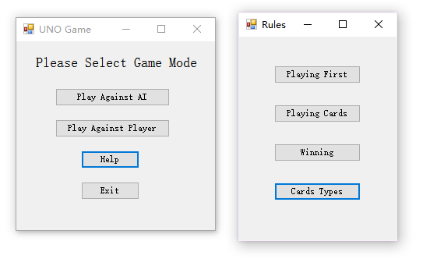

#### Test 2

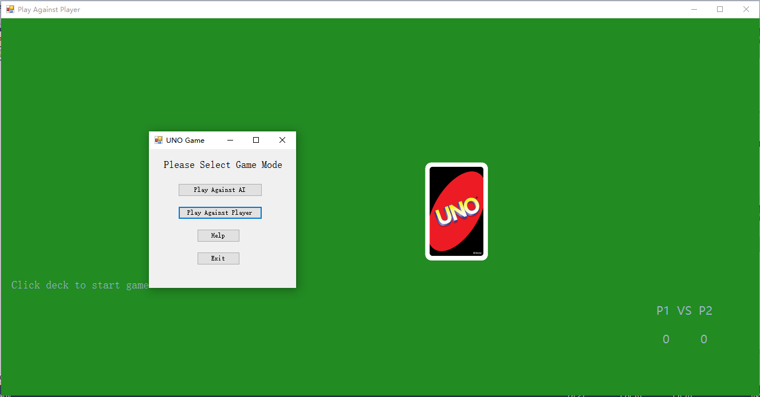

#### Test 3

Clicking on button “Play Against AI” will open the form PlayAgainstAI. However, while loading the form, a new from ChooseAI is displayed first to ask for the AI’s difficulty. Therefore, player will see FormChooseAI first instead of FormPlayAgainstAI.

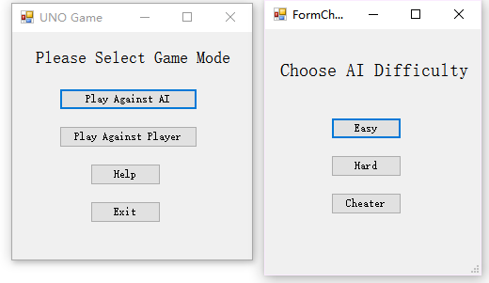

#### Test 4

All the windows were closed and program was immediately shut down when “Exit” button was clicked or main form was closed.

#### Test 5

The game was started correctly with debug button displayed.

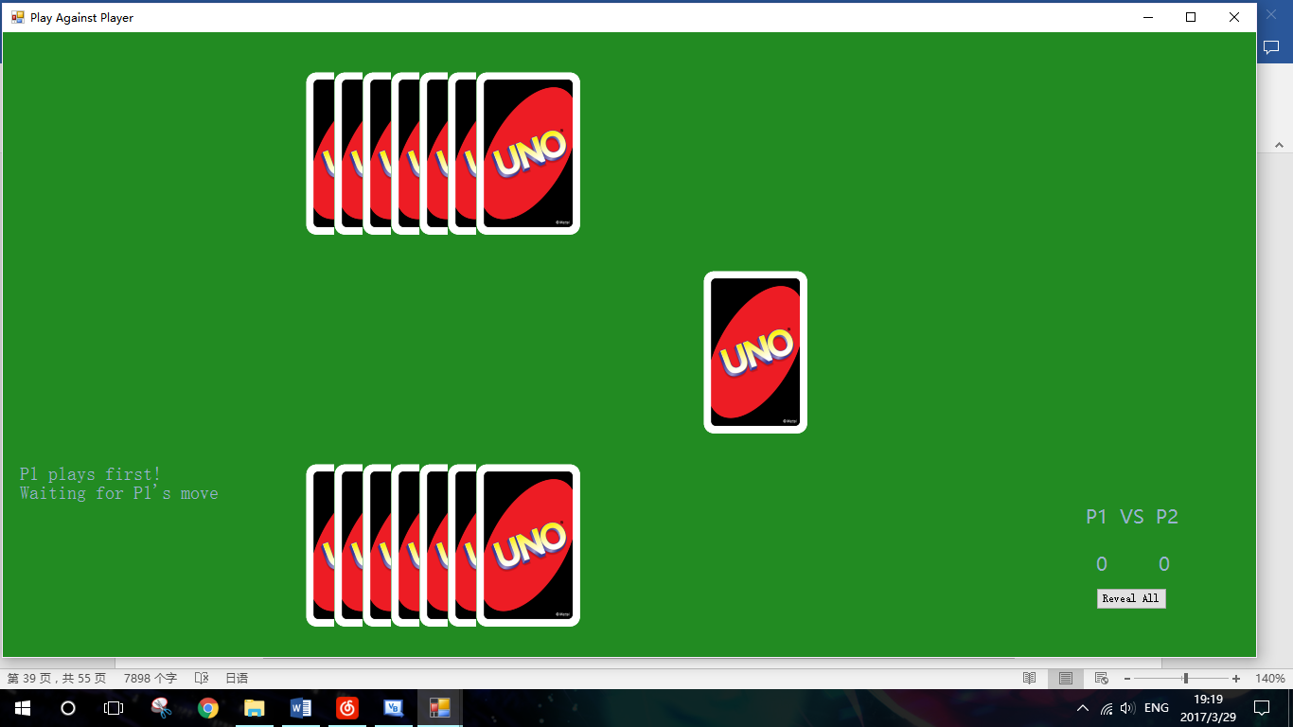

### FormRules

|  |  |  |  |  |  |
| --- | --- | --- | --- | --- | --- |
| Test No. | Purpose | Test Data | Test Type | Expected Outcome | Test Result |
| 1 | Check that each button on Form Rules can display correct message of rules | Click on each button on the Form Rules | Normal | Correct message of rules show up in message boxes | Pass |

#### Test 1

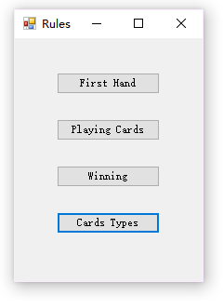

Rules are dived into four different parts: About first player, about playing cards, about winning and the card types.

When clicked, each button should display different messages of rules.

Playing First: At the beginning of a game, each player would be dealt a card randomly from the deck, and their numbers would be compared to decide which player plays first. In the case of non-number card or cards with the same number, new cards will be dealt until one player holds a card with larger number.

Playing Cards: On a player’s turn, he/she must do one of the following: 1. Play a card matching the last played card, which means they have the same colour or number. 2. Draw an extra card as penalty. If the player chooses to draw an extra card, he/she still has a chance to play a matching card, otherwise, the turn would pass to the next player in order.

Winning: After deciding the play order, each player will be dealt with seven cards from the deck. Players can discard their hand on their turns. The game proceeds until one player has reduced his/her hand to zero. This player then wins and the rest lose the game.

Card Types: A standard Uno deck consists of 108 cards, including Blue, Golden, Green, and Red number cards 1 ~ 9 two each, four colour number card 0 one each, four colour word card Skip, Reverse and +2 one each, as well as wild card Wild and Wild +4 four each. Word cards have different abilities and have different playing rules. Skip: Can match non-word card of the same colour; next player in sequence misses a turn. Reverse: Can match non-word card of the same colour; order of play switches directions (when there are only two players, this is equivalent to Skip). +2: Can match non-word card of the same colour; next player in sequence draws two cards. Wild: Can match non-word cards of any colour; player declares next colour to be matched. Wild +4: Can match any card except for card with skip ability (Skip, Reverse or Wild +4); player declares next colour to be matched; next player in sequence draws four cards and misses a turn.

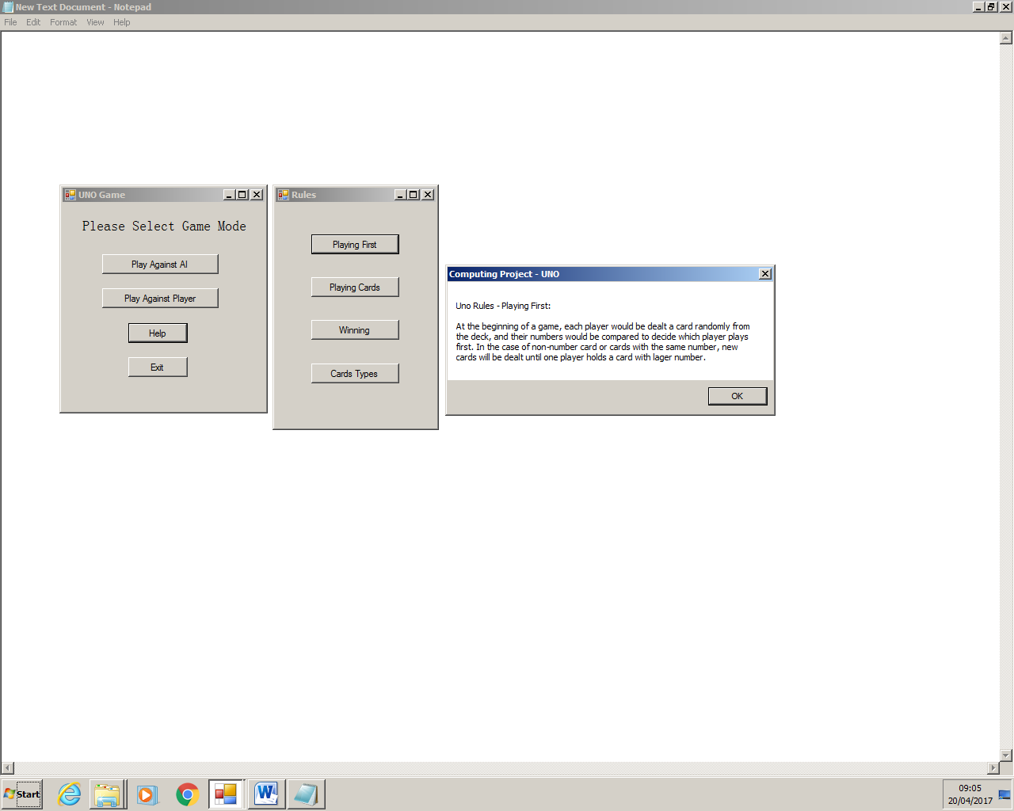

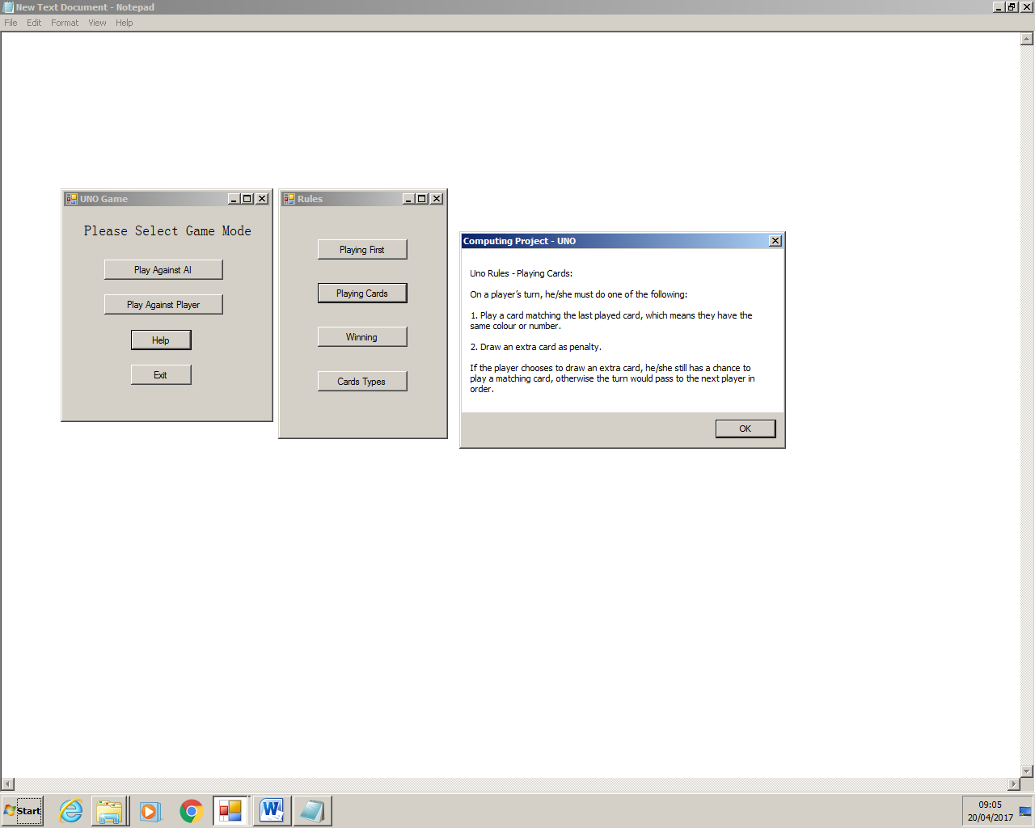

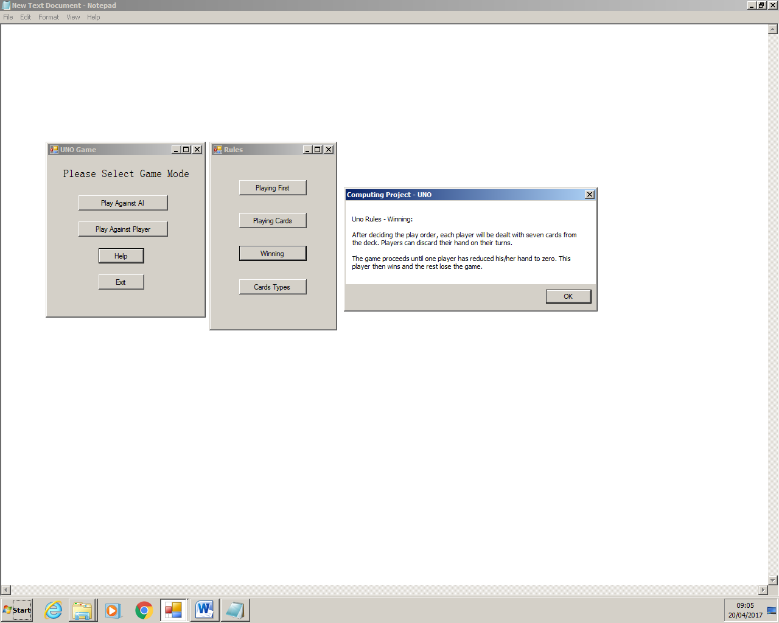

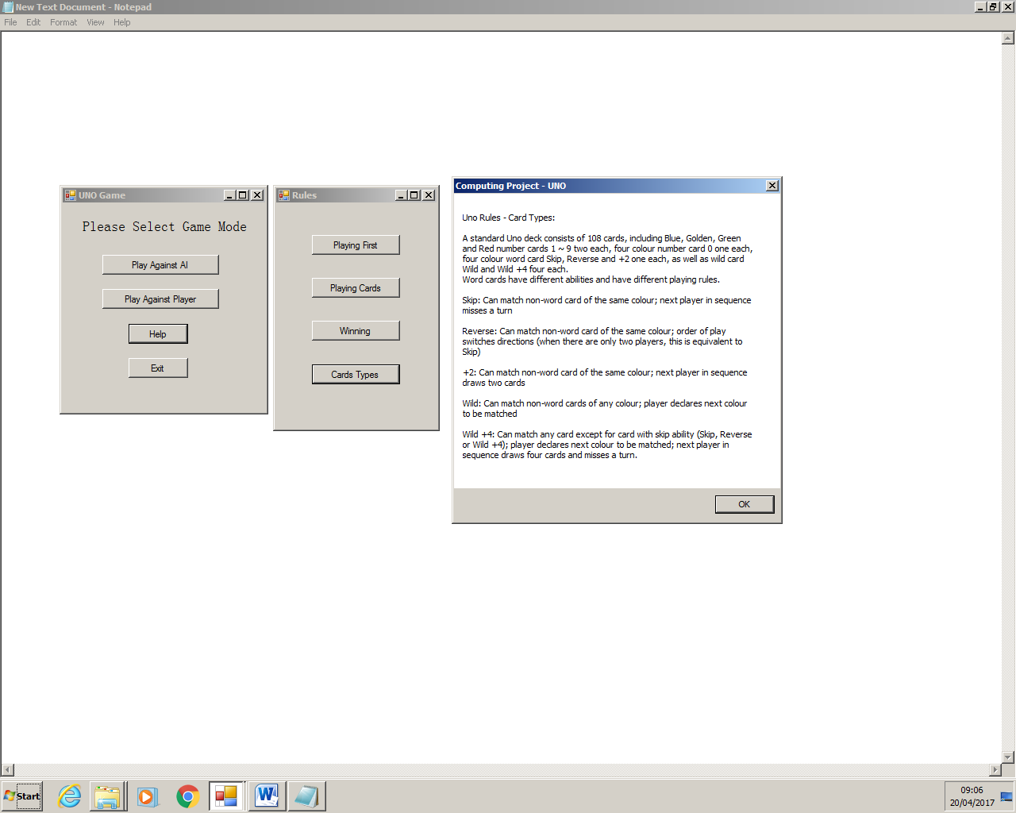

### FormChooseAI

|  |  |  |  |  |  |
| --- | --- | --- | --- | --- | --- |
| Test No. | Purpose | Test Data | Test Type | Expected Outcome | Test Result |
| 1 | Check that the difficulty can be chosen correctly | Click buttons for different difficulties of AI | Normal | The game window should be displayed, and AI of selected difficulty should be run | Pass |
| 2 | Check that program will not crush when no difficulty is selected | Close the window of FormChooseAI | Erroneous | The window should be displayed again, until a difficulty is selected by player | Pass |

#### Test 1

After a button was clicked, game window was displayed and AI of selected difficulty was run. The AI was determined using programming software.

In the example given, Cheater AI was selected, and the codes running was a method of Class CheaterAIGame, which shows that AI running was of correct difficulty.

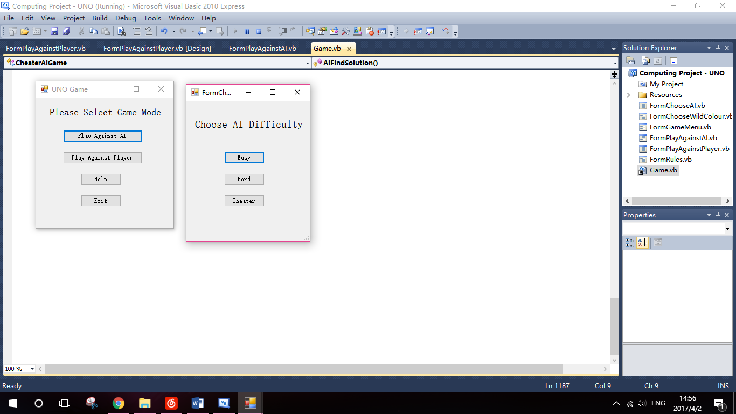

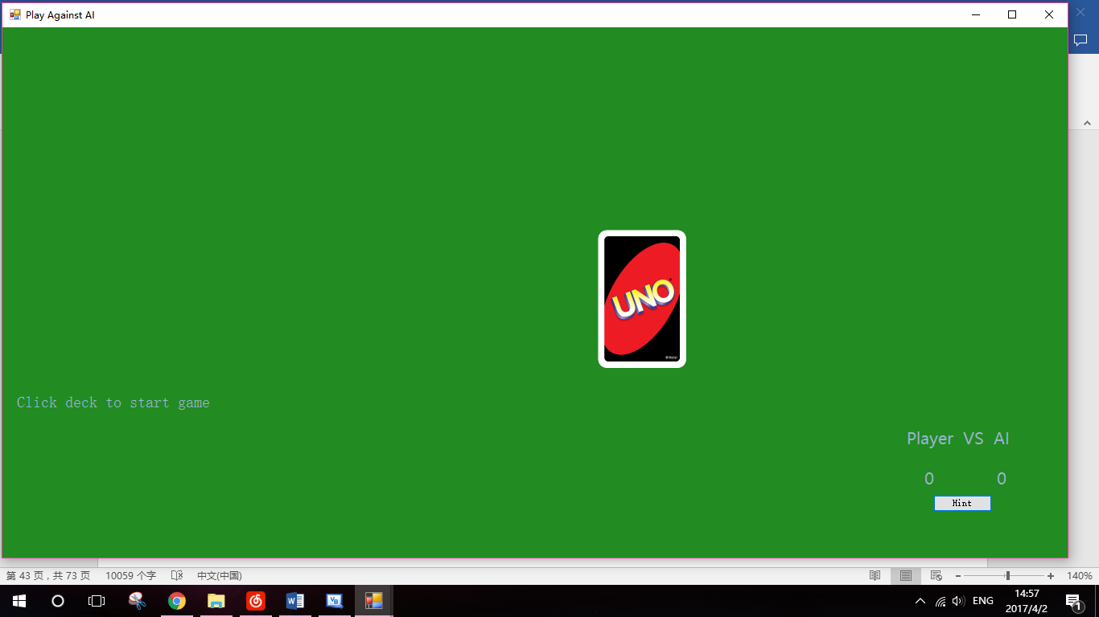

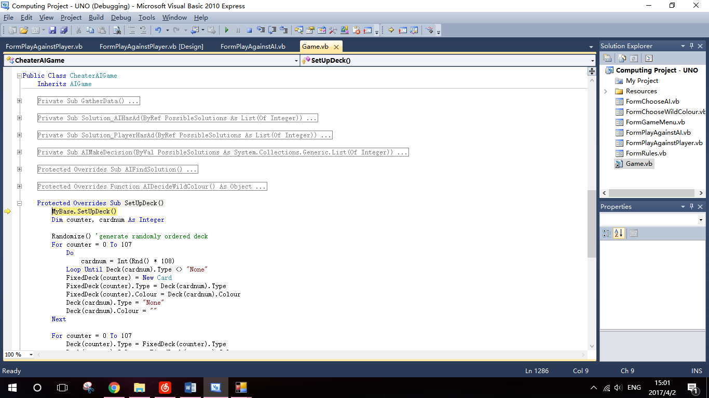

#### Test 2

When the window of FormChooseAI was closed without selecting any difficulty, the windows was displayed again until a button was clicked.

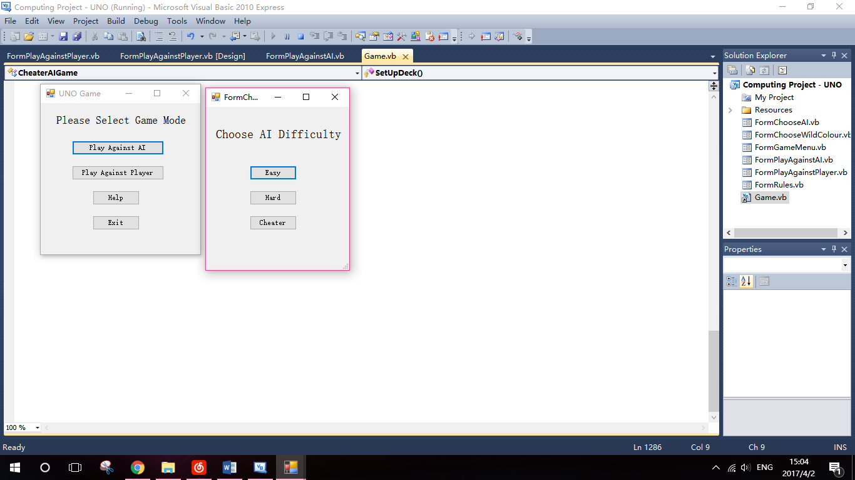

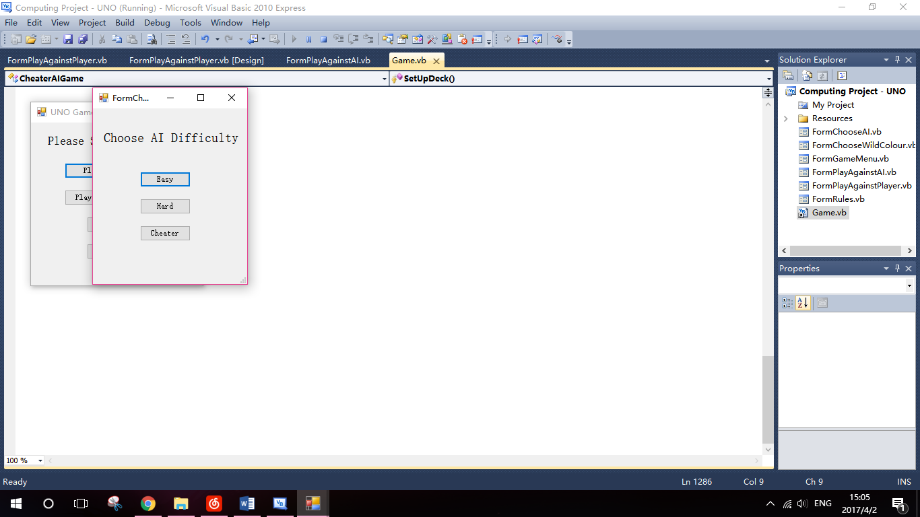

### FormChooseWildColour

|  |  |  |  |  |  |
| --- | --- | --- | --- | --- | --- |
| Test No. | Purpose | Test Data | Test Type | Expected Outcome | Test Result |
| 1 | Check that the colour can be chosen correctly | Click buttons for different colours | Normal | The wild card should have the colour chosen in this form and game would continue | Pass |
| 2 | Check that program will not crush when no colour is selected | Close the window of FormChooseWildColour | Erroneous | The window should be displayed again until a colour is selected by player | Pass |

#### Test 1

A Wild +4 was played, and the window of FormChooseWildColour was displayed to ask for a wild colour.

In this example, colour Golden was selected, and it was displayed beside the image of Wild +4 correctly.

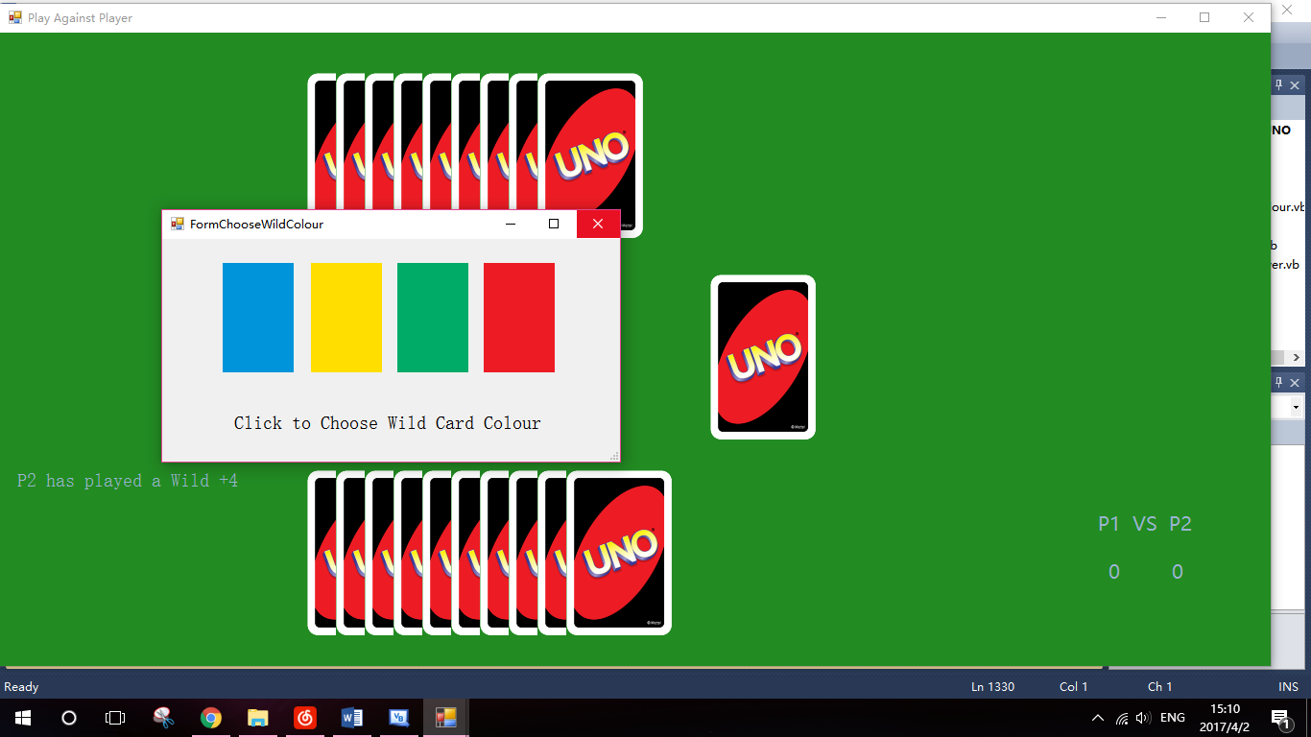

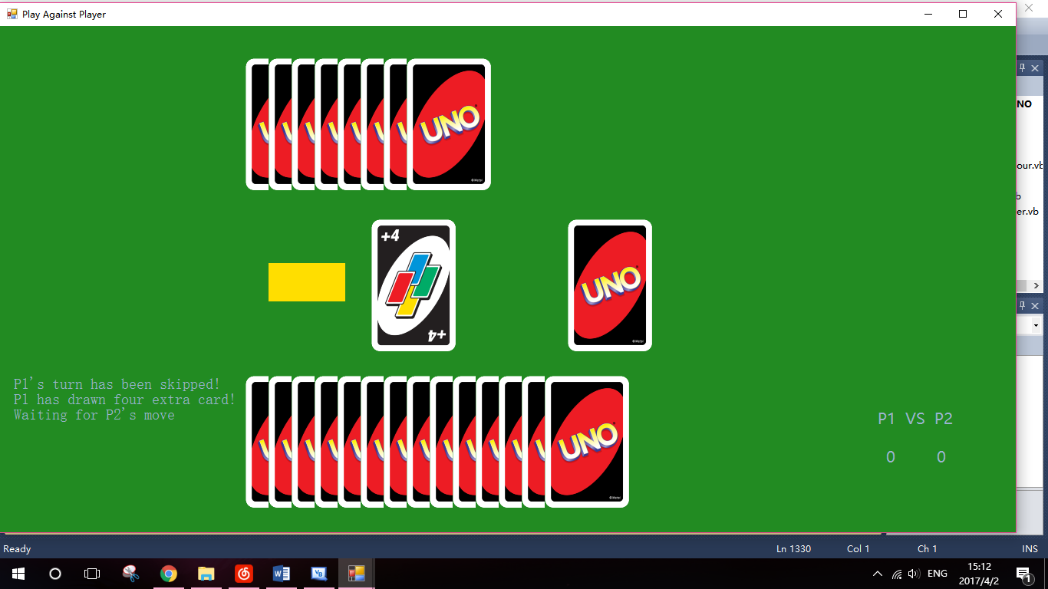

#### Test 2

When no colour was selected and the window was closed directly, another window was displayed until player had chosen a colour from the window.

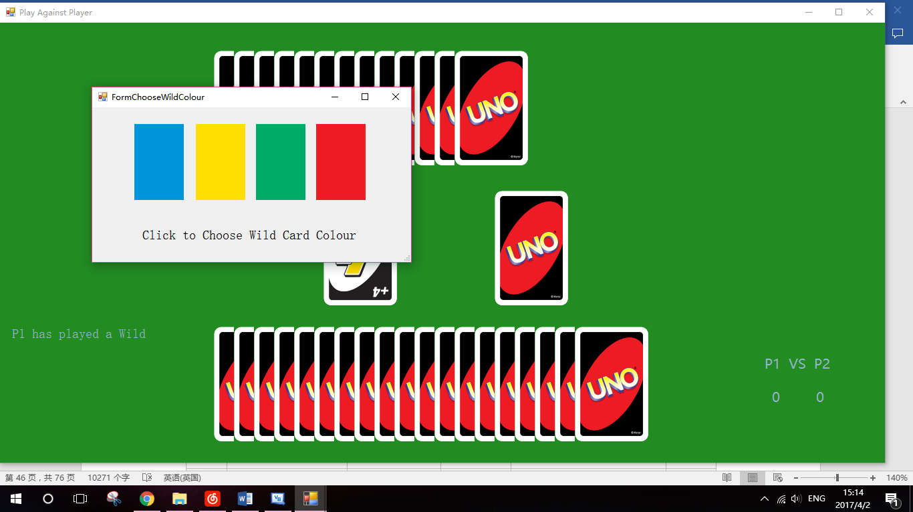

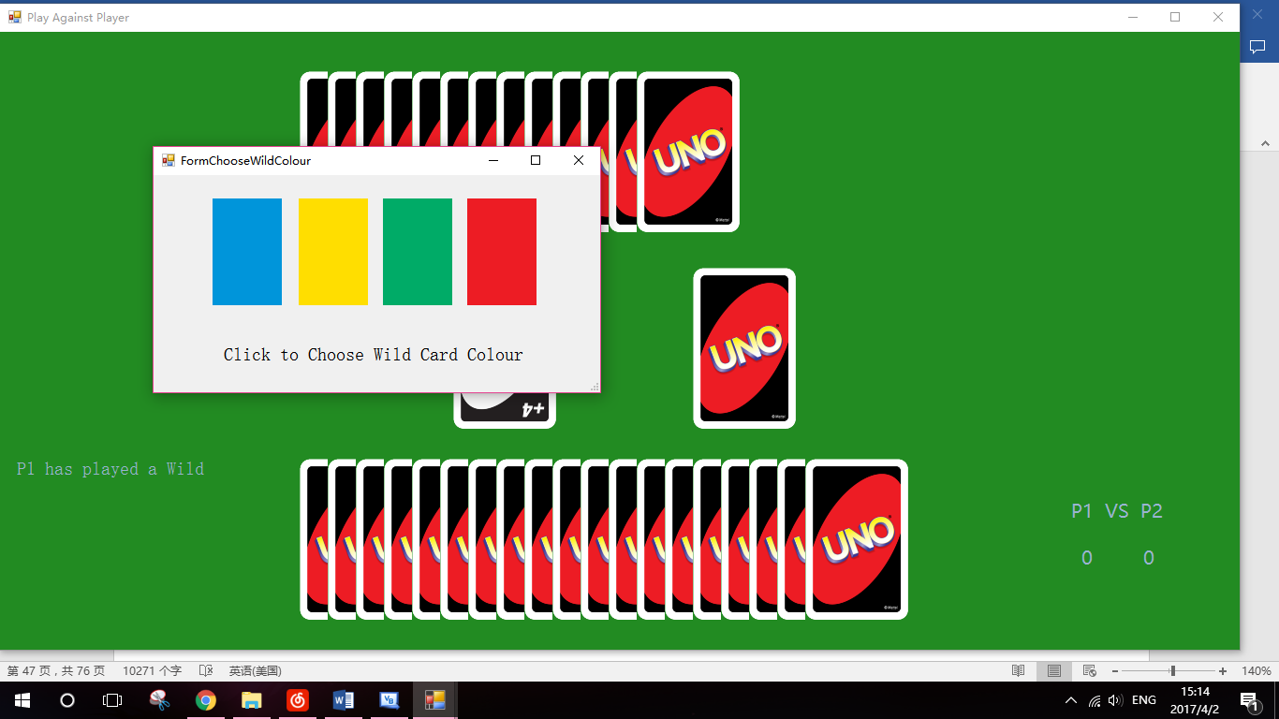

### FormPlayAgainstPlayer

|  |  |  |  |  |  |
| --- | --- | --- | --- | --- | --- |
| Test No. | Purpose | Test Data | Test Type | Expected Outcome | Test Result |
| 1 | Check that the game against player can start correctly | Click on the image of deck. | Normal | The game should start, and in the first place the play order should be determined. | Pass |
| 2 | Check that program can determine the play order using two randomly dealt number cards. | - | Normal | Two different number cards should be displayed on both players’ hand. Message box should display which player will play first and the program will pause for a short period of time. | Pass |
| 3 | Check that 7 cards are dealt to each player. | - | Normal | Each player should have 7 cards in hand. A simple animation is used to dealt the hands. (The cards would appear one by one on the screen) | Pass |
| 4 | Check that game starts with the correct player. | Move the mouse over the hands of player who should play first | Normal | That player’s hand should be displayed when mouse is over it, and the message box should tell that player to play a card. | Pass |
| 5 | Check the display of hands of the player who is playing on this turn | Move the mouse over that player’s hand | Normal | The images of cards are displayed when the mouse is over it, and would change to the back of cards once the mouse leaves | Pass |
| 6 | Check the display of hands of the player who is not playing on this turn | Move the mouse over that player’s hand | Erroneous | The images of cards should not be displayed. | Pass |
| 7 | Check that legal number cards can be played. | Click on the images of legal number cards | Normal | That card should be removed from the hand. The image and status of discard should be updated, and program should be waiting for next player’s move. Correct message is also shown in the message box. | Pass |
| 8 | Check that legal word cards can be played. | Click on the images of legal word cards. | Normal | Except for the outcomes of previous test, the abilities of word cards played should also work. | Pass |
| 9 | Check that player can draw a card from deck as punishment | Click on the image of the deck | Normal | Player should be dealt with a new card. The new card is displayed and program will wait for further move. | Pass |
| 10 | Check that player’s turn will be passed, when player still decides not to play any card after a card has already been drawn from deck | Click on the image of the deck the second time on a turn | Normal | The player’s turn should end and next player starts the turn | Pass |
| 11 | Check that player cannot play an illegal card | Click on the image of a card which is illegal to play on this turn | Erroneous | The card shall not be played. Rather, a message will show to tell the player to choose another card to play | Pass |
| 12 | Check that the player cannot play a hand when it is not in its turn | Click on the image of a hand when it is not on that player’s turn | Erroneous | Nothing should happen | Pass |
| 13 | Check that scoreboard can record the score of both players properly | Play the game until a player wins | Normal | The scoreboard should show the correct scores. | Pass |
| 14 | Check that another game can be successfully started | Click on the image of deck | Normal | The next game should be started successfully, with scoreboard remained the same numbers | Pass |
| 15 | Check that debug button works properly | Click on the debug button “Reveal all”, which is only enabled in debug mode | Normal | Hands of both players should be revealed. | Pass |
| 16 | Check that the number of hands does not exceed 20 | Click on the image of deck and draw the cards until hand is full | Erroneous | A message box will be displayed to warn that hand number cannot exceed 20. And the card will not be dealt to that player. | Pass |
| 17 | Check that game will end properly if there’s no more cards in the deck | Draw a card when there’s no cards in deck | Erroneous | A message box will be displayed to show the deck is empty. The game will end immediately without change in scoreboard. Player can click on the deck to start another game | Pass |

#### Test 1

The game started successfully, and the method for determining the play order was run.

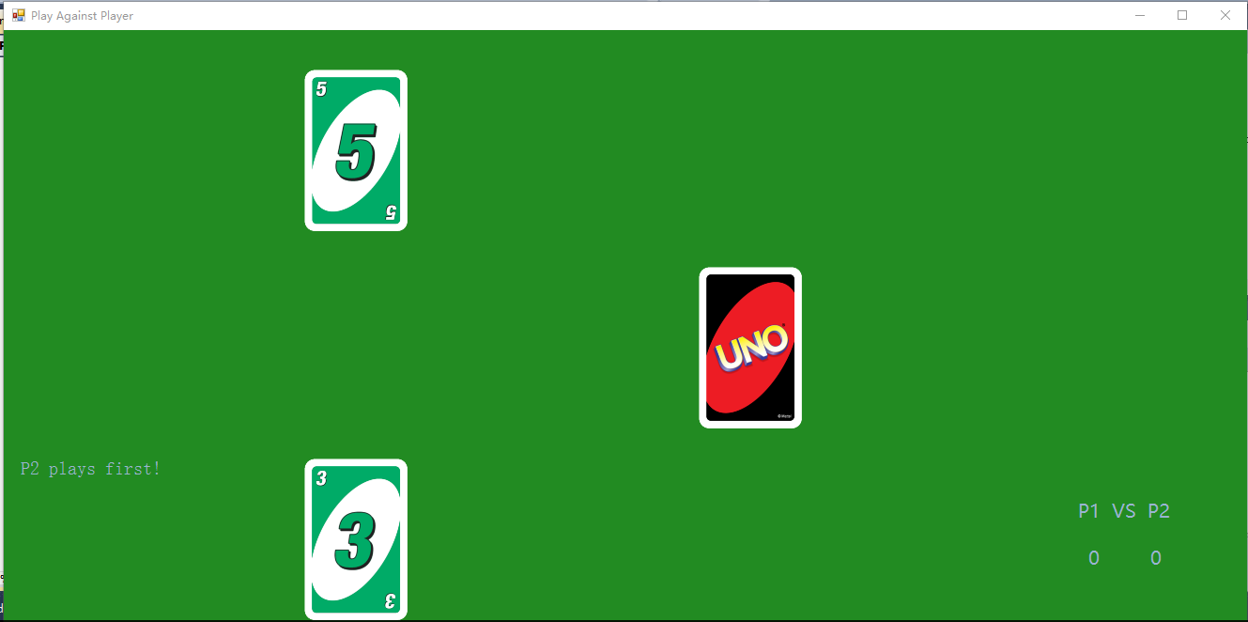

#### Test 2

As shown above, the player order was correctly determined.

#### Test 3

Seven cards were dealt to each player.

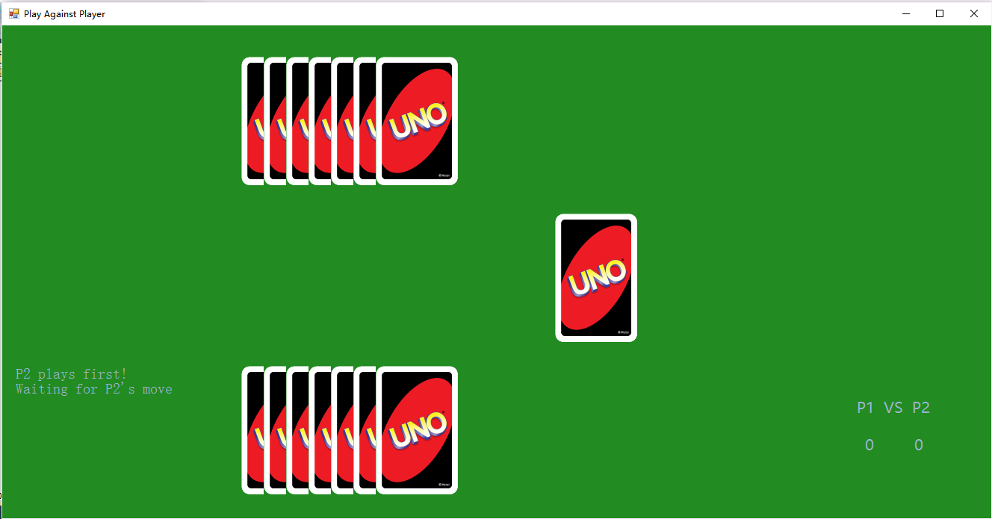

(The screenshot of the animation was not captured)

#### Test 4

As shown above, Player2 would play first.

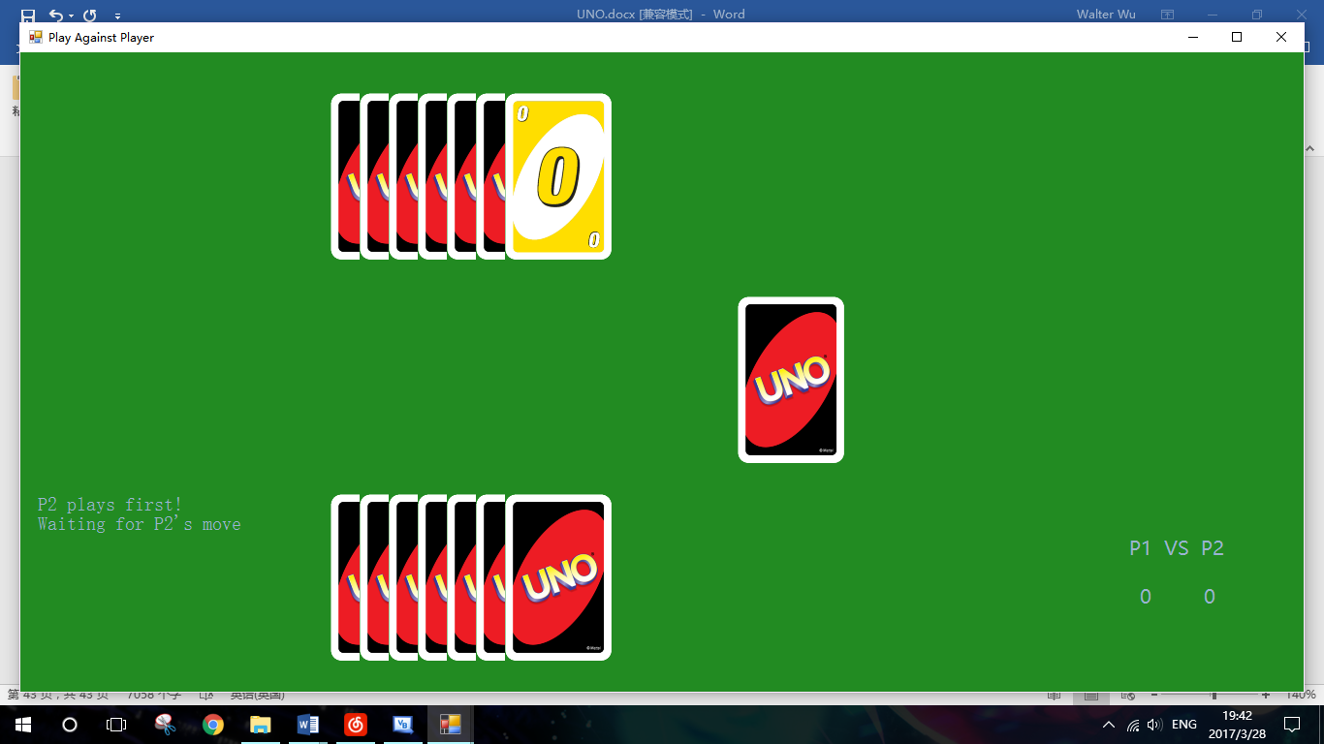

Besides, the hand of P2 was also displayed.

(The mouse was not captured in the screenshot)

#### Test 5

When it's on P2’s turn, the image of hand was shown when the mouse was over it and disappeared once the mouse leaves.

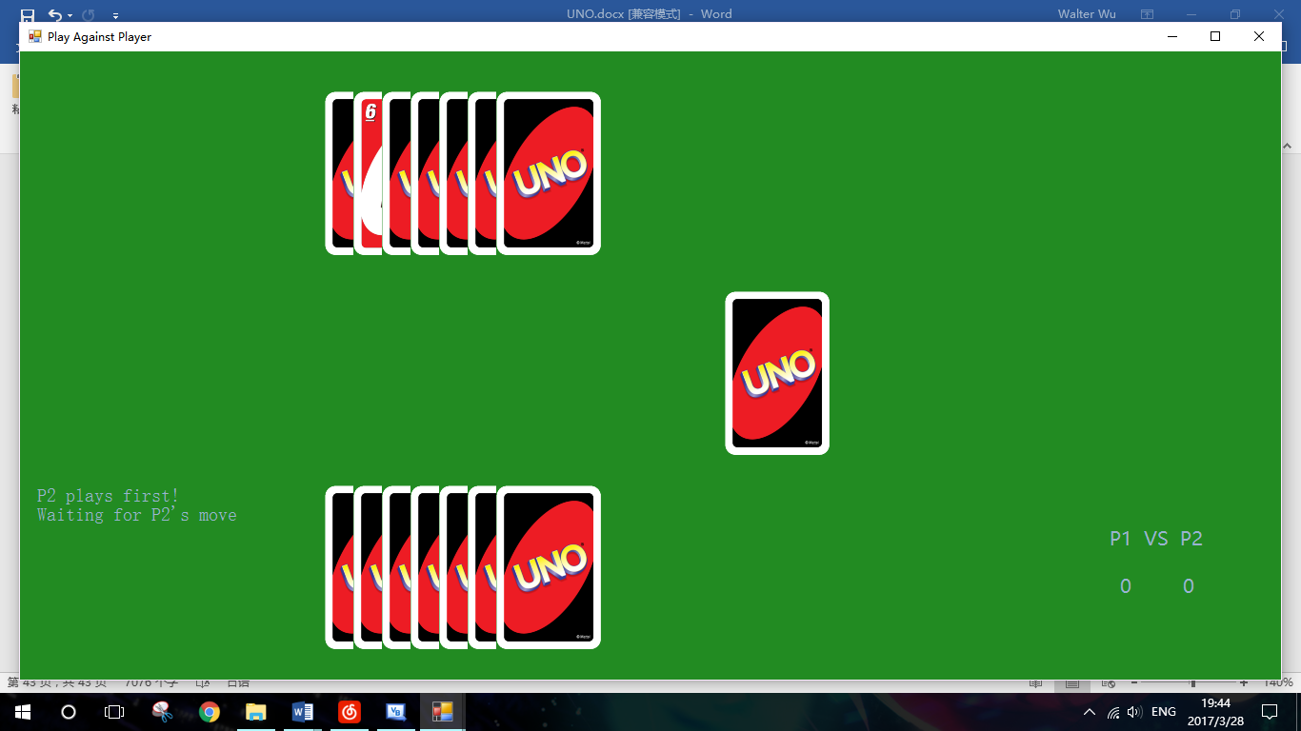

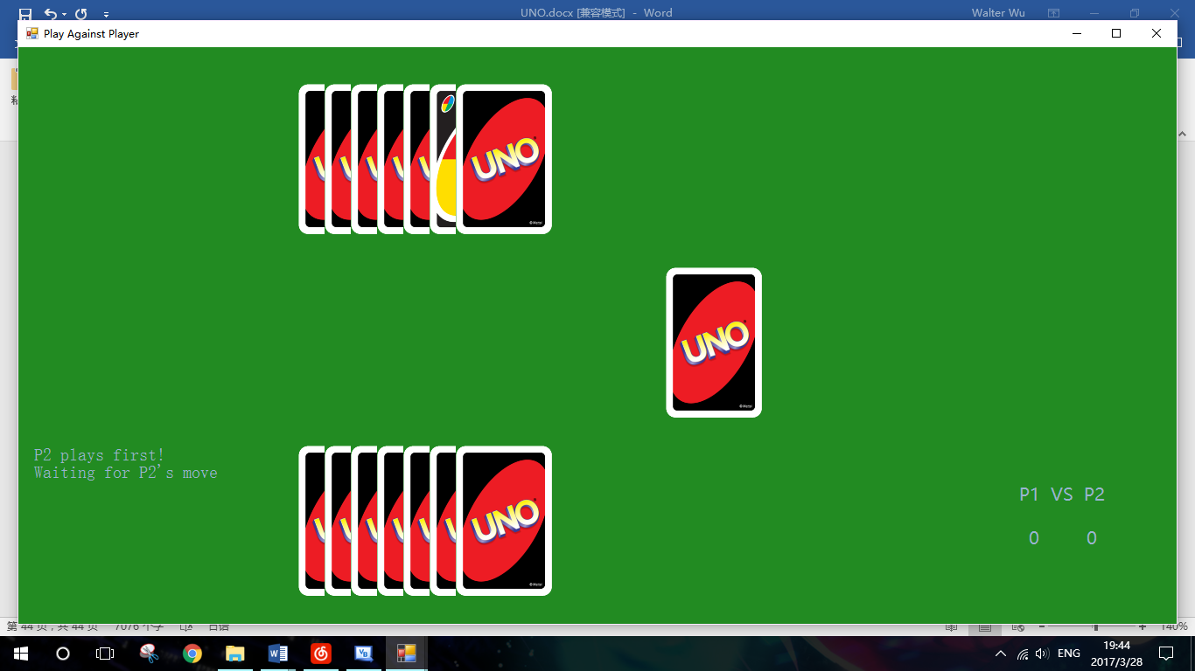

#### Test 6

The mouse was upon the last hand of P1. However, no image of card was displayed as it was on P2’s turn.

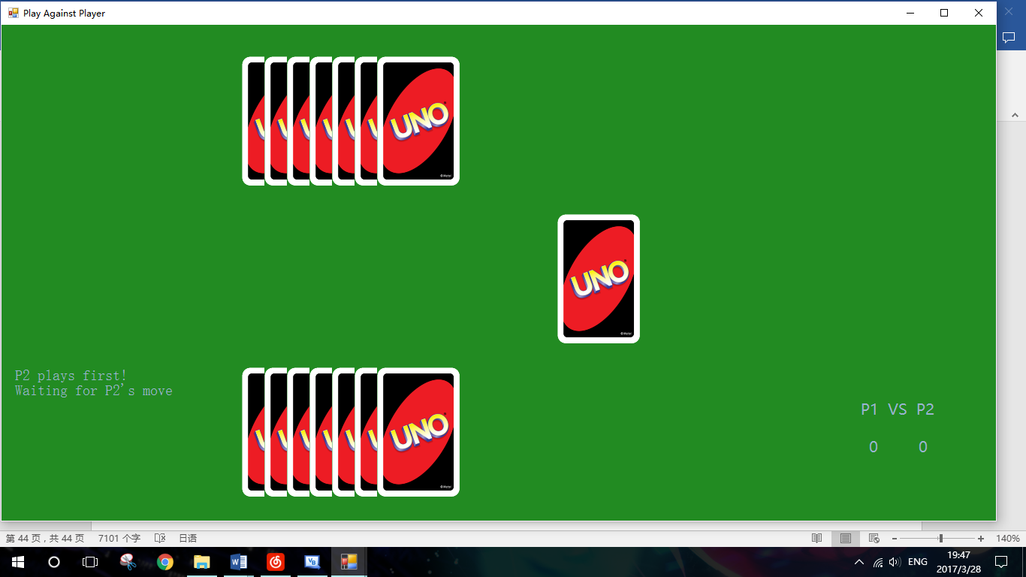

(Mouse was not captured in screenshot)

#### Test 7

Some legal number cards were played. They were successfully removed from player’s hand and the discard was updated. Program was then waiting for another player’s move.

(About legal cards, see analysis)

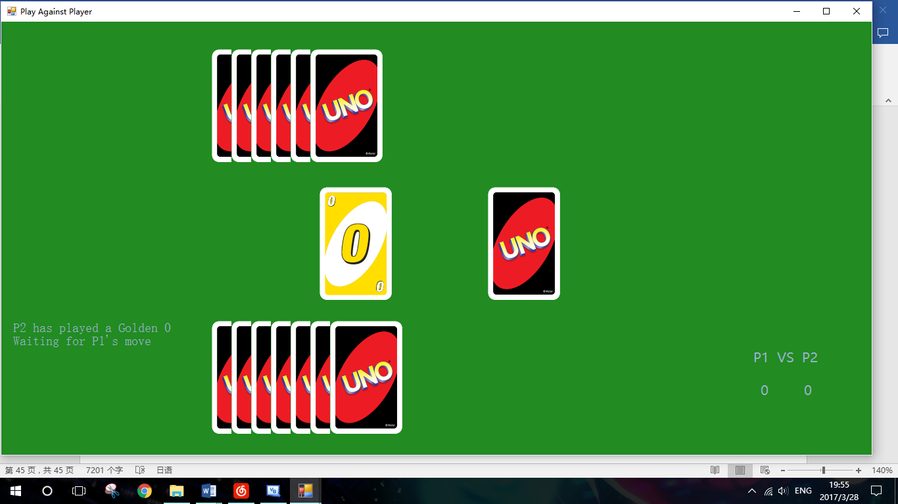

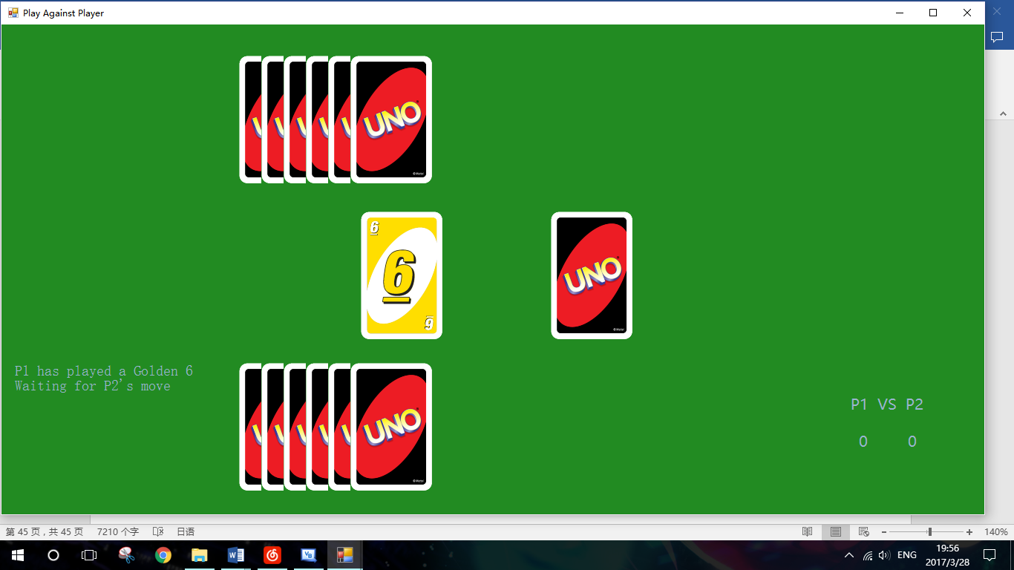

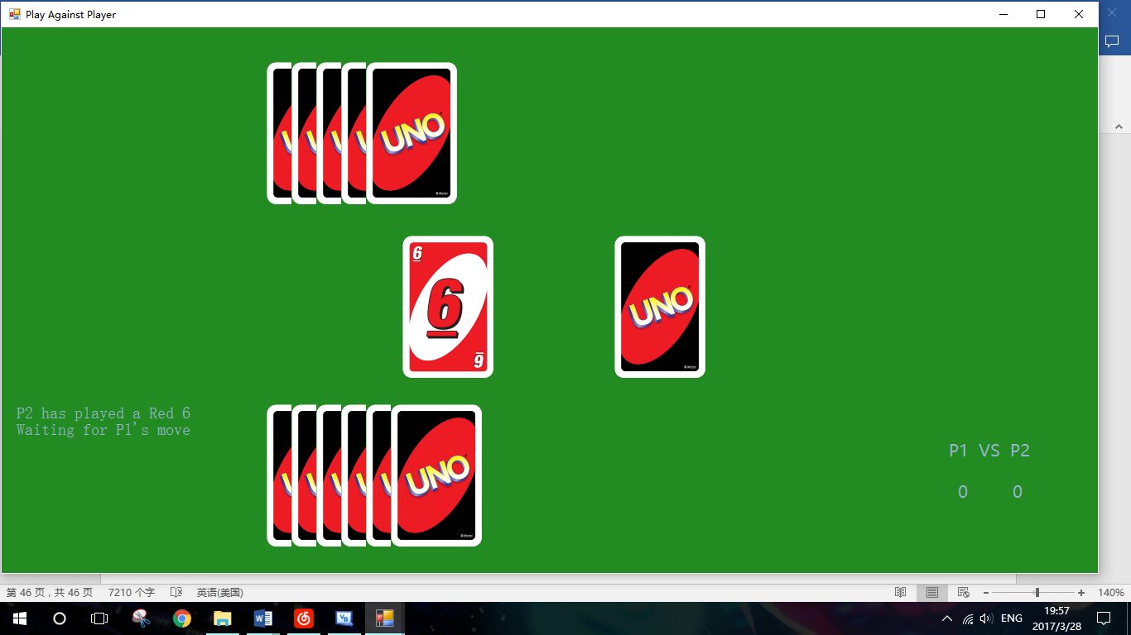

#### Test 8

Legal word cards were played and their abilities worked properly.

(About word cards and their abilities, see analysis.)

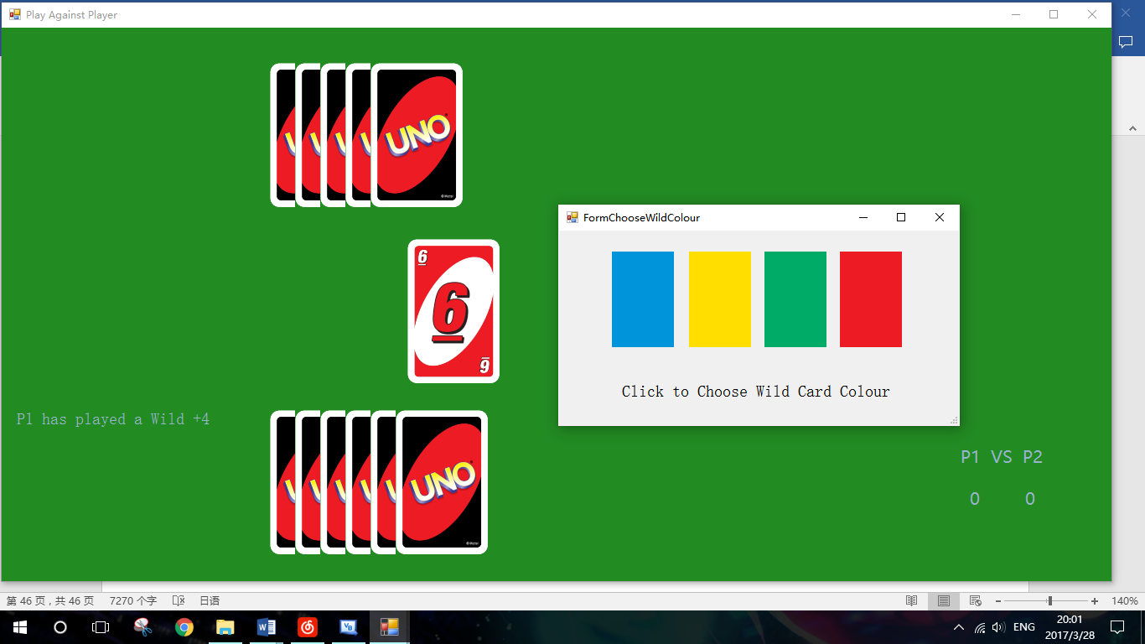

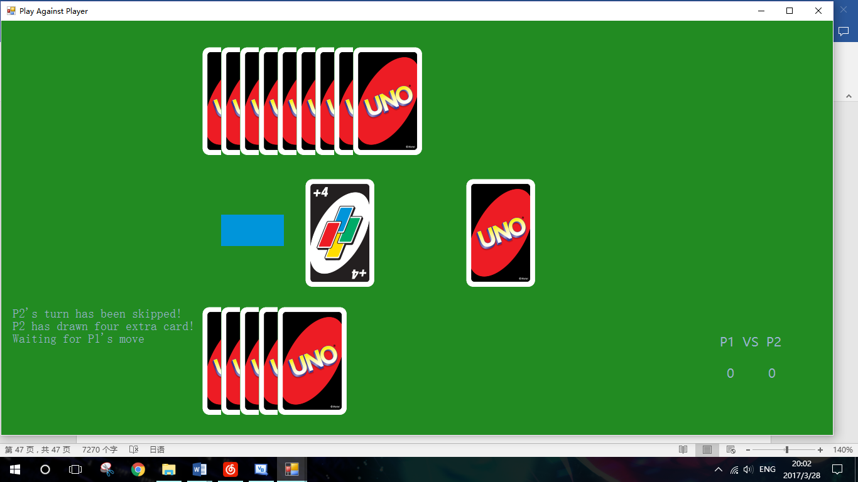

A Wild +4 card was played by P1. FormChooseWildColour popped up to ask for a wild colour. After that, P2 had drawn four cards and its turn was skipped.

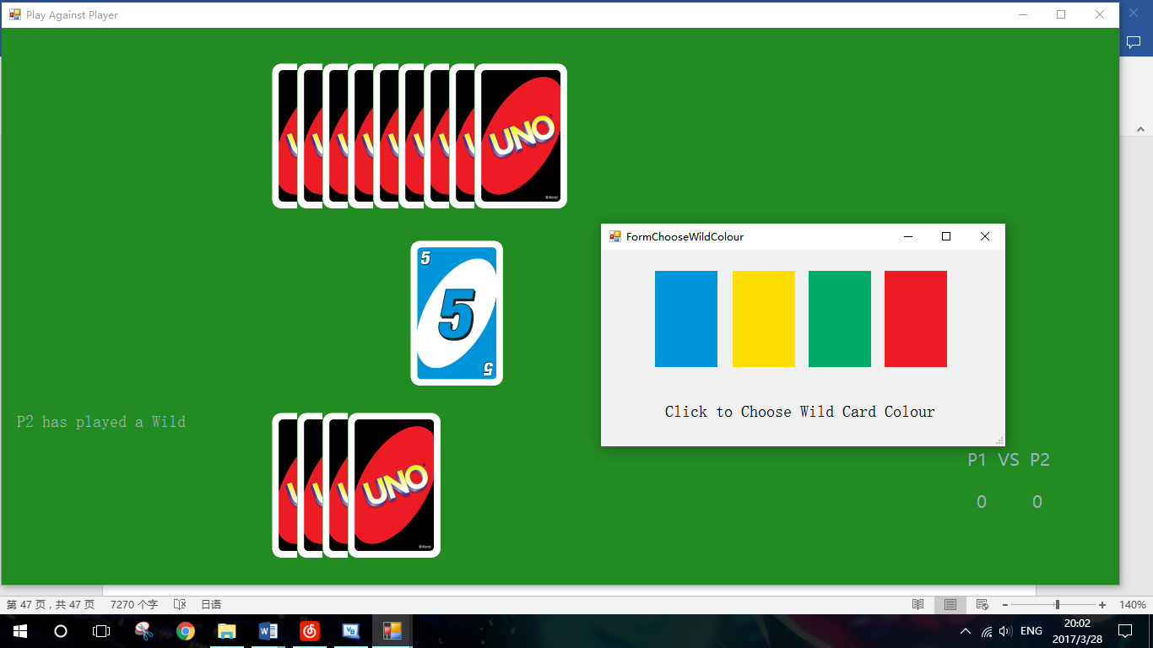

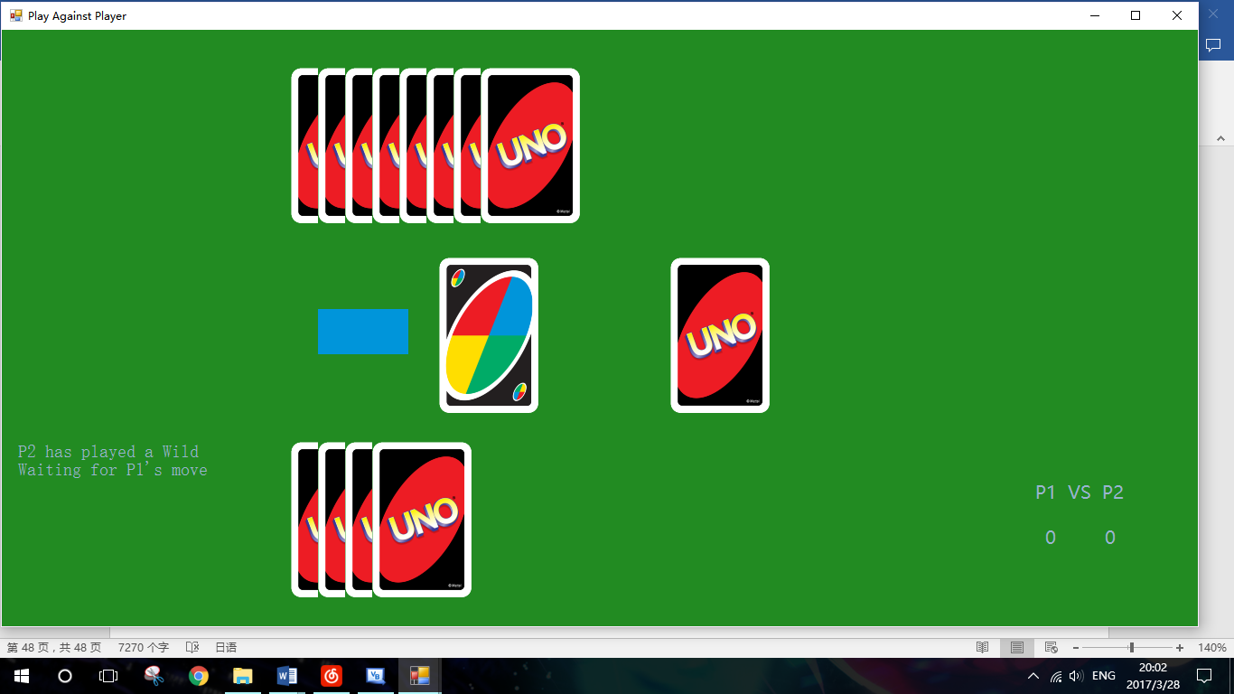

A Wild card was played by P2. FormChooseWildColour popped up to ask for a wild colour.

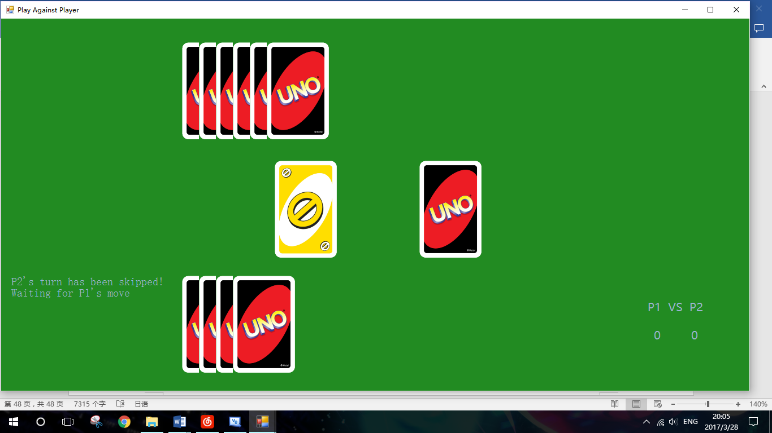

A Golden Skip was played by P1. P2’s next turn was immediately skipped.

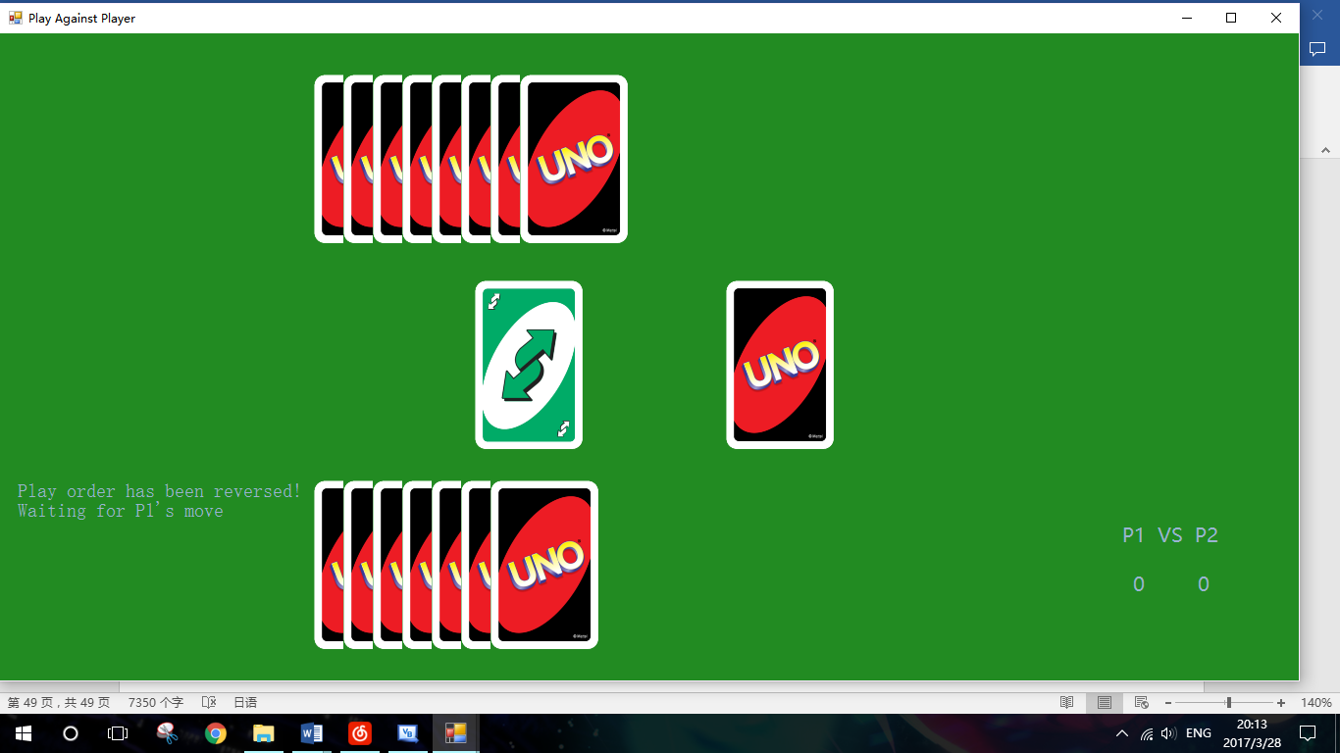

A Green Reverse was played by P2. The player order was then reversed.

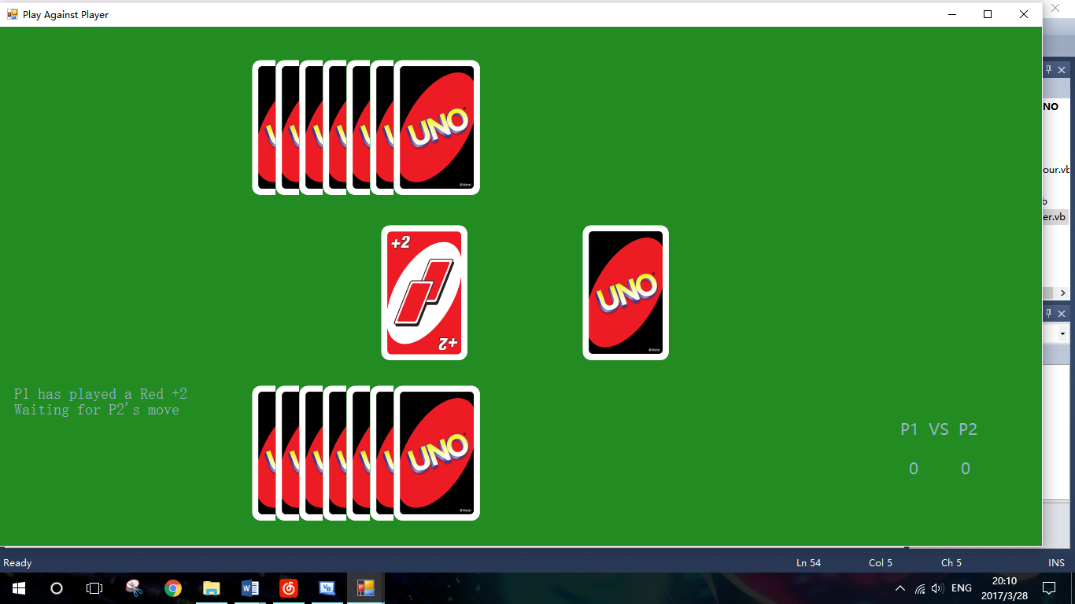

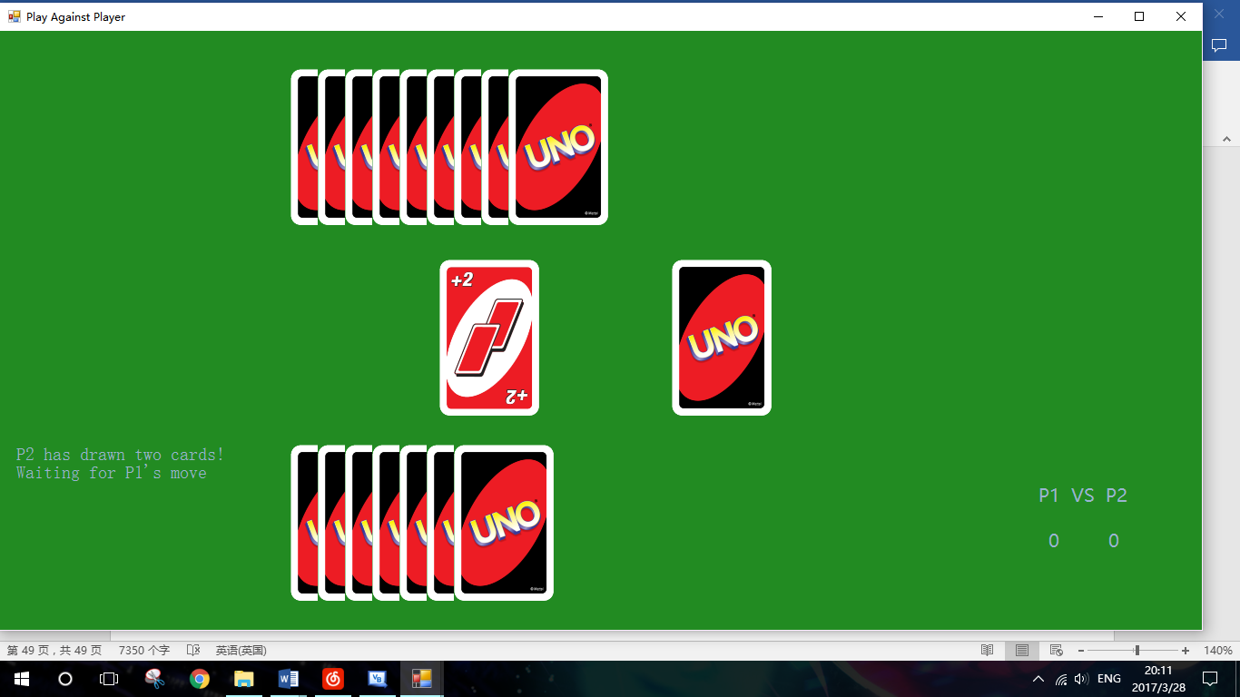

A Red +2 was played by P1. P2 needed to play a wild +4, otherwise P2 must draw two cards as punishment.

#### Test 9

According to the rule of Uno, if a player does not play any card in its turn, that player must draw an extra card from deck as punishment. (See analysis)

The image of deck was clicked, and a new card is added to P2. Program then waited until next instruction was given by player.

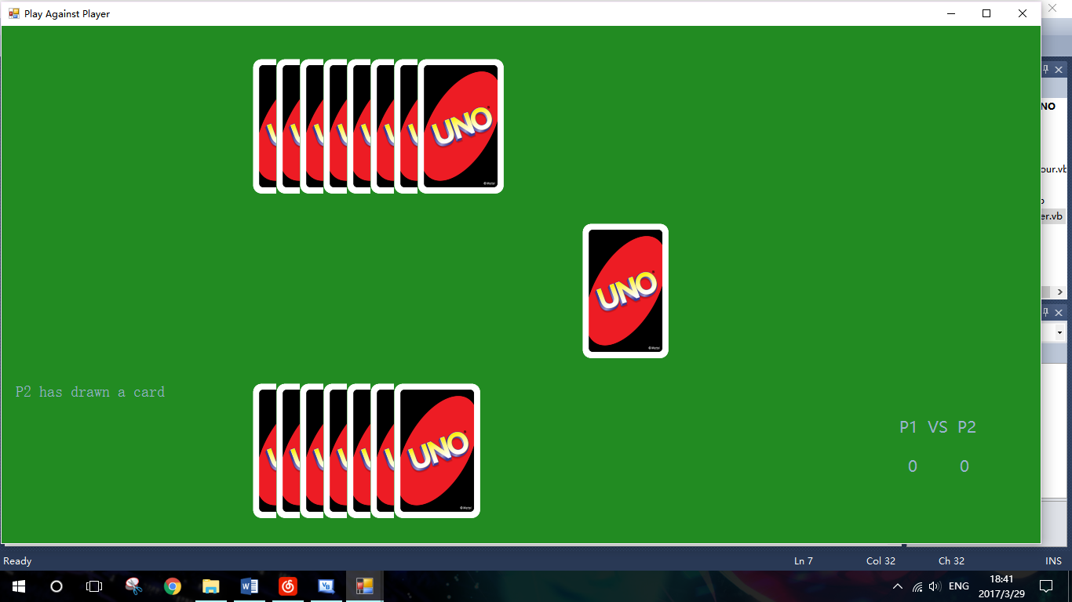

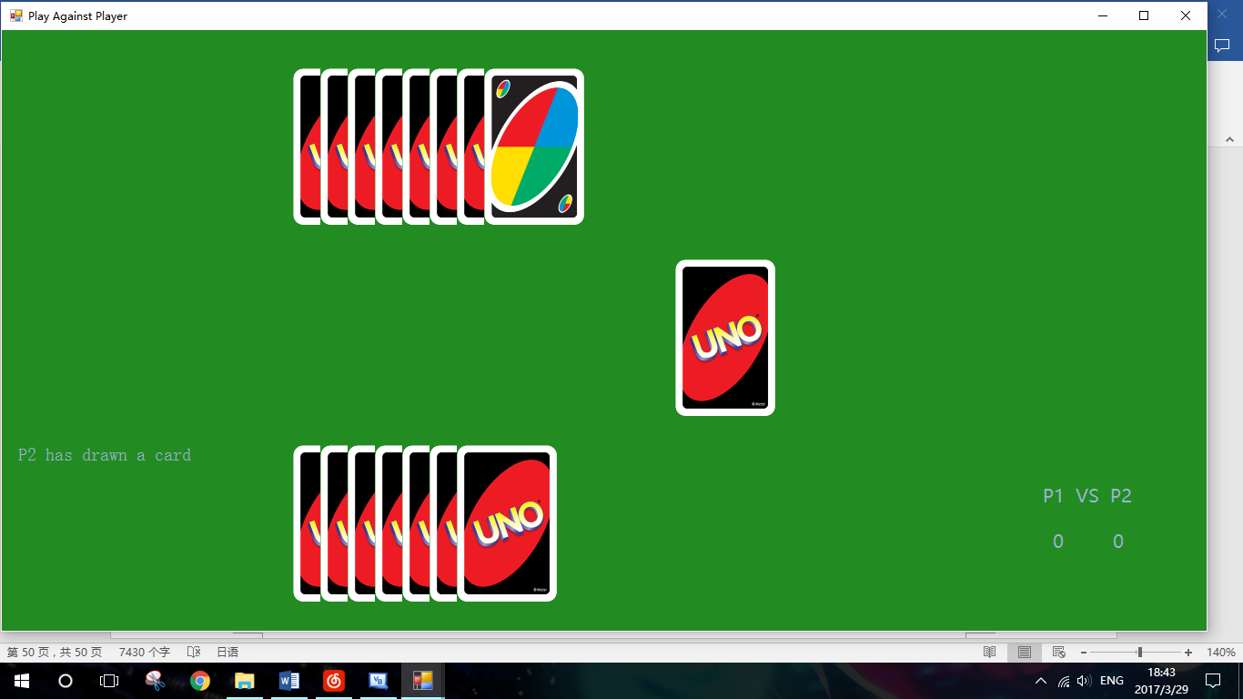

A Wild was dealt to P2. (The mouse was upon it to reveal the image)

#### Test 10

After the deck was clicked the second time, P2’s turn ended immediately and P1 started its turn.

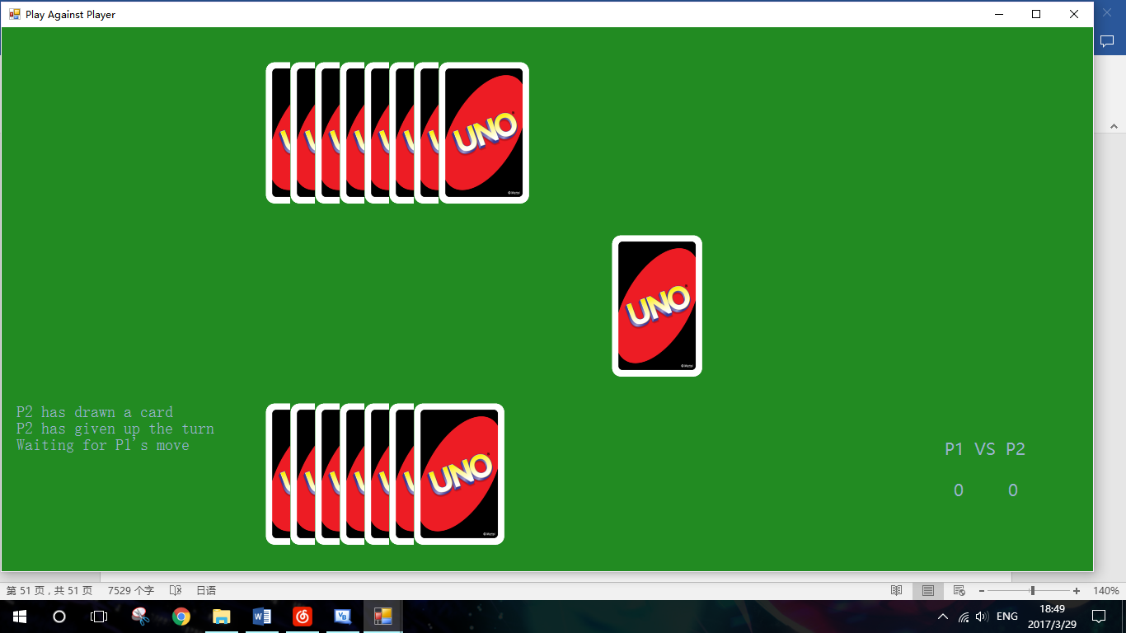

#### Test 11

P2 was trying to play a Blue 9 after P1 had played a Red 2, which is an illegal move. (About illegal cards, see analysis)

This was prevented by the program, and an error message was shown to ask player to choose another card to play.

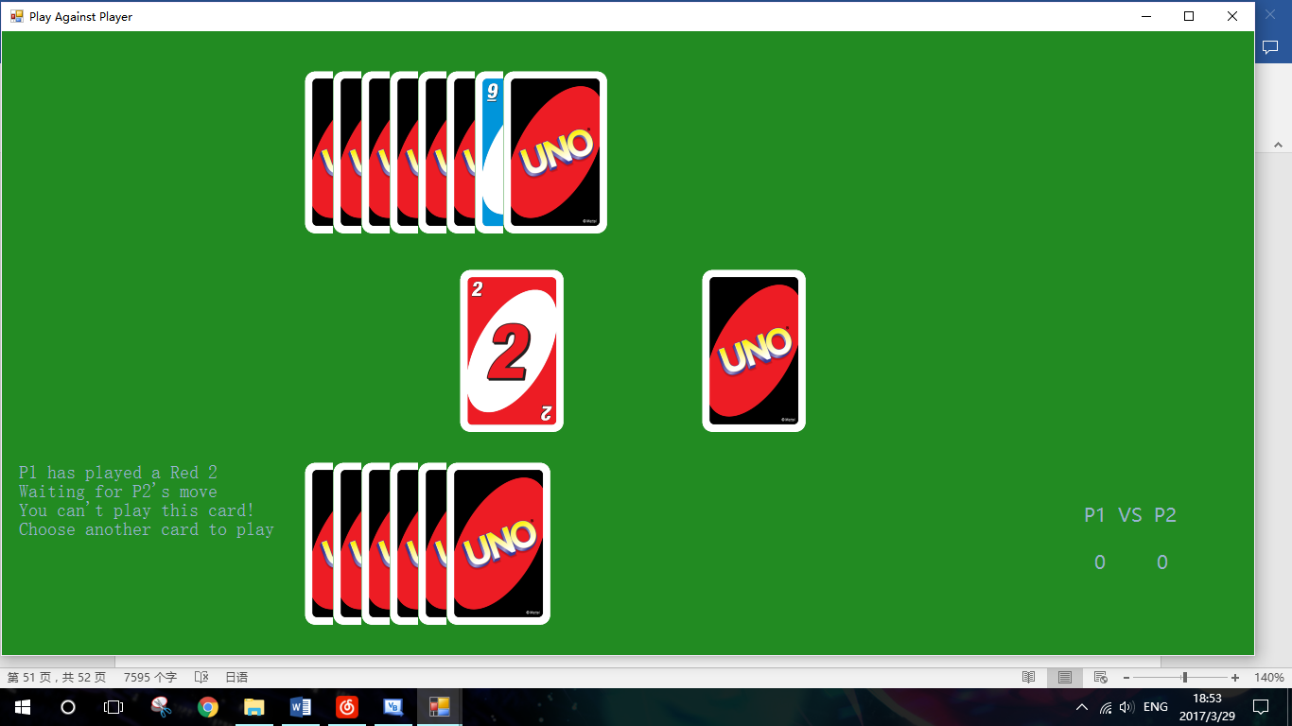

#### Test 12

The last hand of P1 was clicked.

As it was on P1’s turn, nothing happened.

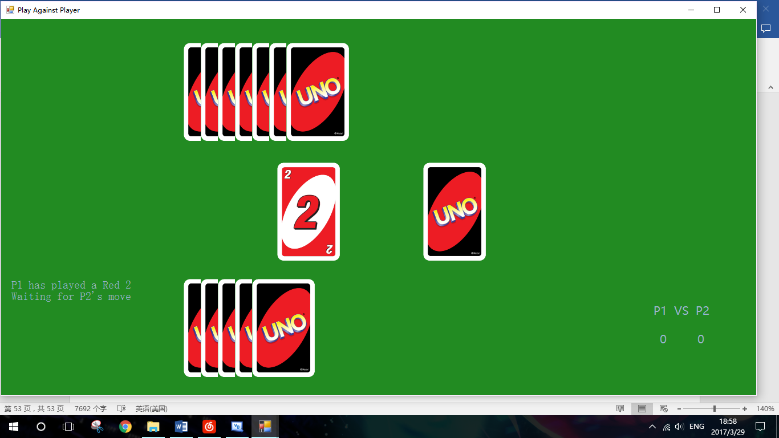

#### Test 13

P1 played all the hand and won the game.

Rest of the hands were shown, and the scoreboard was updated to the correct number.

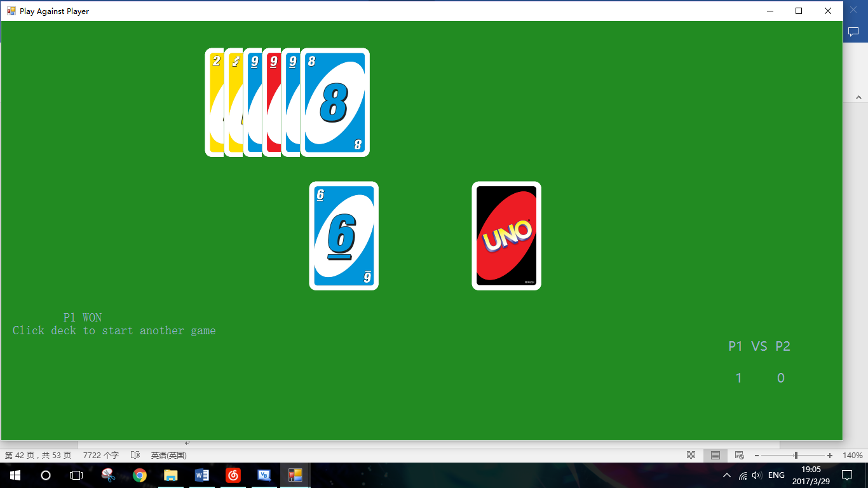

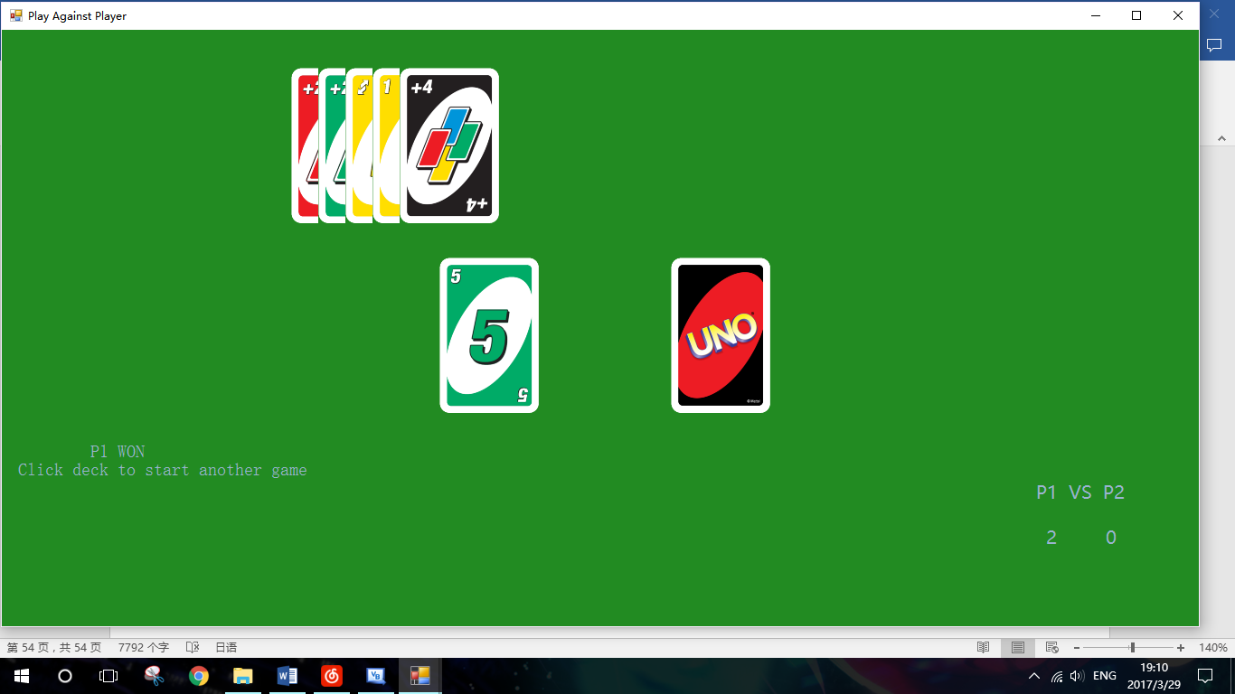

This time P2 won the game.

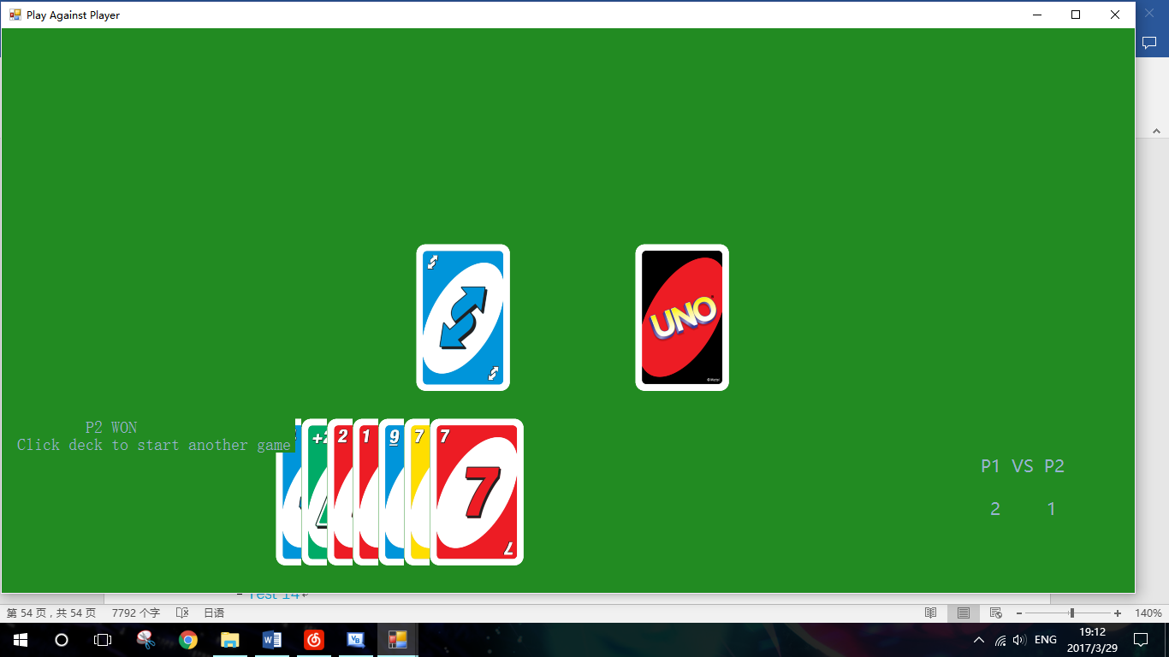

#### Test 14

Another game was successfully started, and the scoreboard remained as well.

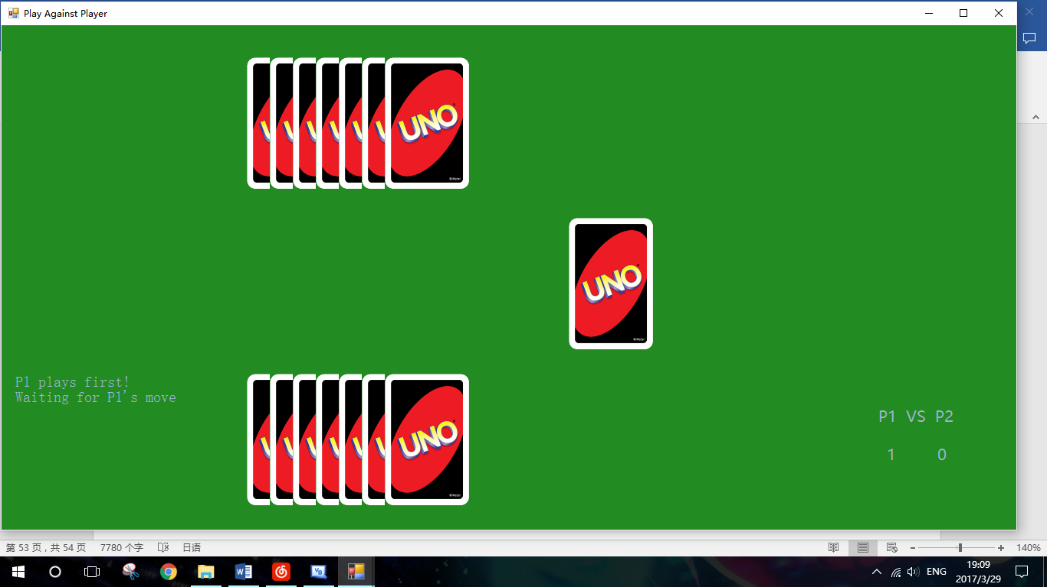

#### Test 15

The debug mode was opened from main menu, and the button “Reveal All” was clicked.

All hands were revealed.

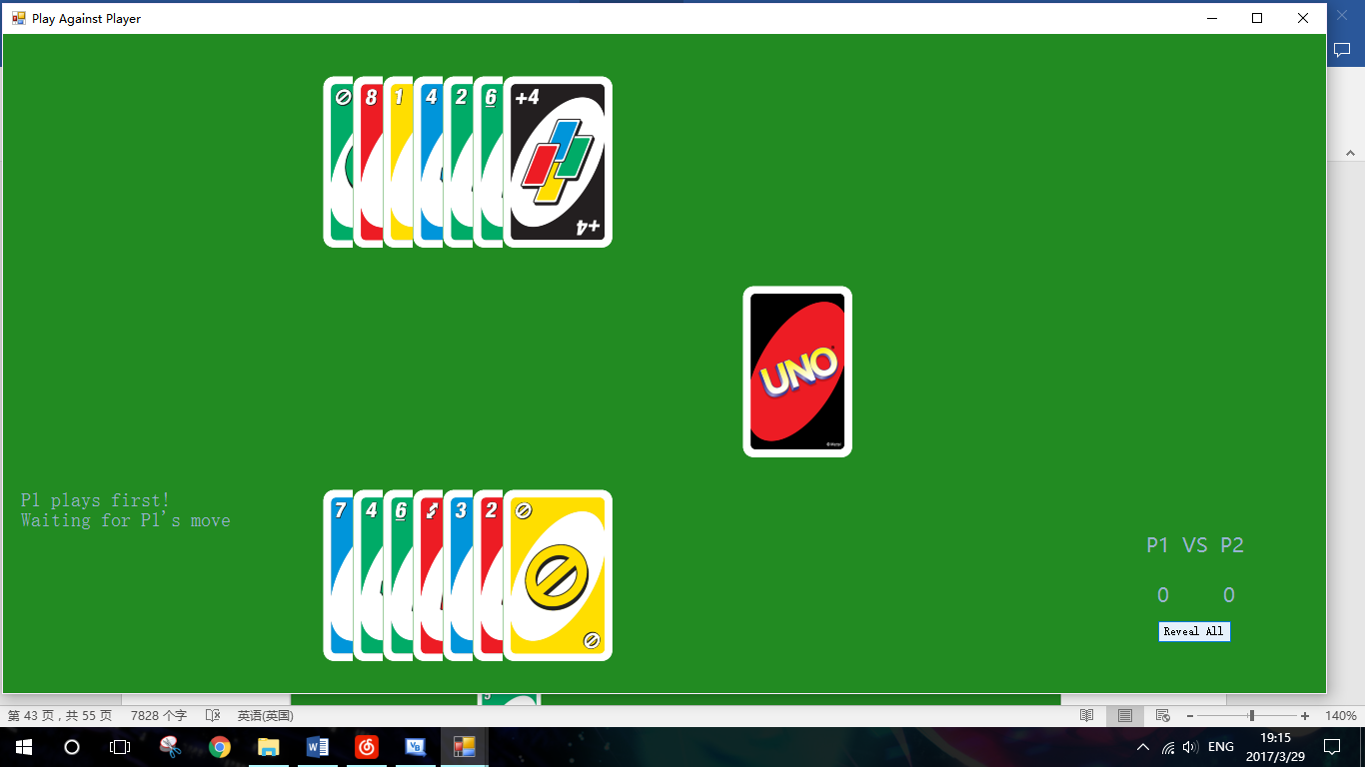

#### Test 16

The message box was correctly shown when the hand number of P1 was about to exceed 20.

The drawing was then prevented and game was able to continue as usual.

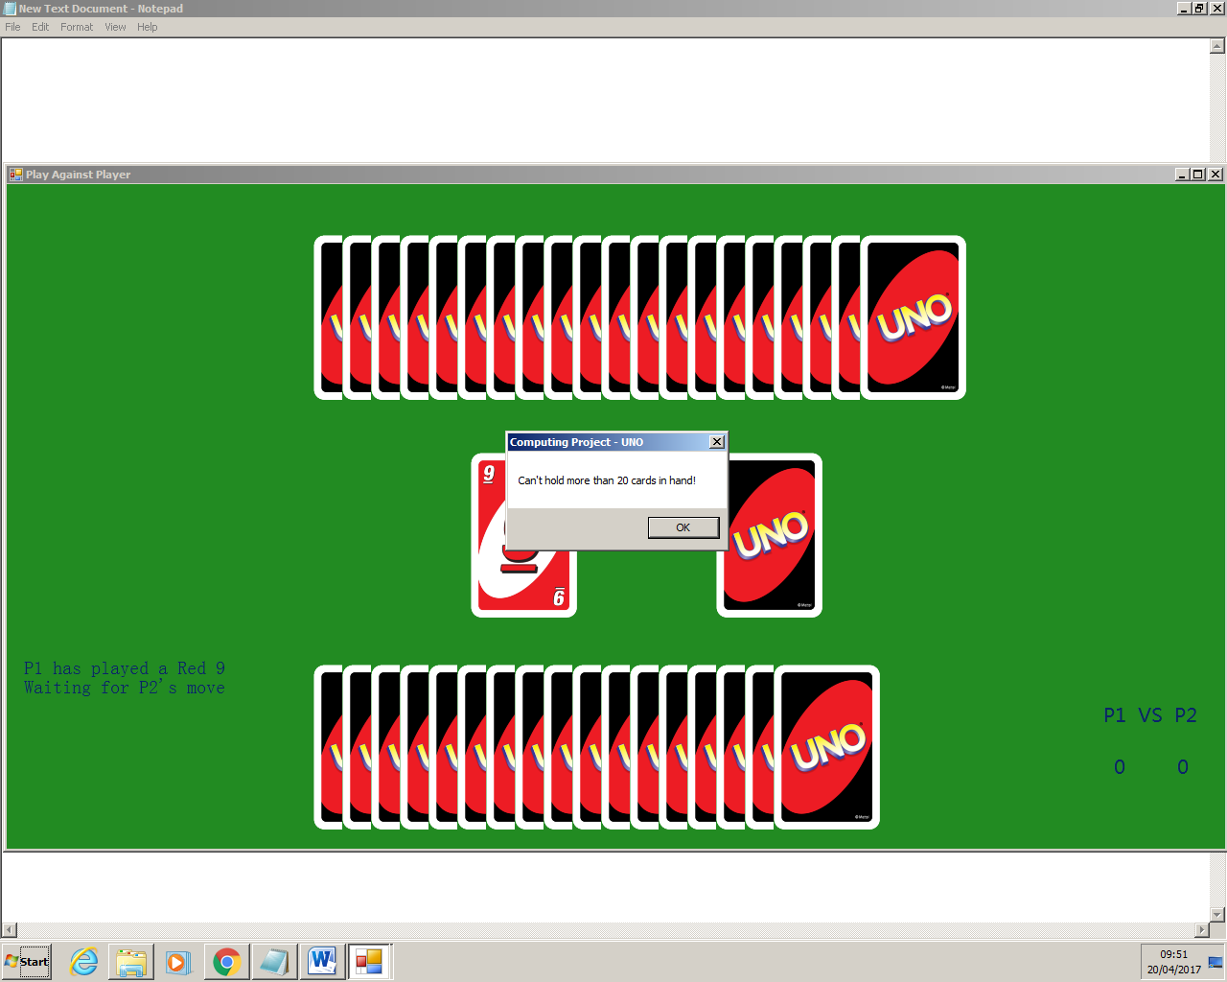

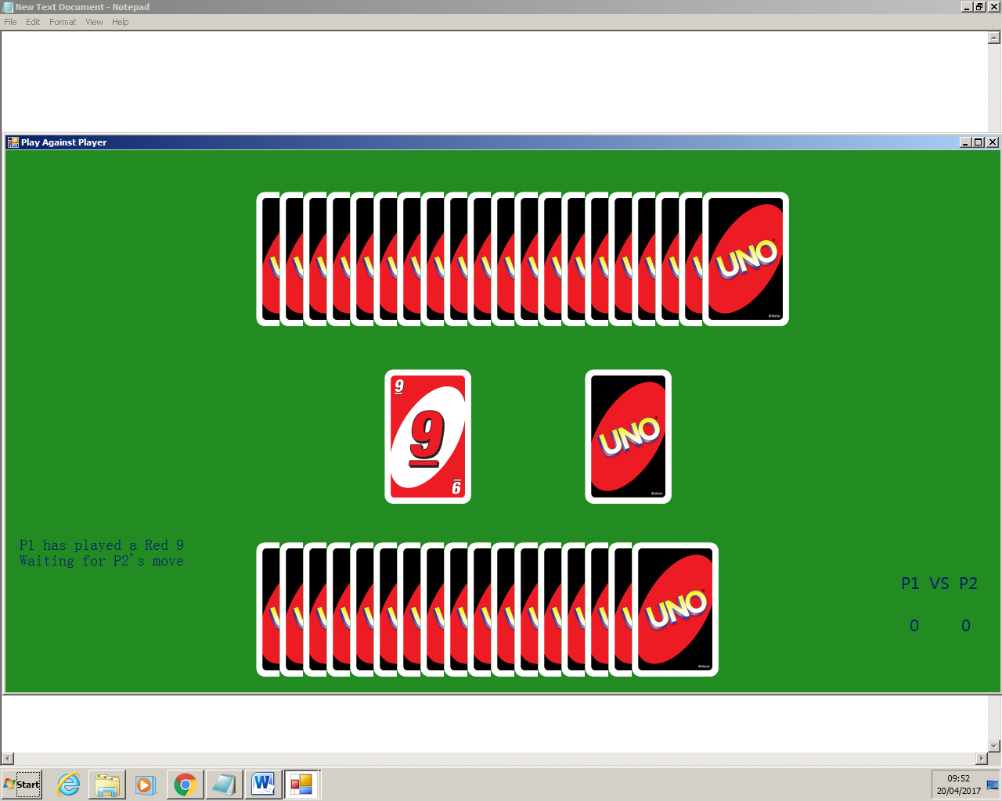

(The difference in front colour was due to change in system settings)

#### Test 17

After all the 108 cards have been drawn from the deck, the game can still proceed normal. However, when any extra drawing was requested, the error will occur since the deck is already empty.

To prevent the error, if a player tries to draw any more cards when the deck is empty, the drawing will be prevented as shown below.

P2 tried to draw a card from the empty deck. The drawing was successfully prevented and correct information was displayed.

The game then ended properly without change in scoreboard, and player was able to start another game by clicking the deck.

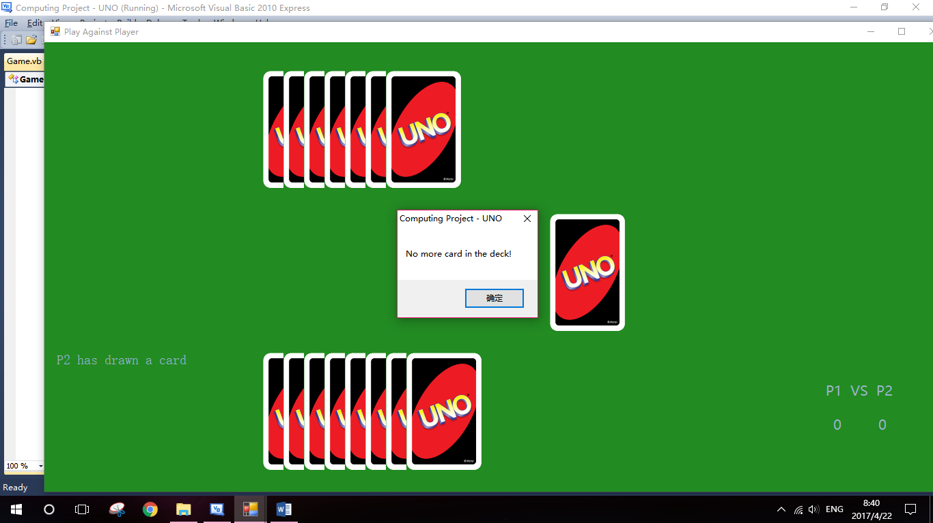

(The language of message box was changed due to system settings)

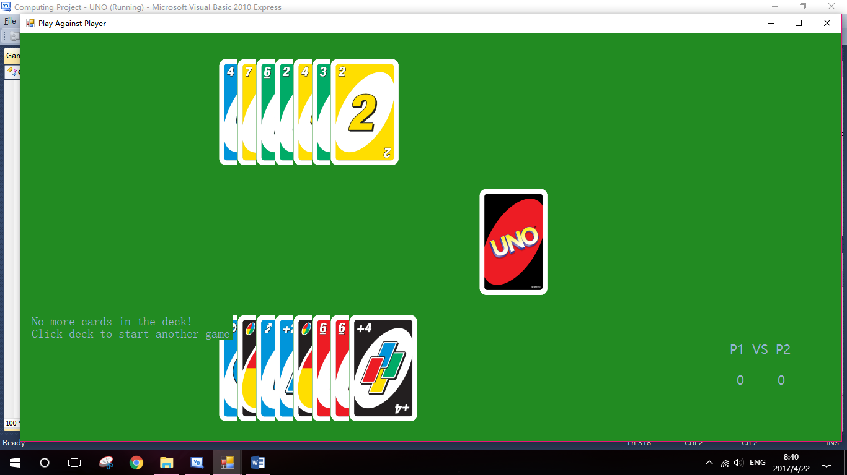

### FormPlayAgainstAI

Since both class PlayerGame and AIGame are inherited from class Game, some functionalities are achieved using same algorithm. Therefore, duplicate testing becomes unnecessary and is not included in this section.

|  |  |  |  |  |  |
| --- | --- | --- | --- | --- | --- |
| Test No. | Purpose | Test Data | Test Type | Expected Outcome | Test Result |
| 1 | Check that the game against AI can start correctly | Click on the image of deck. | Normal | The game should start, and in the first place the play order should be determined. | Pass |
| 2 | Check that if player’s hands are always displayed, and AI’s hands are always hidden | - | Normal | In play against AI mode, only player’s hands should always be shown | Pass |
| 3 | Check that AI can play a legal number card | Play a card, and wait for AI’s move | Normal | That card should be removed from the hand. The image and status of discard should be updated, and program should be waiting for next player’s move. Correct message is also shown in the message box. | Pass |
| 4 | Check that AI can play a legal word card | Play a card, and wait for AI’s move | Normal | Except for the outcomes of the previous test, the abilities of word cards played should work. | Pass |
| 5 | Check that AI will draw a card / pass the turn as punishment when it has no legal card to play, or it chooses to do so | Play the game until AI takes punishment | Normal | Correct message should be shown, and punishment should work on AI | Pass |
| 6 | Check that Hint button works properly | Click on the Hint button during player’s turn | Normal | Arrows should be displayed above all the legal cards. Further messages about the punishments are displayed in the message box | Pass |
| 7 | Check that Easy AI plays card and chooses wild colour randomly | Play a card, and wait for Easy AI’s move (debug mode is used in this testing) | Normal | According to its algorithm, Easy AI should make decisions in a completely random | Pass |
| 8 | Check that Hard AI can play cards according to certain strategy | Play a card, and wait for Hard AI’s move (debug mode is used in this testing) | Normal | Hard AI will play cards using certain strategy | Pass |
| 9 | Check that Cheater AI can play cards according to certain rules | Play a card, and wait for Cheater AI’s move (debug mode is used in this testing) | Normal | Cheater AI will play cards using certain strategy, and it is allowed to look at player’s hand and deck | Pass |
| 10 | Check that AI simulates the reaction time of human player properly | Play a card, and wait for AI’s move | Normal | Program will pause for a short period of time after AI takes its action to get human player sufficient time to react. | Pass |

#### Test 1

The image of deck was clicked, and game was started successfully.

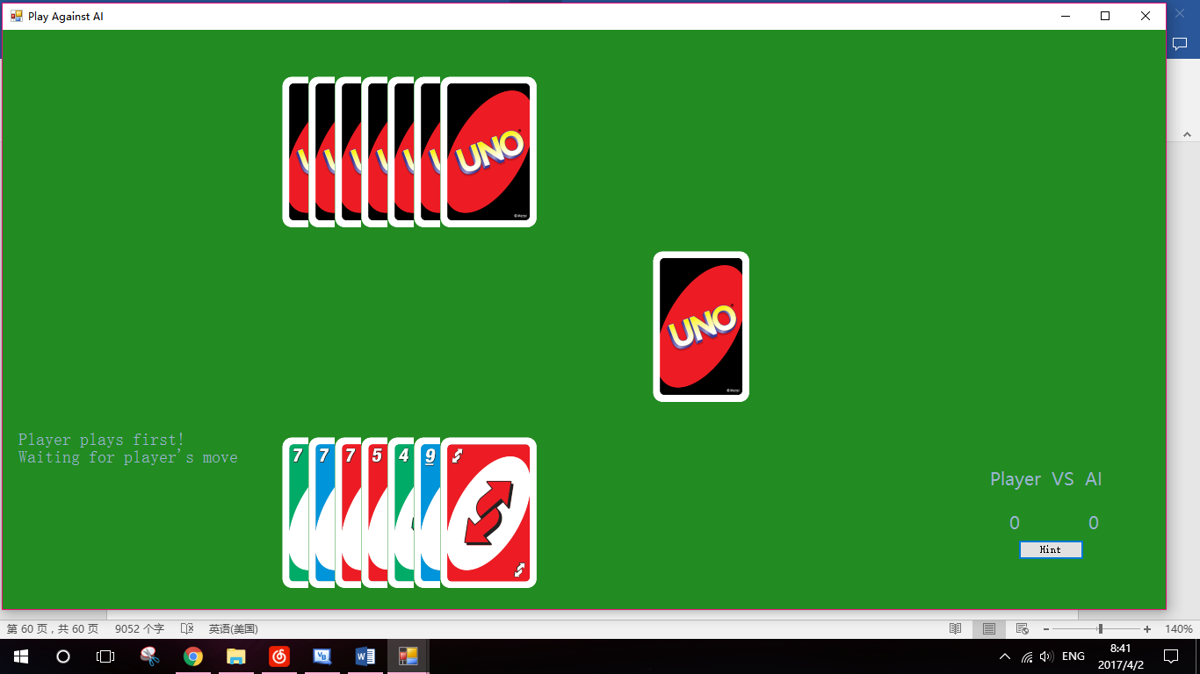

#### Test 2

During the process of game, only player’s hands were displayed.

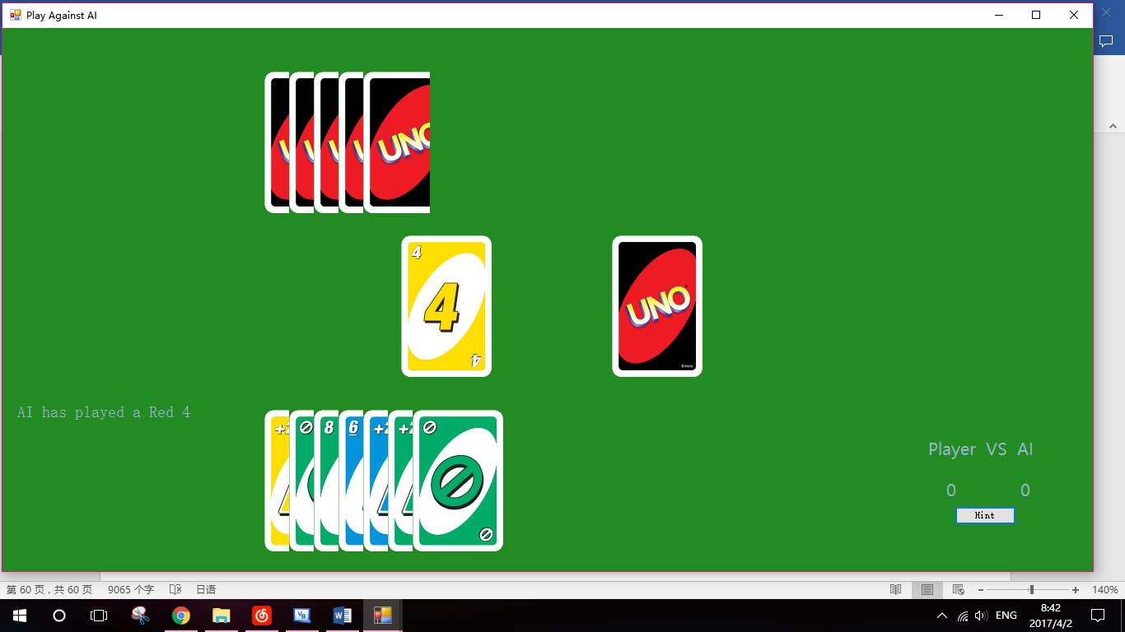

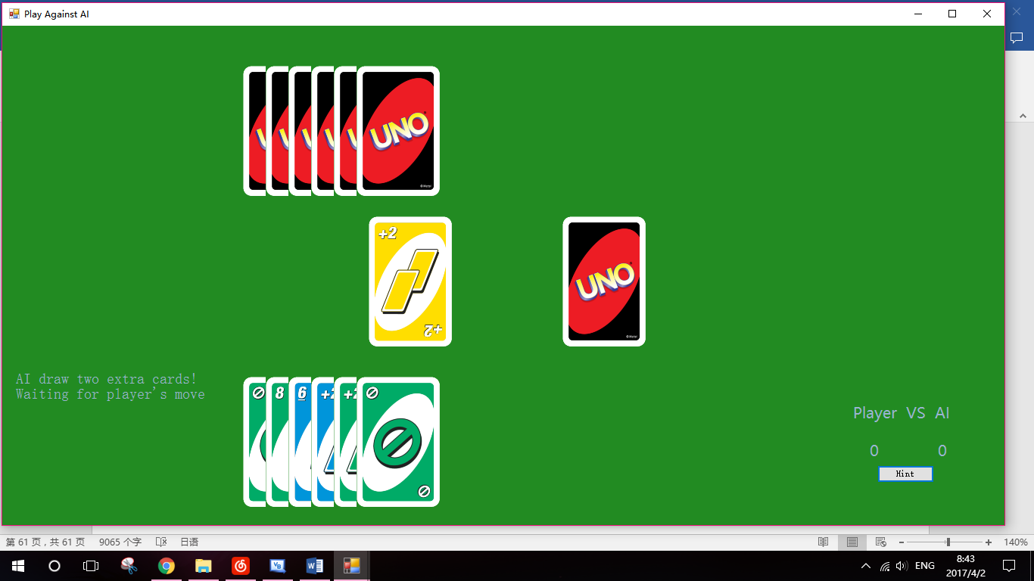

#### Test 3

As shown in the picture, play played a Blue 6 first, and AI followed it with a Blue 9.

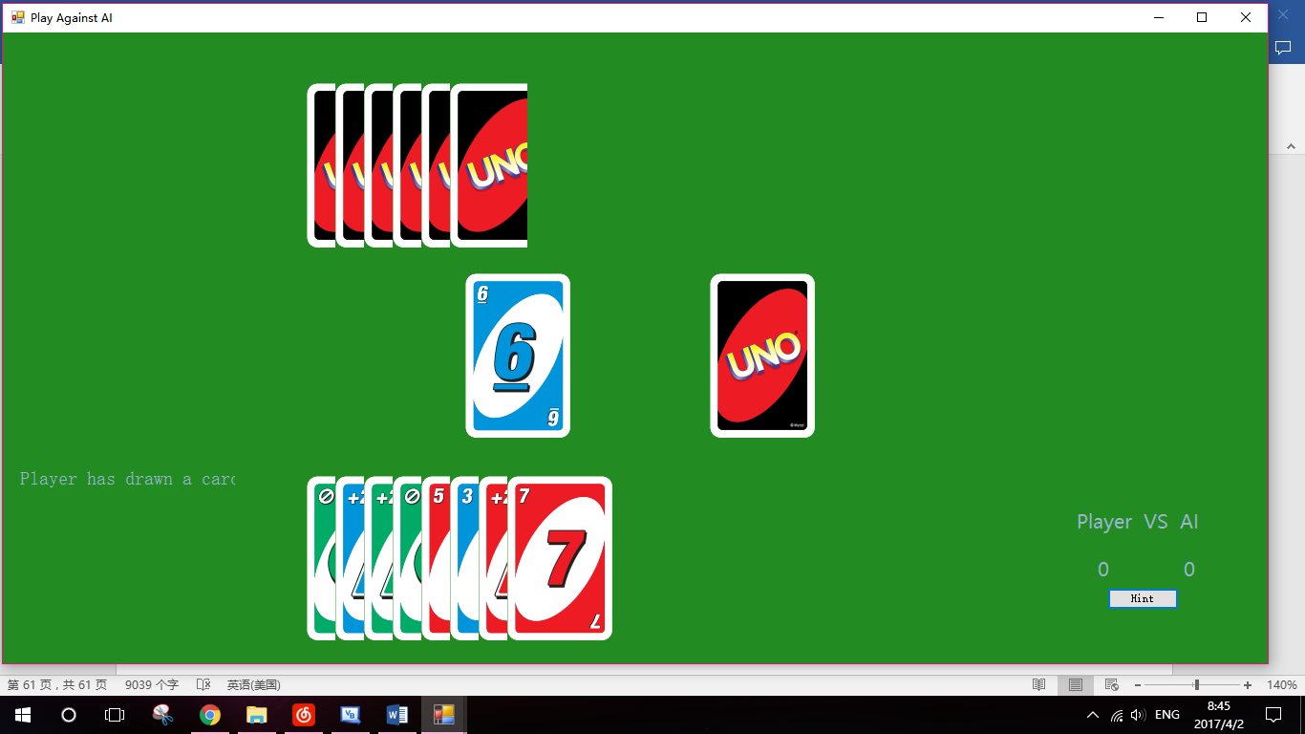

(The misbehaviour in the images of AI’s hand was because the screenshot was captured when the picturebox was loading the image, and was not noticeable to human players during the game)

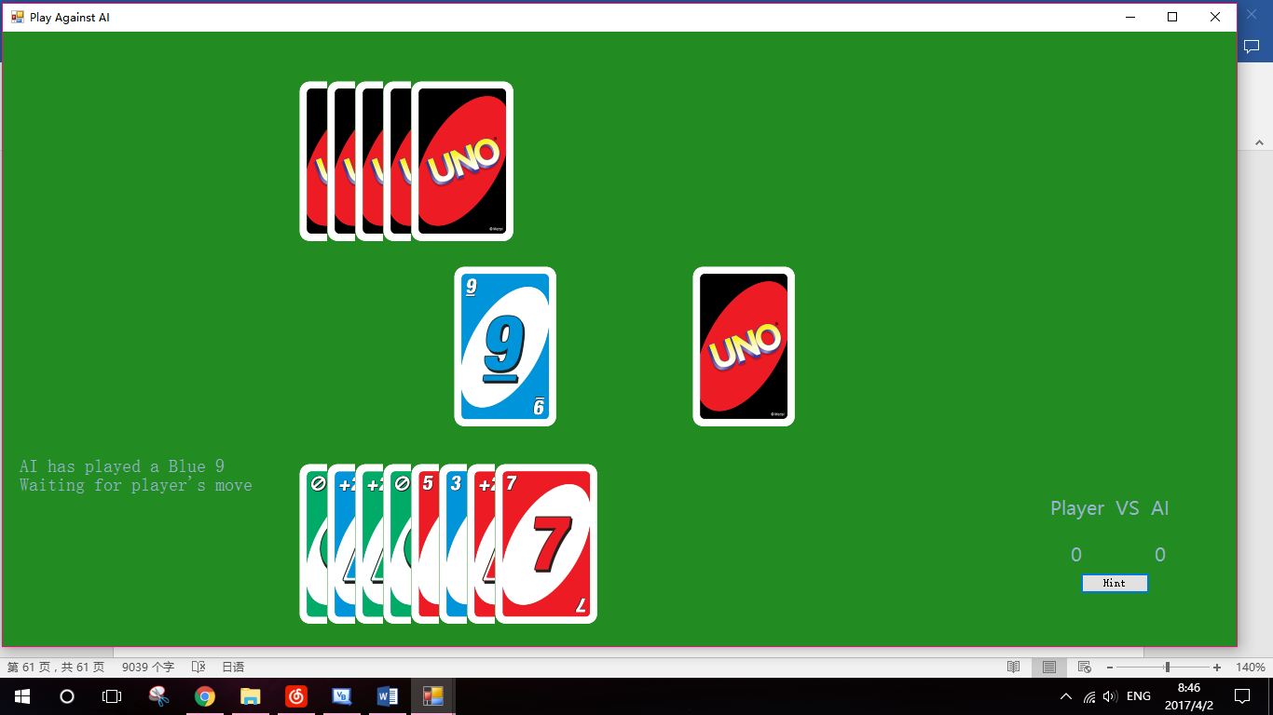

#### Test 4

This test aims at whether AI player can correctly play legal word cards, but not the functionalities of word cards. The functionalities of each word card have been tested in last testing section, and therefore were not tested here.

The AI player played a Green Reverse, and the play order was successfully reversed.

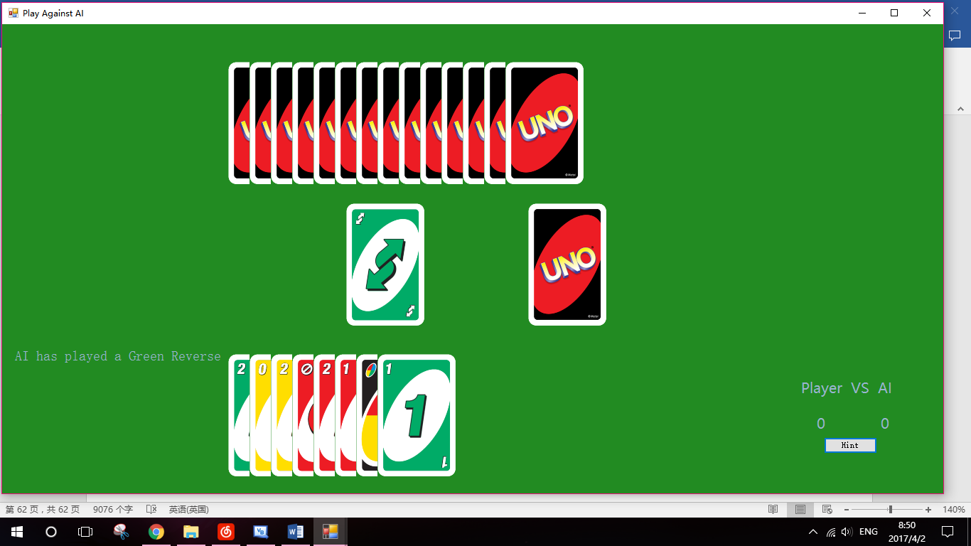

AI played a Wild +4, and its functionalities were corrected applied to player.

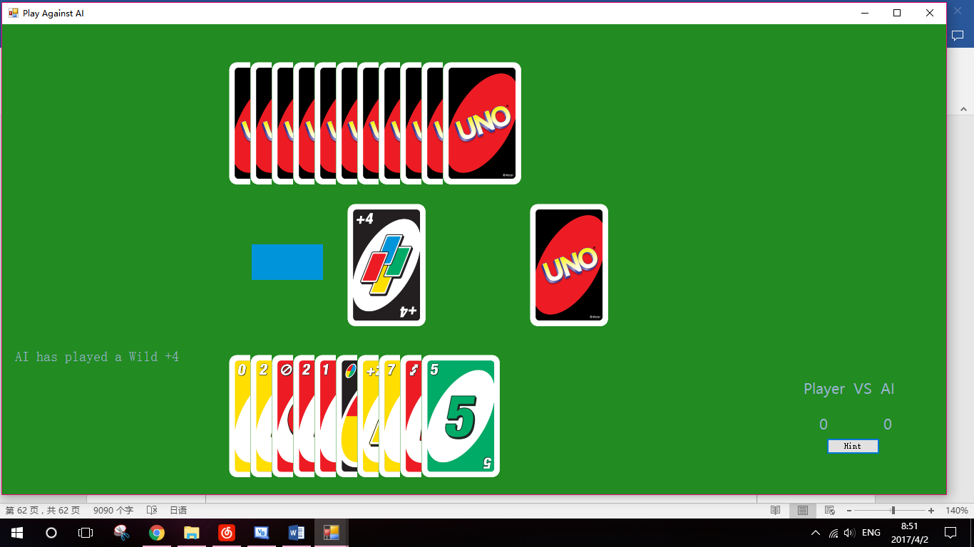

#### Test 5

As shown in the following picture, the AI drew an extra card as punishment.

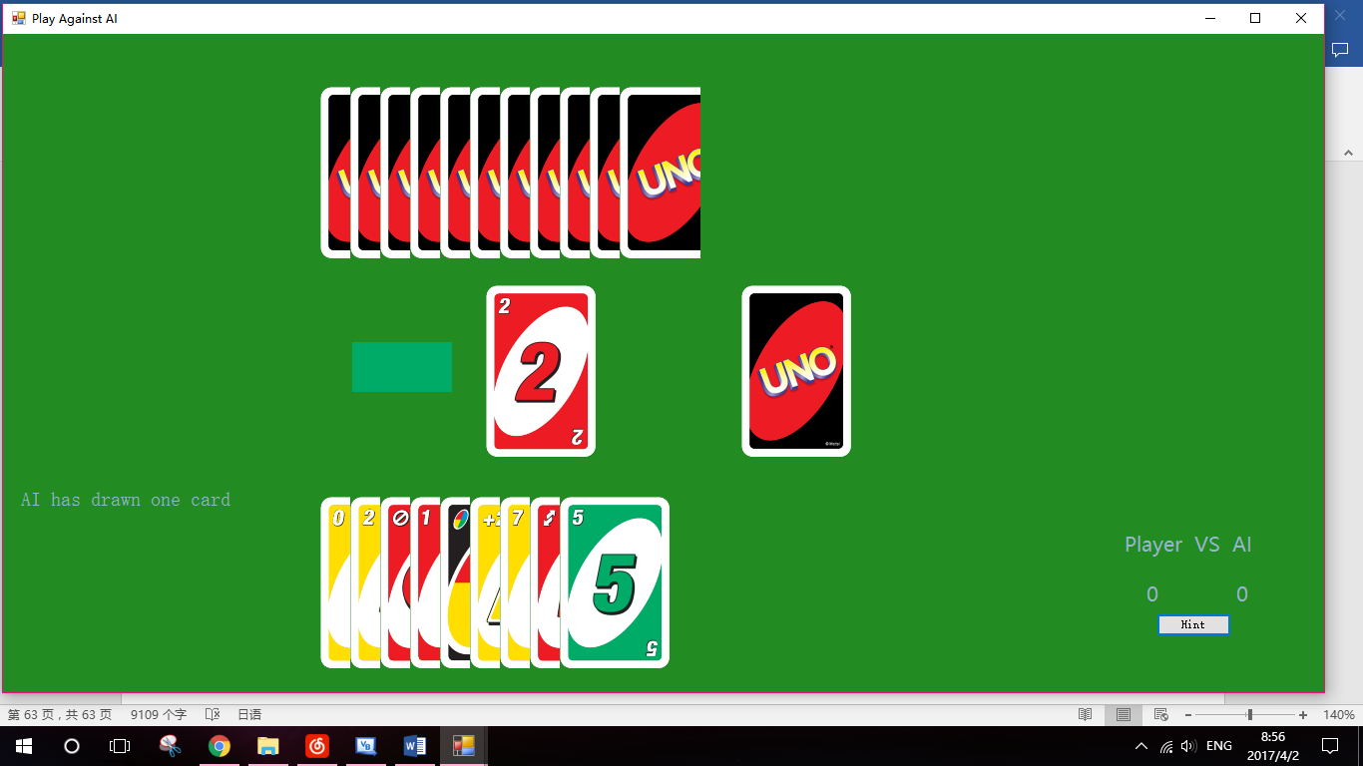

(The misbehaviour of pictureboxes was because the screenshot was captured during the refresh of pictures.)

In the following situation, AI had no red cards in hand. After it drew a card as punishment, it still had no legal card to play. Therefore it had to pass the turn.

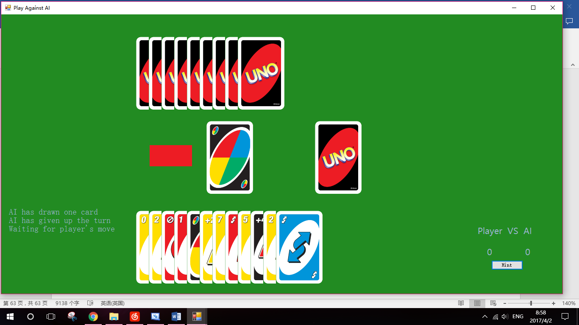

#### Test 6

The discard was Blue 7. Only Blue +2 and Blue 5 can be played in player’s hand.

The player had not drawn a card on this turn yet. If the deck was clicked, an extra card will be dealt to player.

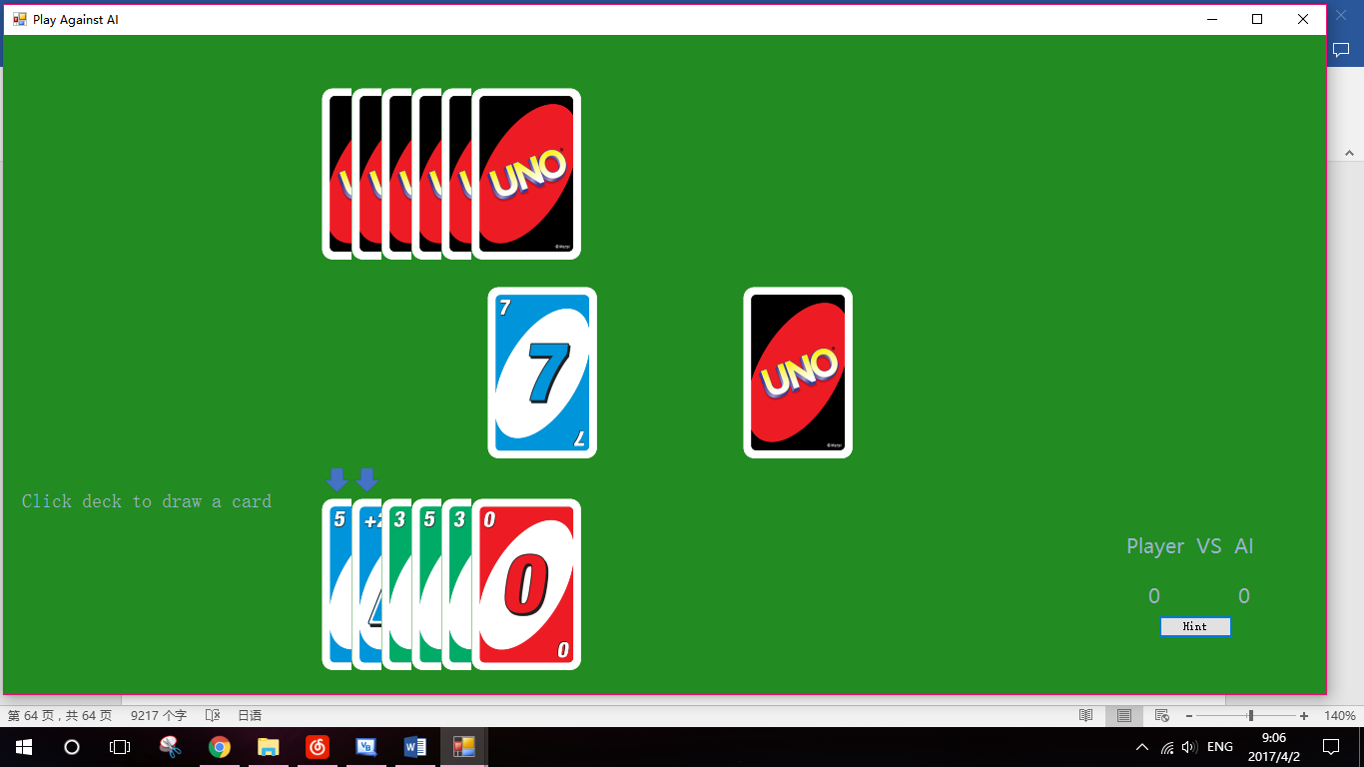

This time, player had drawn an extra card. If the deck is clicked, the turn will be passed to AI.

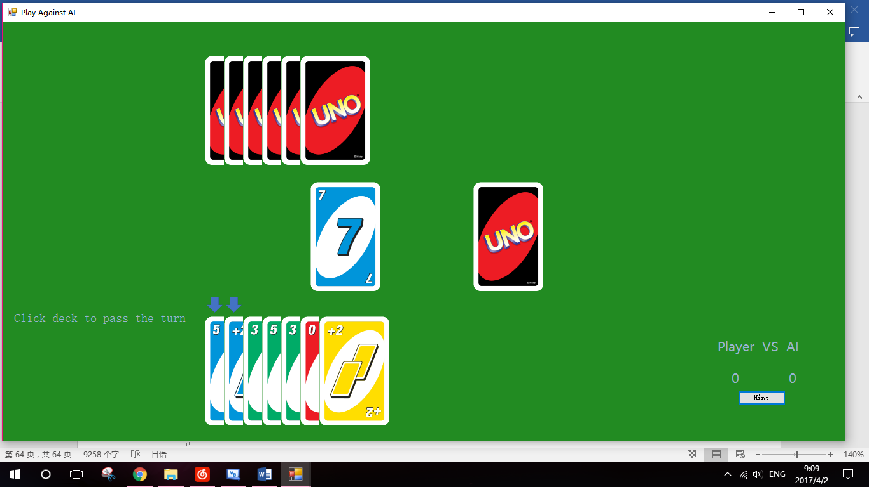

#### Test 7

Easy AI will add all legal cards to the list that contains all the possible solutions. When it needs to play a card, it will select a random card using random number generator.

For more details about Easy AI, see Algorithm.

Under the following situation, a Red 2 was played by Easy AI in the first place.

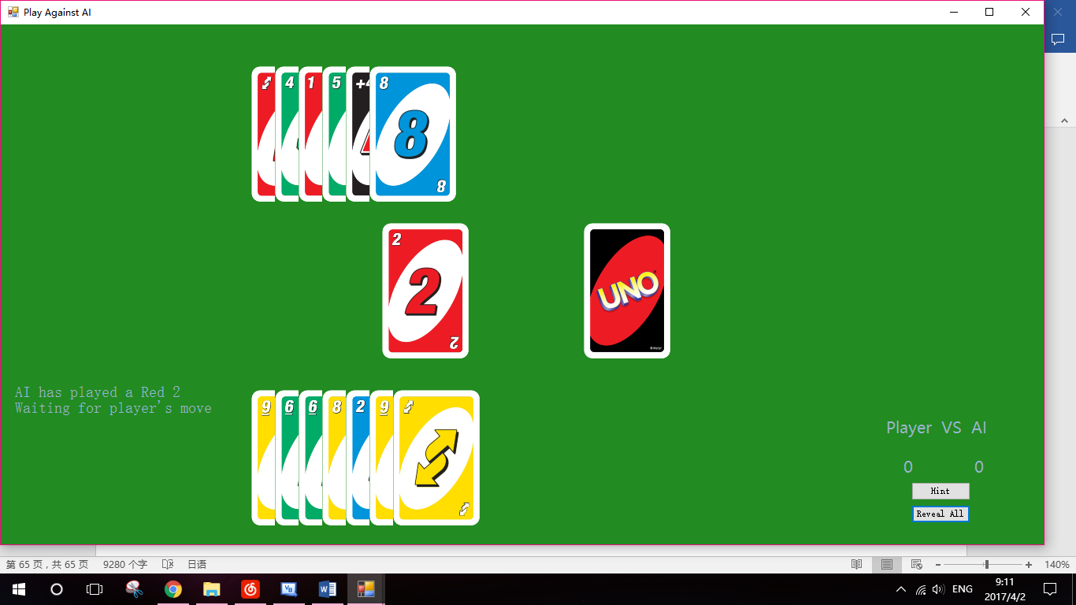

(Debug mode was used to reveal AI’s hand)

Player then played a Blue 2.

At that moment AI had two choices: Blue 8 and Wild +4. Under normal circumstances, playing Blue 8 first would be more sensible.

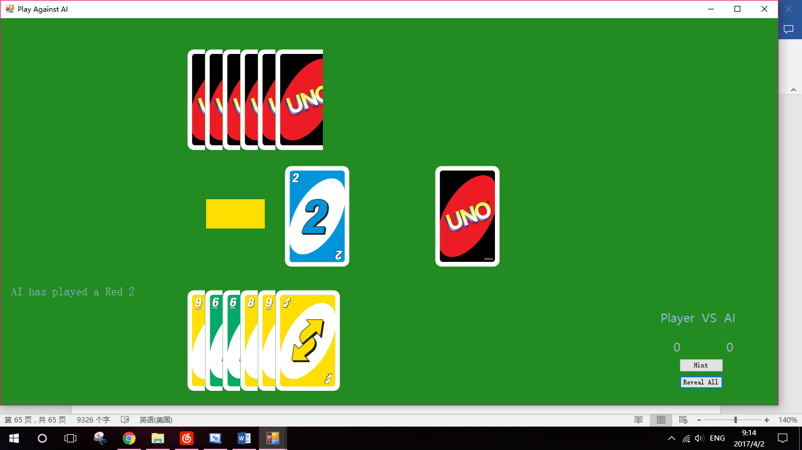

(Misbehaviour of pictures was due to the refresh of pictureboxes)

However, Easy AI acts randomly, and it played the Wild +4 first.

Its algorithm then chooses the wild colour for Wild +4 randomly. Golden was chosen, but the Easy AI had no Golden card in hand and had to take the punishments.

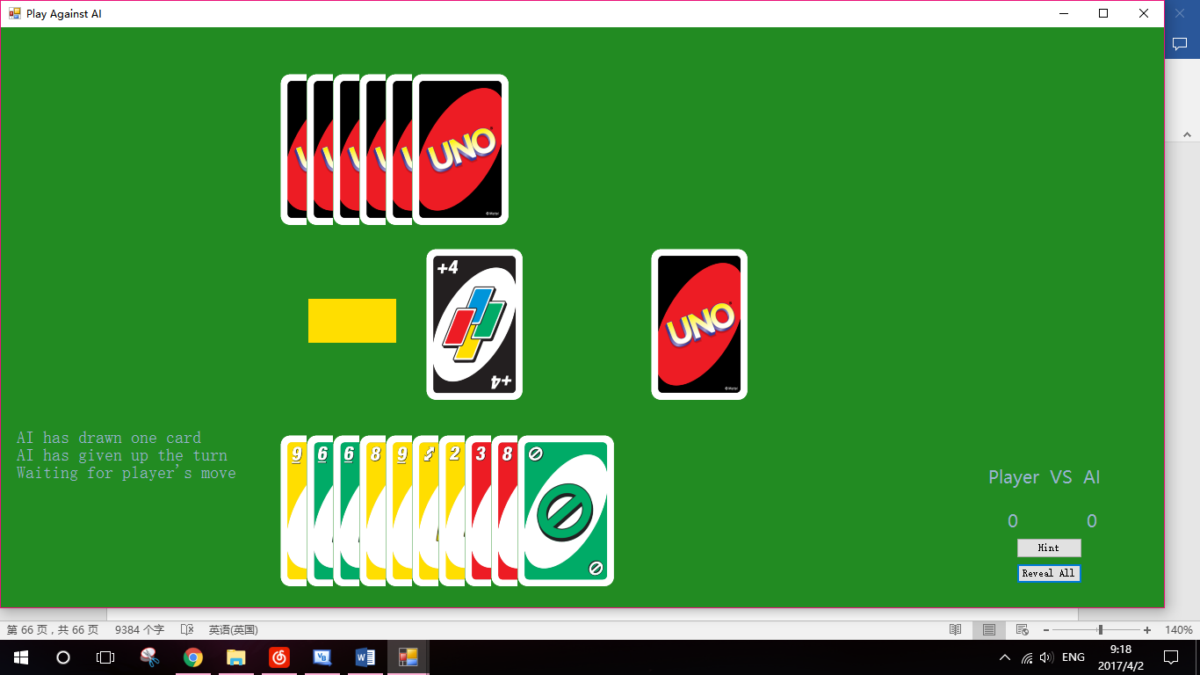

#### Test 8

The Hard AI will use algorithm GatherData to collect the data needed and use certain strategy to play the game. It, however, is not allowed to cheat.

When player has only one card in hand, it will try to prevent the player from playing that card and winning.

Under normal circumstances, it will play the hands that have same colour with the discard. When no such cards are found, it will try to find a card with same number (if the discard is a number card), or use a wild card to change the colour of discard.

For more details about Hard AI’s strategy, see Algorithm.

Following graphs show the moves of Hard AI on several turns.

Initially, player played a Golden 2. AI followed it with a Golden Reverse. Player’s turn was then skipped, and AI played a Golden 8.

After player played a Golden 9, AI played a Blue 9 and successfully changed the colour of discard to Blue.

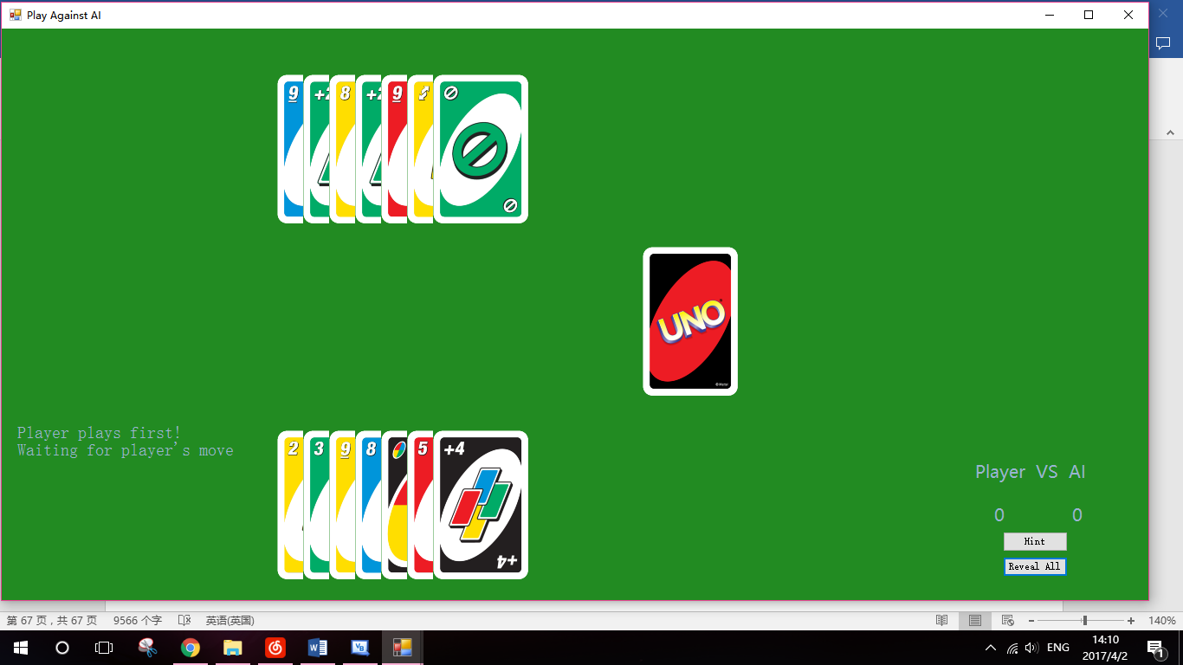

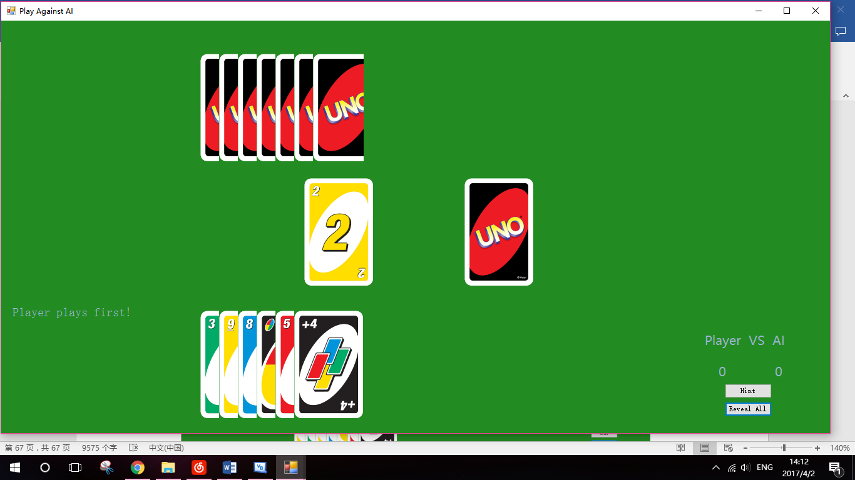

(Part of the screenshots were not captured due to difficulties in capturing AI’s move)

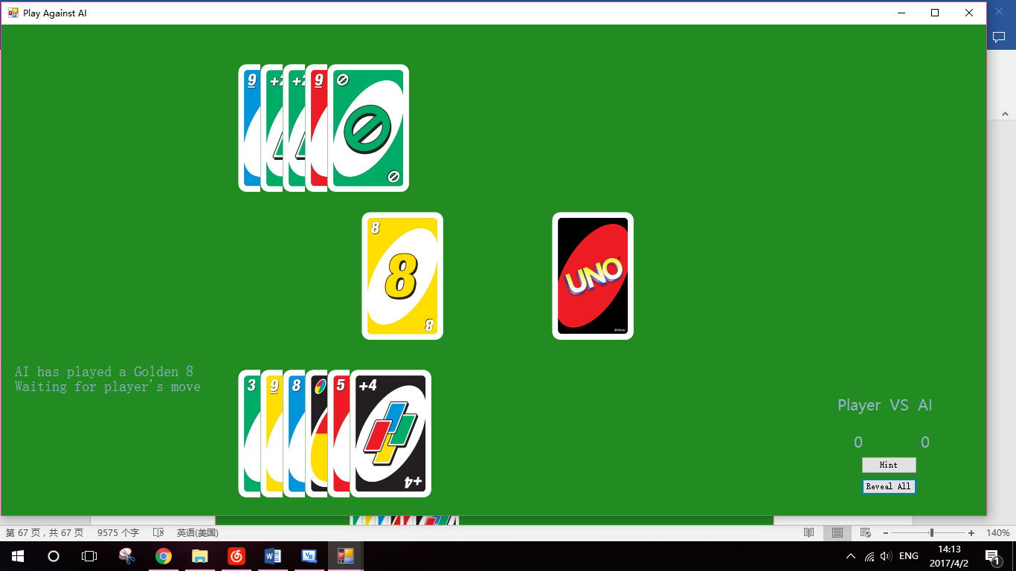

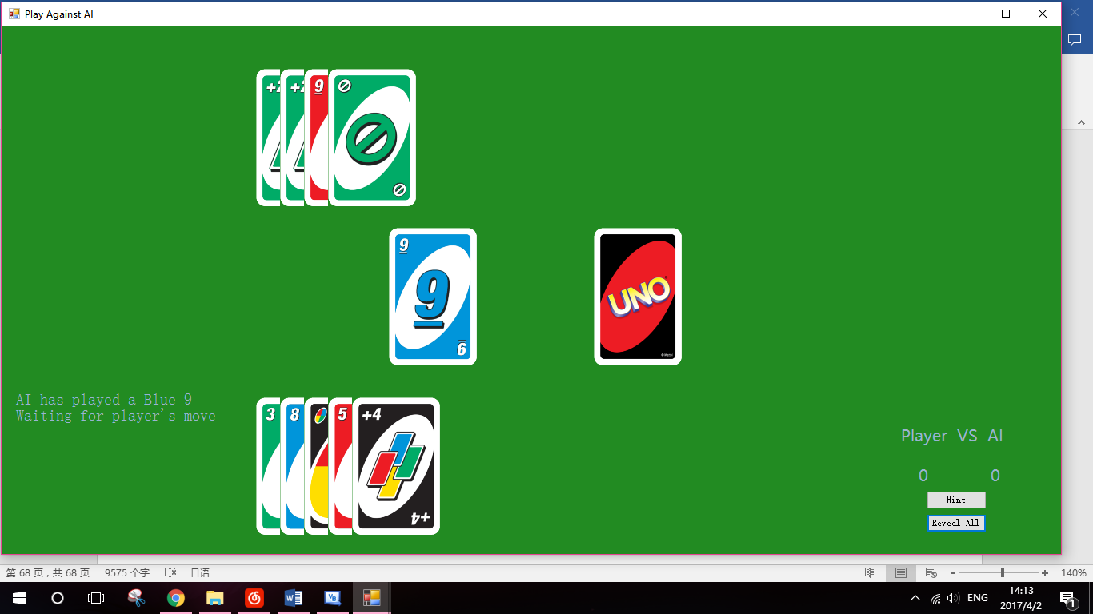

When the Hard AI plays a wild card, it will always choose the colour which it has most hands of.

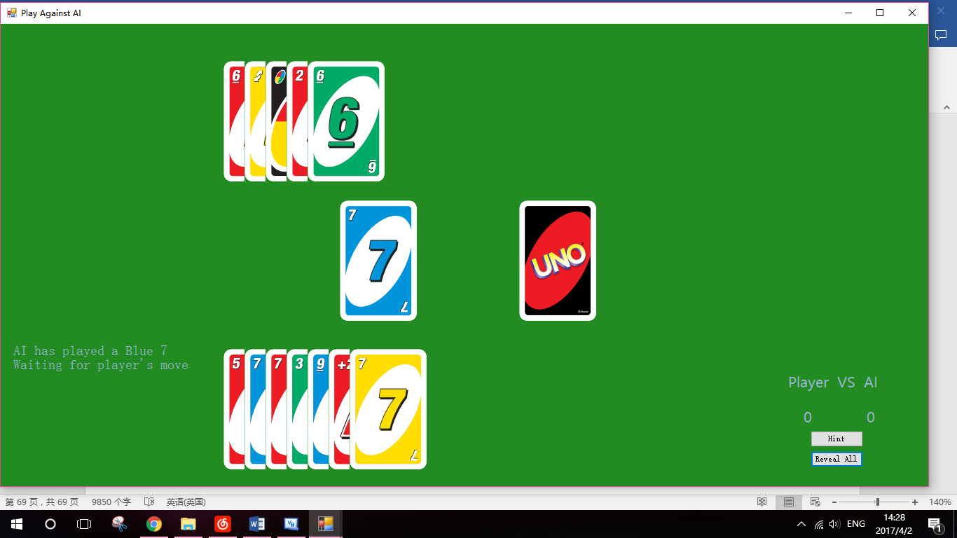

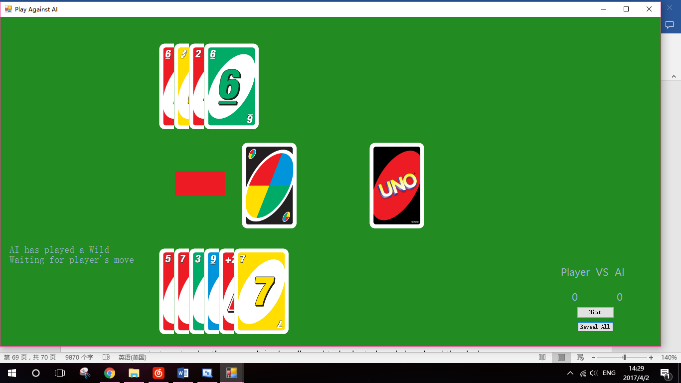

#### Test 9

The Cheater AI will use algorithm GatherData to collect the data needed and use certain strategy to play the game. It is also allowed to look at player’s hand and the deck.

When player has only one card in hand, it will try to prevent the player from playing that card and winning. If it does not have any card that can do so in hand, it will draw a card and try again. If still no such card is found, it will give up and pass the turn.

When the next card in the deck is a wild card, it has a possibility of 70% to draw that card.

Under normal circumstances, it will play the hands that have same colour with the discard. When no such cards are found, it will try to find a card with same number (if the discard is a number card), or use a wild card to change the colour of discard according to the number of non-wild cards in player’s and AI’s hand.

For more details about Hard AI’s strategy, see Algorithm.

Cheater AI’s move: Red 6, Red +2, Red Reverse, Red 9

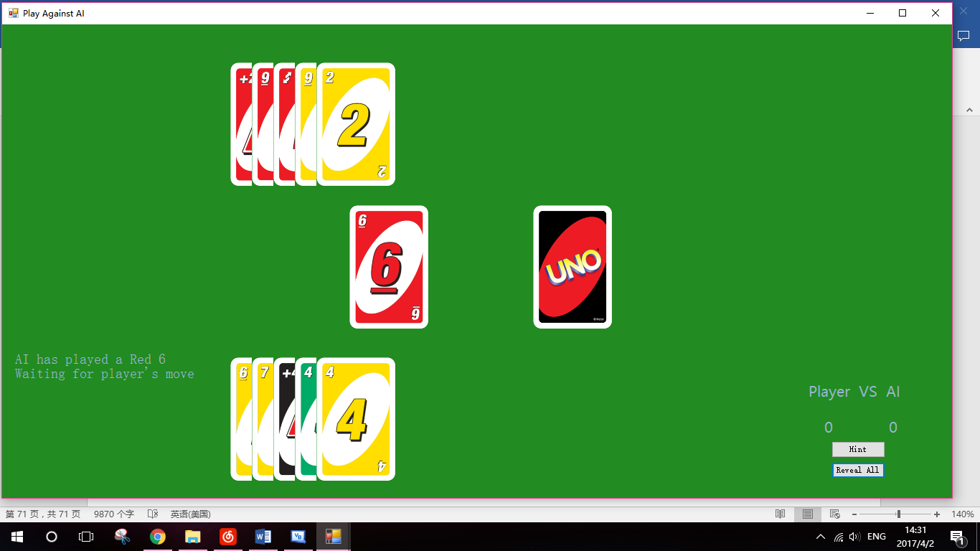

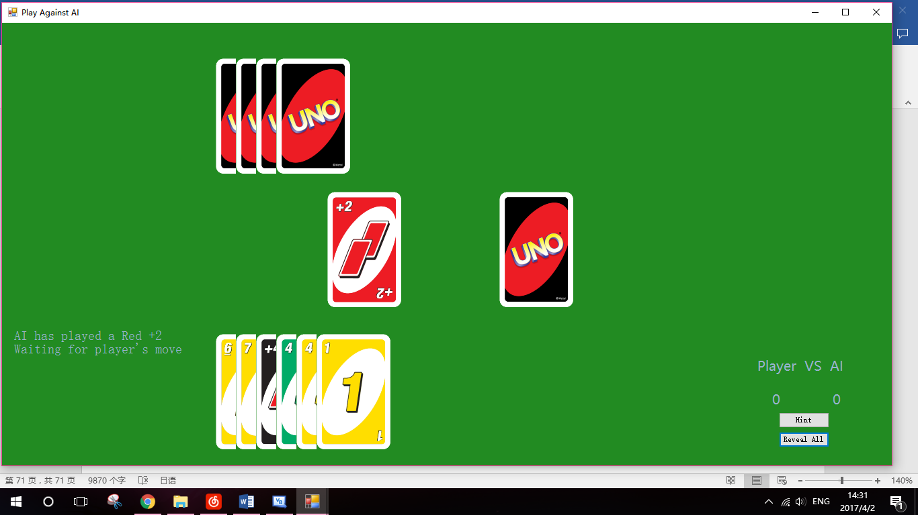

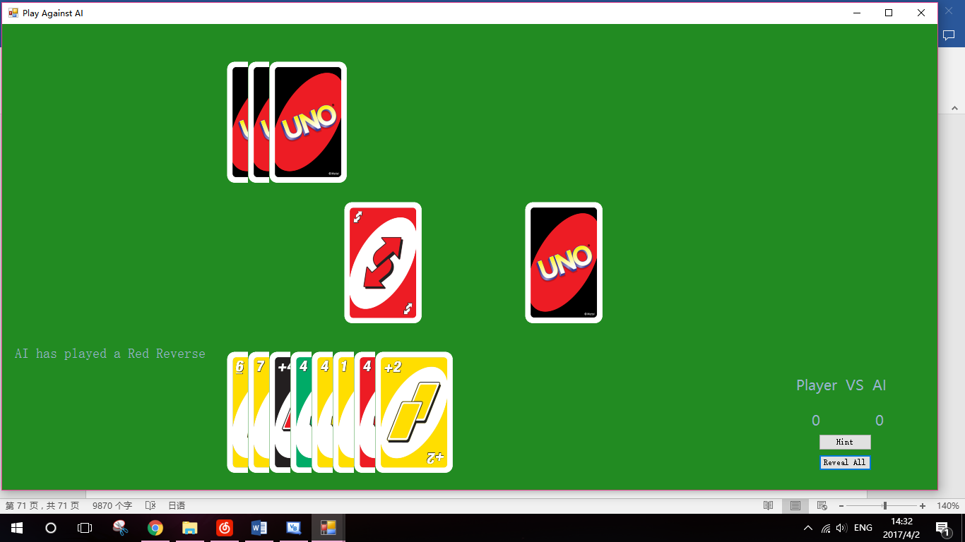

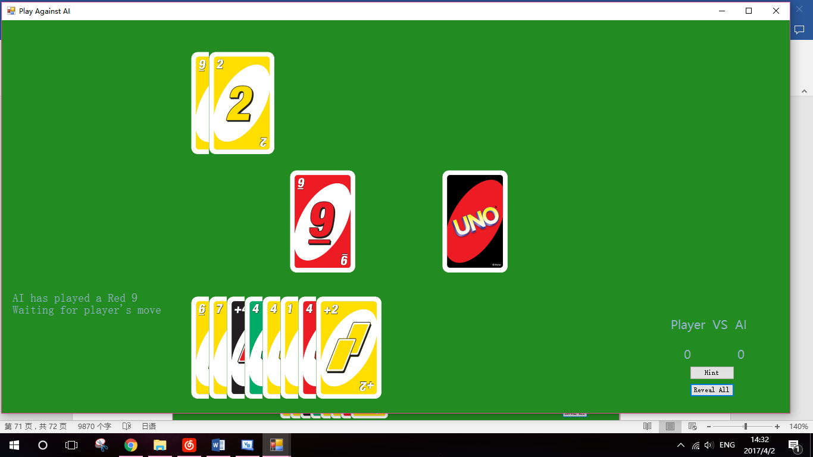

#### Test 10

The AI player uses My.Application.DoEvents() and System.Threading.Thread.Sleep() to pause the program and give player enough time to understand what is happening.

Testing shows that AI pauses for enough time for human to react.

# Appraisal

## Comparison of Actual Performances against Objectives

#### Objective 1: Game Menu

* 1. A simple game menu with different choices will be displayed when the application is run.

The objective is met. A game menu with “Play against AI”, “Play against Player”, “Help” and “Exit” buttons is displayed when the application is run.

* 1. The game menu should contain different game modes including tutorial, player against player and player against AI, as well as an Exit option.

The objective is met. A game menu with “Play against AI”, “Play against Player”, “Help” and “Exit” buttons is displayed when the application is run.

#### Objective 2: Uno Game

Specific Objectives:

* 1. Simulate a standard 108-card Uno deck, which consists of 25 of each colour (Blue, Golden, Green and Red) and each colour has two of each type except for type zero, of which each colour only has one. The types including number type 1 to 9, “Skip”, “Reverse” and “+2”. Besides this, the deck also contains 4 “Wild” cards and 4 “Wild +4” cards (2017 Wikipedia).

The objective is met. A proper deck with correct cards is created each time a game is started. The number of each cards was checked using build-in testing tools and was found to be correct.

* 1. The game can be started by clicking on the picture of deck displayed in the middle of screen.

The objective is met. In any game mode, when the image of deck is clicked, the game would start.

* 1. The Uno game should start with dealing each player one card to decide which player to play first. The player who holds the card of larger number can play first. If one player is dealt with a non-number card or their numbers are the same, another two cards would be dealt until the play sequence is decided.

The objective is met. Every time a game starts, two cards with different number are dealt to each player, and the player holds card with larger number would player first.

* 1. On the player’s turn, player should be able to play a card that fits the rules (see description above) or draw a card from deck by clicking either the picture of card or deck. If the player chooses to draw an extra card, (s)he still has a chance to play a card, otherwise, the turn would be passed to next player.

The objective is met. On a player’s turn, player is able to play a legal card by clicking the image of card, or draw a card by clicking the image of deck. After clicking deck for the first time, player can still play a legal card or click the deck again to give up the turn.

* 1. If player tries to play a card that does not meet the rules, an error message would show and ask player to choose another card to play.

The objective is met. If a player clicks on the image of an illegal card, an error messages will be displayed and player can choose another card to play.

* 1. The functions of word card (Skip, Reverse, +2, Wild and Wild +4) should all be enabled as the description above.

The objective is met. All word cards have correct abilities: Skip and Reverse card will skip the opponent’s turn and let player gain an extra turn. +2 card will force the opponent to draw two cards on next turn, unless a Wild +4 card is played to override the +2 card. Wild card enables the player to choose the colour needed by next card freely, and Wild +4 has abilities of both Skip and Wild, besides it will force the opponent to draw four extra cards.

* 1. When a wild card is played by a player, a new window will be opened to ask for a colour for that wild card.

The objective is met. A proper window is opened each time a Wild or Wild +4 card is played.

* 1. A player can hold no more than 20 cards. If more cards are dealt to player’s hand, an error message would be displayed and the dealing would be prevented.

The objective is met. When more cards are dealt to player who holds 20 cards in hand, an error message will be displayed and the dealing will be prevented.

* 1. The game lasts until a player has zero cards in hand. The winning message will be shown and all cards in the opponent’s hand will be displayed. Player then can start another match by clicking the deck again.

The objective is met. When a player played all its hand, a winning message is shown and all cards remained will be displayed. The game can also be started again by clicking the deck.

* 1. A simple scoreboard would display the win counter of each player. If the game window is closed, the scores will be reset to zero.

The objective is met. The scoreboard displays the correct number of wins of each player, and the win counters are reset every time the windows is open.

#### Objective 3: Player against Player Mode

Specific Objectives:

* 1. This game mode supports an Uno game between two players.

The objective is met. Two human players can play against each other in this mode.

* 1. Since two players should not see each other’s hand, when it’s on Player1’s turn, Player1 will have to move the mouse over P1’s hand and the cards will be displayed. After the mouse leaves the image of deck, its image will be changed to the back of card again. When it’s on a player’s turn, then only that player’s hand will be displayed in this way. Moving mouse over the opponent’s hand will not cause the cards to be displayed.

The objective is met. The hands of a player will only be revealed when it is on that player’s turn, and that player moves the mouse over the image of card. When player moves the mouse over the opponent’s hand, the images of card will not be revealed.

* 1. Player can only click the picture of a hand and play this card on his/her turn.

The objective is met. If the hand was clicked when it is not that player’s turn, nothing will happen.

#### Objective 4: Player against AI Mode

Specific Objectives:

* 1. This game mode supports an Uno game between a human player and an AI player of different difficulties.

The objective is met. Player can play against an AI player of different difficulties in this game mode.

* 1. Before the game starts, a difficulty window would be open and ask the player to choose a difficulty for AI.

The objective is met. When the “Player against AI” mode is selected in the game menu, a window ChooseAI will be displayed first. After a difficulty is chosen, the game window of selected AI will open.

* 1. Fair AI players are not allowed to cheat, but only make decisions based on its own hand and discards.

The objective is met. Easy AI and Hard AI will only use legal information, which is mainly the number of hands of different types, to make decisions.

* 1. A hint button should be displayed on the game window, and all hands that can be played on this turn will be indicated by arrows when clicked. Considering the game should be fair in PvP mode, this function will not be supported on the player against player game.

The objective is met. The hint button is displayed properly in Player against AI mode. When it is clicked during the player’s turn, all the legal cards will be pointed out by blue arrows. And information of punishment is also shown (draw a card / draw two cards / give up the turn)

#### Objective 5: Cheater AI

Specific Objectives:

* 1. The cheater is allowed to look at cards in the deck and its opponent’s hand, but nothing further than that.

The objective is met. Cheater AI uses information about cards in its hand and player’s hand, as well as the next card in deck to make decisions.

#### Objective 6: Debug Mode

Specific Objectives:

6.1 A debug mode should be supported to make the future testing easier.

The objective is met. The debug mode is supported and can be switched on by right clicking the button for each game mode in game menu.

6.2 The debug mode includes a “Reveal All” button, which will display both players’ hand after clicked.

The objective is met. When the debug mode is on, after the game starts, the “Reveal all” button would be displayed below the “Hint” button. When clicked, both players’ hand will be revealed.

6.3 The debug mode can be open by some special operations on Game Menu (e.g. right click on the game button rather left click)

The objective is met. The debug mode can be switched on by right clicking the button for each game mode in game menu.

#### Objective 7: Help Menu

7.1 The Help menu should divide the rules into parts and display them individually.

The objective is met. Rules of Uno are divided into four parts and are displayed individually with different button clicked.

## User Feedback

Feedback were collected from several college students including people who are familiar with the Uno game and who have not played this game before, as well as my computing Mr. Lord.

#### General Comments

Mr. Lord, my computing teacher, tried out my application as a new player to the Uno game.

His first impression to the game was great. He found that, the user interface was very clear and easy to use. The images of cards were displayed clearly in both player’s hands and the discard area, the methods of playing card or drawing card from deck were also reasonable. He agreed that the design of game was excellent.

Besides, as a new player’s point of view, he found that rules of the game given in the help menu were very detailed and clear, and had helped him a lot in learning the game. He also pointed out that the hint button given in Play against AI mode was very helpful, because this gave a more straightforward understanding of the relationship between discard and next legal card. He, however, suggested that the instructions displayed during the game can be more outstanding so player can read them easily.

He also pointed that, the designing of different game modes and AI players of different difficulties was very good. He felt that the Hard AI and Cheater AI are very challenging, especially to a new player.

About the Player against Player mode, he believed that the method of hiding hands from the opponent was very good. Although it may cause difficulties in selecting a card from the hands, it was the best way to keep hands unseen from the other player.

Some of my college students who haven’t play Uno before also tried my game. They all agreed that the program helped them to learn the rules of Uno in a vivid way, and the hint button was particularly helpful. One of the students, Johnson, felt that the Cheater AI was not as challenging as expected, especially after getting familiar with the game mechanism. He found that the game based heavily on random factors, and thus the difficulties of AI players were ambiguous.

Hsin, the Hearthstone player who is interested in the possibility of Cheater AI, has also tried out the program. He played ten matches against the Cheater AI, and scored 4:6 in total. He commented that the difficulties of Hard AI and Cheater AI didn’t differ a lot, and agreed that the cheating might not be very helpful to AI player without particularly design algorithms.

#### Potential Improvements

Although the program was successful and has met all the objectives, there are still some potential improvements that can be done to make the program better.

Mr. Lord suggested the words displayed within the game can use another front or use different colours to make them more outstanding. This can be done easily by adding more text box in the game window, and changing the front size and colour when different types of information are displayed.

Besides, sounds of playing and drawing cards can be added to make the game more realistic. Those sound effects can be found on some free-sharing website, and can be activated every a card is played or drawn.

Other students in my college suggested that more animation can be added to make the game more vivid, for example, the animation of drawing and playing cards. This will make the game smoother and give player a better understanding of what is going on in the game.

Except for that, more game modes could be implemented. Since the algorithms have performed reliably in Uno games containing two players, it is possible to add more players into the game by amending the codes responsible for passing the turn between players. As the program is heavily object oriented, amending of codes can be done easily.

## Conclusion

The application of Uno game is successful and all the objectives have been met. The program gives a very straightforward and clear understanding of the traditional Uno game and helps the new players to get the hand of it easily. Additionally, it also provides an example of Cheater AI in card games and gives useful data of its behavior.

# Appendix

## Bibliography

1. Anon, (2017). Hearthstone (video game). [online] Available at: https://en.wikipedia.org/wiki/Hearthstone_(video_game) [Accessed 2 Feb. 2017].
2. En.wikipedia.org. (2017). Uno (card game). [online] Available at: https://en.wikipedia.org/wiki/Uno_(card_game) [Accessed 2 Mar. 2017].
3. En.wikipedia.org. (2017). Artificial intelligence. [online] Available at: https://en.wikipedia.org/wiki/Artificial_intelligence [Accessed 1 Apr. 2017].
4. En.wikipedia.org. (2017). Artificial intelligence (video games). [online] Available at: https://en.wikipedia.org/wiki/Artificial_intelligence_(video_games)#Cheating_AI [Accessed 1 Apr. 2017].
5. Msdn.microsoft.com. (2017). *Rnd Function (Visual Basic)*. [online] Available at: https://msdn.microsoft.com/en-us/library/f7s023d2(v=vs.90).aspx [Accessed 20 Apr. 2017].

## Resource

The original images of Uno deck were created by WackoSamurai found at: <http://wackosamurai.deviantart.com/art/Uno-Deck-572559133>

## Survey

A survey about user requirements of Uno game was conducted using website Survey Monkey at URL <https://www.surveymonkey.co.uk/r/H3KLXGQ>.

The screen shots of result collected are shown below.

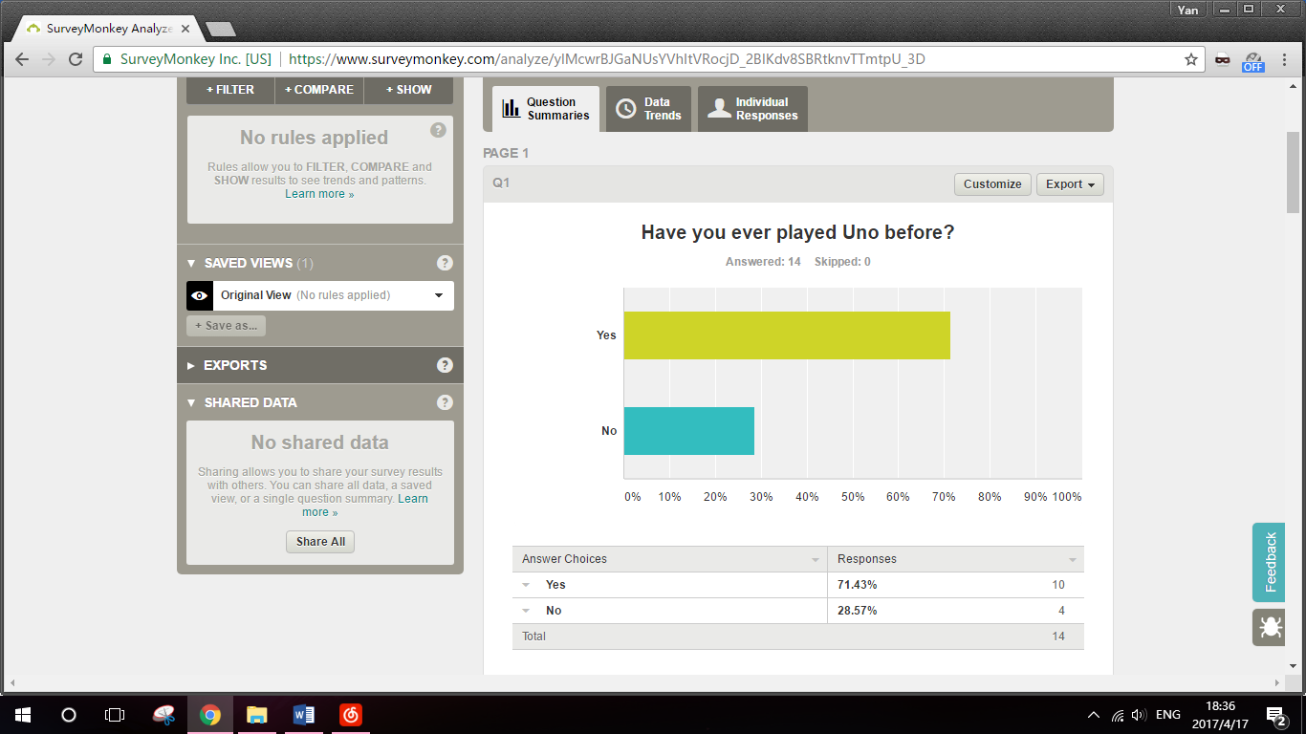

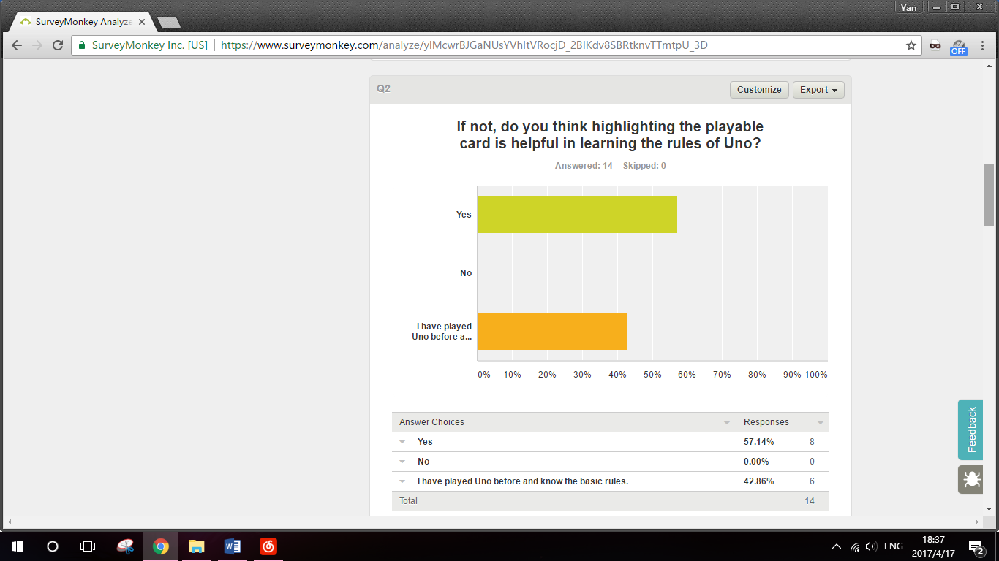 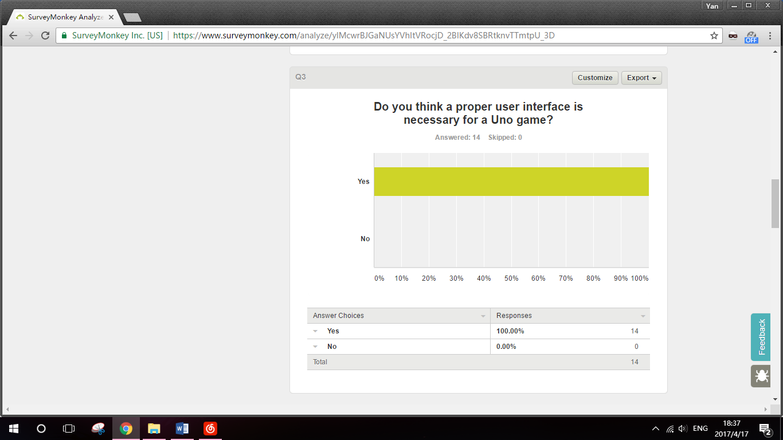

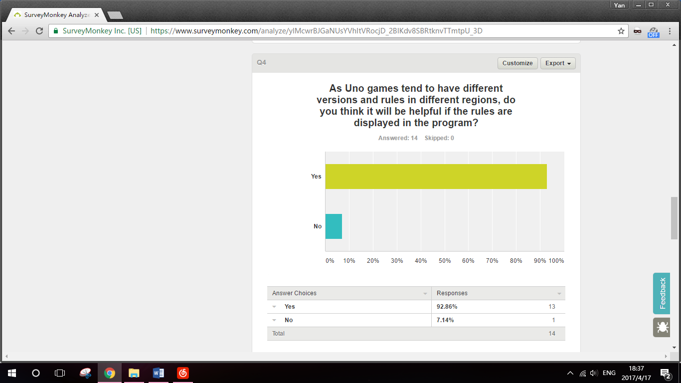 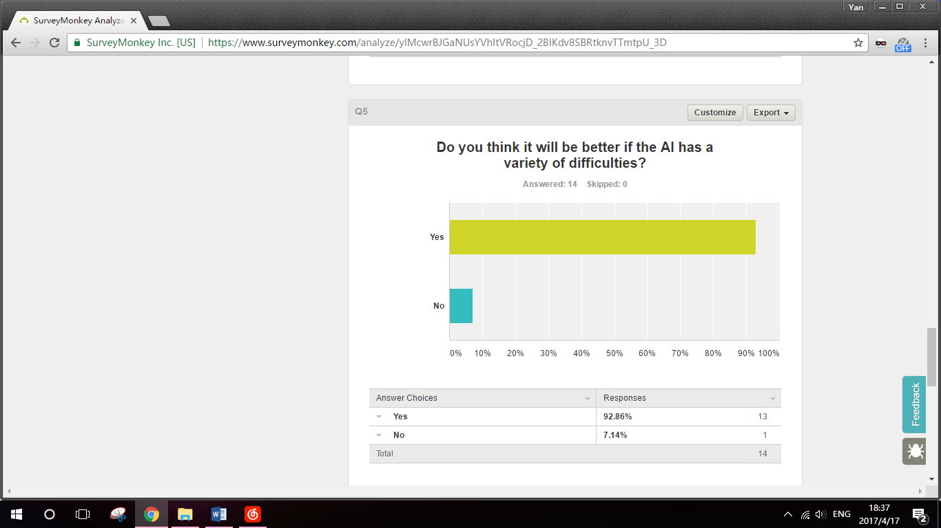 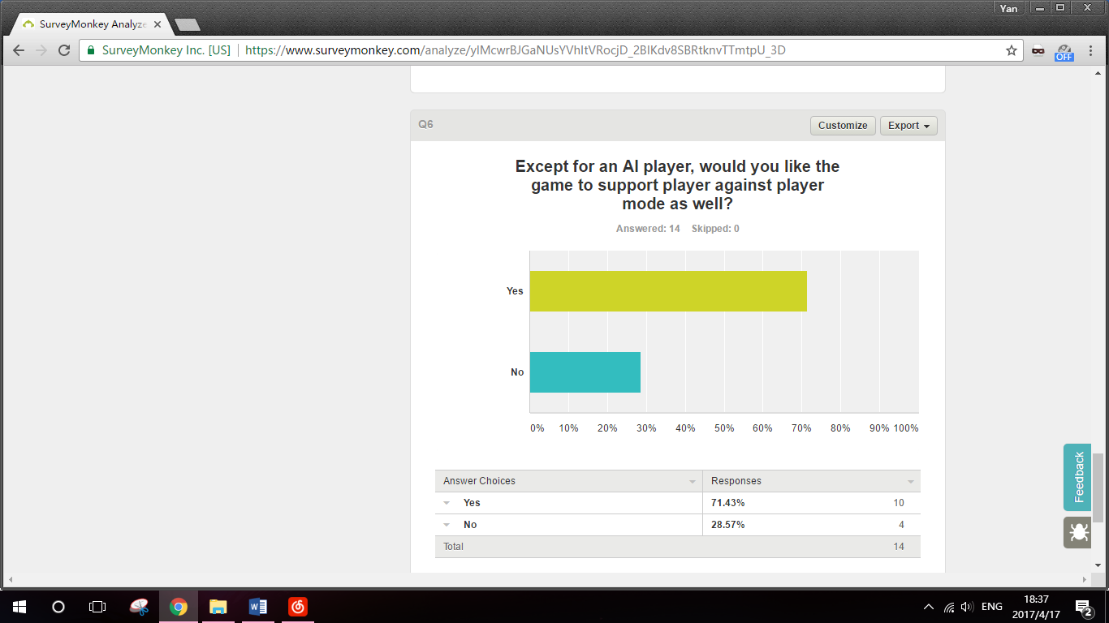

## Coding

### FormGameMenu.vb

Public Class FormGameMenu

Public Shared WildColour As String

Public Shared Sleeping As Boolean = False

Private Sub ButtonPlayAgainstPlayer_Click(ByVal sender As System.Object, ByVal e As System.Windows.Forms.MouseEventArgs) Handles ButtonPlayAgainstPlayer.MouseDown

Dim PVPWindow As New FormPlayAgainstPlayer

PVPWindow.Show()

If e.Button = Windows.Forms.MouseButtons.Right Then

FormPlayAgainstPlayer.Debug = True

Else

FormPlayAgainstPlayer.Debug = False

End If

End Sub

Private Sub ButtonPlayAgainstAI_Click(ByVal sender As System.Object, ByVal e As System.Windows.Forms.MouseEventArgs) Handles ButtonPlayAgainstAI.MouseDown

Dim AIWindow As New FormPlayAgainstAI

AIWindow.Show()

If e.Button = Windows.Forms.MouseButtons.Right Then

FormPlayAgainstAI.Debug = True

Else

FormPlayAgainstAI.Debug = False

End If

End Sub

Private Sub ButtonExit_Click(ByVal sender As System.Object, ByVal e As System.EventArgs) Handles ButtonExit.Click

Me.Close()

End Sub

Private Sub Button1_Click(ByVal sender As System.Object, ByVal e As System.EventArgs) Handles Button1.Click

Dim HelpWindow As New FormRules

HelpWindow.Show()

End Sub

End Class

### FormRules.vb

Public Class FormRules

Private Sub Button2_Click(ByVal sender As System.Object, ByVal e As System.EventArgs) Handles Button2.Click

Dim help As String

help = "Uno Rules - Playing Cards:" + vbCrLf + vbCrLf

help += "On a player’¡¥s turn, he/she must do one of the following:" + vbCrLf + vbCrLf

help += "1. Play a card matching the last played card, which means they have the same colour or number." + vbCrLf + vbCrLf

help += "2. Draw an extra card as penalty." + vbCrLf + vbCrLf

help += "If the player chooses to draw an extra card, he/she still has a chance to play a matching card, otherwise the turn would pass to the next player in order."

MsgBox(help)

End Sub

Private Sub Button1_Click(ByVal sender As System.Object, ByVal e As System.EventArgs) Handles Button1.Click

Dim help As String

help = "Uno Rules - Card Types:" + vbCrLf + vbCrLf

help += "A standard Uno deck consists of 108 cards, including Blue, Golden, Green and Red number cards 1 ~ 9 two each, four colour number card 0 one each, four colour word card Skip, Reverse and +2 one each, as well as wild card Wild and Wild +4 four each. " + vbCrLf

help += "Word cards have different abilities and have different playing rules." + vbCrLf + vbCrLf

help += "Skip: Can match non-word card of the same colour; next player in sequence misses a turn" + vbCrLf + vbCrLf

help += "Reverse: Can match non-word card of the same colour; order of play switches directions (when there are only two players, this is equivalent to Skip)" + vbCrLf + vbCrLf

help += "+2: Can match non-word card of the same colour; next player in sequence draws two cards" + vbCrLf + vbCrLf

help += "Wild: Can match non-word cards of any colour; player declares next colour to be matched" + vbCrLf + vbCrLf

help += "Wild +4: Can match any card except for card with skip ability (Skip, Reverse or Wild +4); player declares next colour to be matched; next player in sequence draws four cards and misses a turn." + vbCrLf + vbCrLf

MsgBox(help)

End Sub

Private Sub Button4_Click(ByVal sender As System.Object, ByVal e As System.EventArgs) Handles Button4.Click

Dim help As String

help = "Uno Rules - Playing First:" + vbCrLf + vbCrLf

help += "At the beginning of a game, each player would be dealt a card randomly from the deck, and their numbers would be compared to decide which player plays first. In the case of non-number card or cards with the same number, new cards will be dealt until one player holds a card with lager number."

MsgBox(help)

End Sub

Private Sub Button3_Click(ByVal sender As System.Object, ByVal e As System.EventArgs) Handles Button3.Click

Dim help As String

help = "Uno Rules - Winning:" + vbCrLf + vbCrLf

help += "After deciding the play order, each player will be dealt with seven cards from the deck. Players can discard their hand on their turns." + vbCrLf + vbCrLf

help += "The game proceeds until one player has reduced his/her hand to zero. This player then wins and the rest lose the game."

MsgBox(help)

End Sub

End Class

### FormChooseWildColour.vb

Public Class FormChooseWildColour

Private Sub PictureBox1_Click(ByVal sender As System.Object, ByVal e As System.EventArgs) Handles PictureBox1.Click, PictureBox2.Click, PictureBox3.Click, PictureBox4.Click

Dim PBClicked As PictureBox = DirectCast(sender, PictureBox)

Select Case PBClicked.Name

Case "PictureBox1"

FormGameMenu.WildColour = "Blue"

Case "PictureBox2"

FormGameMenu.WildColour = "Golden"

Case "PictureBox3"

FormGameMenu.WildColour = "Green"

Case "PictureBox4"

FormGameMenu.WildColour = "Red"

End Select

Me.Close()

End Sub

Private Sub FormChooseWildColour_Load(ByVal sender As System.Object, ByVal e As System.EventArgs) Handles MyBase.Load

FormGameMenu.WildColour = "Cancel"

End Sub

End Class

### FormChooseAI.vb

Public Class FormChooseAI

Private Sub Button1_Click(ByVal sender As System.Object, ByVal e As System.EventArgs) Handles Button1.Click

FormPlayAgainstAI.Difficulty = "Easy"

Me.Close()

End Sub

Private Sub Button2_Click(ByVal sender As System.Object, ByVal e As System.EventArgs) Handles Button2.Click

FormPlayAgainstAI.Difficulty = "Cheater"

Me.Close()

End Sub

Private Sub Button3_Click(ByVal sender As System.Object, ByVal e As System.EventArgs) Handles Button3.Click

FormPlayAgainstAI.Difficulty = "Hard"

Me.Close()

End Sub

Private Sub FormChooseAI_Load(ByVal sender As System.Object, ByVal e As System.EventArgs) Handles MyBase.Load

FormPlayAgainstAI.Difficulty = "Unselected"

End Sub

End Class

### FormPlayAgainstPlayer.vb

Public Class FormPlayAgainstPlayer

Public Shared P1WinCounter, P2WinCounter As Integer

Public Shared GameStart As Boolean

Public Shared CurrentGame As PlayerGame

Public Shared PB As List(Of PictureBox)

Public Shared Lab2 As Label

Public Shared Lab3 As Label

Public Shared Debug As Boolean

Public Shared Msg As Label

Private Sub FormPlayAgainstPlayer_Load(ByVal sender As System.Object, ByVal e As System.EventArgs) Handles MyBase.Load

GameStart = False

PB = New List(Of PictureBox)

Button1.Hide()

P1WinCounter = 0 'reset win counter

P2WinCounter = 0

Dim Ctr As Control 'put all 43 pictureboxes into the list

Dim i As Integer

For i = 1 To 43

Ctr = Controls("PictureBox" & i)

PB.Add(DirectCast(Ctr, PictureBox))

Next

Ctr = Controls("Label2") 'set control of Label2

Lab2 = DirectCast(Ctr, Label)

Ctr = Controls("Label3") 'set control of Label3

Lab3 = DirectCast(Ctr, Label)

Ctr = Controls("Label4") 'set control of ListBox1

Msg = DirectCast(Ctr, Label)

Msg.Text = "Click deck to start game"

End Sub

Private Sub PictureBox42_Click(ByVal sender As System.Object, ByVal e As System.EventArgs) Handles PictureBox42.Click

If Not FormGameMenu.Sleeping Then 'prevent extra click during sleeping

If Debug Then

Button1.Show()

End If

If Not GameStart Then

CurrentGame = New PlayerGame()

GameStart = True

Else

CurrentGame.GiveUpTurn()

End If

End If

End Sub

Private Sub PictureBox1_Click(ByVal sender As System.Object, ByVal e As System.EventArgs) Handles PictureBox1.Click, PictureBox2.Click, PictureBox3.Click, PictureBox4.Click, PictureBox5.Click, PictureBox6.Click, PictureBox7.Click, PictureBox8.Click, PictureBox9.Click, PictureBox10.Click, PictureBox11.Click, PictureBox12.Click, PictureBox13.Click, PictureBox14.Click, PictureBox15.Click, PictureBox16.Click, PictureBox17.Click, PictureBox18.Click, PictureBox19.Click, PictureBox20.Click

Dim PBClicked As PictureBox = DirectCast(sender, PictureBox)

If GameStart = True Then

If CurrentGame.WhoseTurn = "P1" Then

CurrentGame.PlayCard(CurrentGame.P1Hand, (Mid$(PBClicked.Name, 11, Len(PBClicked.Name) - 10)) - 1, CurrentGame.DealingPlaceP1)

End If

End If

End Sub

Private Sub PictureBox21_Click(ByVal sender As System.Object, ByVal e As System.EventArgs) Handles PictureBox21.Click, PictureBox22.Click, PictureBox23.Click, PictureBox24.Click, PictureBox25.Click, PictureBox26.Click, PictureBox27.Click, PictureBox28.Click, PictureBox29.Click, PictureBox30.Click, PictureBox31.Click, PictureBox32.Click, PictureBox33.Click, PictureBox34.Click, PictureBox35.Click, PictureBox36.Click, PictureBox37.Click, PictureBox38.Click, PictureBox39.Click, PictureBox40.Click

Dim PBClicked As PictureBox = DirectCast(sender, PictureBox)

If GameStart = True Then

If CurrentGame.WhoseTurn = "P2" Then

CurrentGame.PlayCard(CurrentGame.P2Hand, CInt(Mid$(PBClicked.Name, 11, Len(PBClicked.Name) - 10)) - 21, CurrentGame.DealingPlaceP2)

End If

End If

End Sub

Private Sub PictureBox1_MouseEnter(ByVal sender As System.Object, ByVal e As System.EventArgs) Handles PictureBox1.MouseEnter, PictureBox2.MouseEnter, PictureBox3.MouseEnter, PictureBox4.MouseEnter, PictureBox5.MouseEnter, PictureBox6.MouseEnter, PictureBox7.MouseEnter, PictureBox8.MouseEnter, PictureBox9.MouseEnter, PictureBox10.MouseEnter, PictureBox11.MouseEnter, PictureBox12.MouseEnter, PictureBox13.MouseEnter, PictureBox14.MouseEnter, PictureBox15.MouseEnter, PictureBox16.MouseEnter, PictureBox17.MouseEnter, PictureBox18.MouseEnter, PictureBox19.MouseEnter, PictureBox20.MouseEnter

Dim PBClicked As PictureBox = DirectCast(sender, PictureBox)

Dim HandNumber As Integer

HandNumber = CInt(Mid$(PBClicked.Name, 11, Len(PBClicked.Name) - 10)) - 1

If GameStart = True Then

If CurrentGame.WhoseTurn = "P1" Then

CurrentGame.DrawPictureBox((HandNumber + 1), CurrentGame.P1Hand(HandNumber).Colour, CurrentGame.P1Hand(HandNumber).Type)

End If

End If

End Sub

Private Sub PictureBox21_MouseEnter(ByVal sender As System.Object, ByVal e As System.EventArgs) Handles PictureBox21.MouseEnter, PictureBox22.MouseEnter, PictureBox23.MouseEnter, PictureBox24.MouseEnter, PictureBox25.MouseEnter, PictureBox26.MouseEnter, PictureBox27.MouseEnter, PictureBox28.MouseEnter, PictureBox29.MouseEnter, PictureBox30.MouseEnter, PictureBox31.MouseEnter, PictureBox32.MouseEnter, PictureBox33.MouseEnter, PictureBox34.MouseEnter, PictureBox35.MouseEnter, PictureBox36.MouseEnter, PictureBox37.MouseEnter, PictureBox38.MouseEnter, PictureBox39.MouseEnter, PictureBox40.MouseEnter

Dim PBClicked As PictureBox = DirectCast(sender, PictureBox)

Dim HandNumber As Integer

HandNumber = CInt(Mid$(PBClicked.Name, 11, Len(PBClicked.Name) - 10)) - 21

If GameStart = True Then

If CurrentGame.WhoseTurn = "P2" Then

CurrentGame.DrawPictureBox((HandNumber + 21), CurrentGame.P2Hand(HandNumber).Colour, CurrentGame.P2Hand(HandNumber).Type)

End If

End If

End Sub

Private Sub PictureBox1_MouseLeave(ByVal sender As System.Object, ByVal e As System.EventArgs) Handles PictureBox1.MouseLeave, PictureBox2.MouseLeave, PictureBox3.MouseLeave, PictureBox4.MouseLeave, PictureBox5.MouseLeave, PictureBox6.MouseLeave, PictureBox7.MouseLeave, PictureBox8.MouseLeave, PictureBox9.MouseLeave, PictureBox10.MouseLeave, PictureBox11.MouseLeave, PictureBox12.MouseLeave, PictureBox13.MouseLeave, PictureBox14.MouseLeave, PictureBox15.MouseLeave, PictureBox16.MouseLeave, PictureBox17.MouseLeave, PictureBox18.MouseLeave, PictureBox19.MouseLeave, PictureBox20.MouseLeave

Dim PBClicked As PictureBox = DirectCast(sender, PictureBox)

If GameStart = True Then

If CurrentGame.WhoseTurn = "P1" Then

CurrentGame.DrawPictureBox((Mid$(PBClicked.Name, 11, Len(PBClicked.Name) - 10)), "", "Back")

End If

End If

End Sub

Private Sub PictureBox21_MouseLeave(ByVal sender As System.Object, ByVal e As System.EventArgs) Handles PictureBox21.MouseLeave, PictureBox22.MouseLeave, PictureBox23.MouseLeave, PictureBox24.MouseLeave, PictureBox25.MouseLeave, PictureBox26.MouseLeave, PictureBox27.MouseLeave, PictureBox28.MouseLeave, PictureBox29.MouseLeave, PictureBox30.MouseLeave, PictureBox31.MouseLeave, PictureBox32.MouseLeave, PictureBox33.MouseLeave, PictureBox34.MouseLeave, PictureBox35.MouseLeave, PictureBox36.MouseLeave, PictureBox37.MouseLeave, PictureBox38.MouseLeave, PictureBox39.MouseLeave, PictureBox40.MouseLeave

Dim PBClicked As PictureBox = DirectCast(sender, PictureBox)

If GameStart = True Then

If CurrentGame.WhoseTurn = "P2" Then

CurrentGame.DrawPictureBox((Mid$(PBClicked.Name, 11, Len(PBClicked.Name) - 10)), "", "Back")

End If

End If

End Sub

Private Sub Button1_Click(ByVal sender As System.Object, ByVal e As System.EventArgs) Handles Button1.Click

CurrentGame.RevealALLHand()

End Sub

End Class

### FormPlayAgainstAI.vb

Public Class FormPlayAgainstAI

Public Shared P1WinCounter, P2WinCounter As Integer

Public Shared GameStart, Debug As Boolean

Public Shared CurrentGameEasy As EasyAIGame

Public Shared CurrentGameCheater As CheaterAIGame

Public Shared CurrentGameHard As HardAIGame

Public Shared PB As List(Of PictureBox)

Public Shared Lab2, Lab3, Msg As Label

Public Shared Difficulty As String

Private Sub FormPlayAgainstAI_Load(ByVal sender As System.Object, ByVal e As System.EventArgs) Handles MyBase.Load

GameStart = False

PB = New List(Of PictureBox)

Button1.Hide() 'Hide Debug button

P1WinCounter = 0 'reset win counter

P2WinCounter = 0

Dim Ctr As Control 'put all 43 pictureboxes into the list

Dim i As Integer

For i = 1 To 63

Ctr = Controls("PictureBox" & i)

PB.Add(DirectCast(Ctr, PictureBox))

Next

For i = 43 To 62 'hide hint arrows

PB(i).Hide()

Next

Ctr = Controls("Label2") 'set control of Label2

Lab2 = DirectCast(Ctr, Label)

Ctr = Controls("Label3") 'set control of Label3

Lab3 = DirectCast(Ctr, Label)

Ctr = Controls("Label4") 'set control of ListBox1

Msg = DirectCast(Ctr, Label)

Msg.Text = "Click deck to start game"

Do

Dim ChooseDifficulty As New FormChooseAI 'ask for difficulty

ChooseDifficulty.ShowDialog()

Loop Until Difficulty <> "Unselected"

End Sub

Public Sub PictureBox42_Click(ByVal sender As System.Object, ByVal e As System.EventArgs) Handles PictureBox42.Click

If Not FormGameMenu.Sleeping Then 'prevent extra click during sleeping

If Debug Then

Button1.Show()

End If

If Difficulty = "Easy" Then

If Not GameStart Then

CurrentGameEasy = New EasyAIGame()

GameStart = True

Else

If CurrentGameEasy.WhoseTurn = "P1" Then

CurrentGameEasy.GiveUpTurn()

End If

End If

ElseIf Difficulty = "Hard" Then

If Not GameStart Then

CurrentGameHard = New HardAIGame()

GameStart = True

Else

If CurrentGameHard.WhoseTurn = "P1" Then

CurrentGameHard.GiveUpTurn()

End If

End If

ElseIf Difficulty = "Cheater" Then

If Not GameStart Then

CurrentGameCheater = New CheaterAIGame()

GameStart = True

Else

If CurrentGameCheater.WhoseTurn = "P1" Then

CurrentGameCheater.GiveUpTurn()

End If

End If

End If

End If

End Sub

Private Sub PictureBox1_Click(ByVal sender As System.Object, ByVal e As System.EventArgs) Handles PictureBox1.Click, PictureBox2.Click, PictureBox3.Click, PictureBox4.Click, PictureBox5.Click, PictureBox6.Click, PictureBox7.Click, PictureBox8.Click, PictureBox9.Click, PictureBox10.Click, PictureBox11.Click, PictureBox12.Click, PictureBox13.Click, PictureBox14.Click, PictureBox15.Click, PictureBox16.Click, PictureBox17.Click, PictureBox18.Click, PictureBox19.Click, PictureBox20.Click

Dim PBClicked As PictureBox = DirectCast(sender, PictureBox)

If Not FormGameMenu.Sleeping Then 'prevent extra click while AI's thinking

If Difficulty = "Easy" Then

If GameStart = True Then

If CurrentGameEasy.WhoseTurn = "P1" Then

CurrentGameEasy.PlayCard(CurrentGameEasy.P1Hand, (Mid$(PBClicked.Name, 11, Len(PBClicked.Name) - 10)) - 1, CurrentGameEasy.DealingPlaceP1)

End If

End If

ElseIf Difficulty = "Hard" Then

If GameStart = True Then

If CurrentGameHard.WhoseTurn = "P1" Then

CurrentGameHard.PlayCard(CurrentGameHard.P1Hand, (Mid$(PBClicked.Name, 11, Len(PBClicked.Name) - 10)) - 1, CurrentGameHard.DealingPlaceP1)

End If

End If

ElseIf Difficulty = "Cheater" Then

If GameStart = True Then

If CurrentGameCheater.WhoseTurn = "P1" Then

CurrentGameCheater.PlayCard(CurrentGameCheater.P1Hand, (Mid$(PBClicked.Name, 11, Len(PBClicked.Name) - 10)) - 1, CurrentGameCheater.DealingPlaceP1)

End If

End If

End If

End If

End Sub

Private Sub Button1_Click(ByVal sender As System.Object, ByVal e As System.EventArgs) Handles Button1.Click

If GameStart Then

If Difficulty = "Easy" Then

CurrentGameEasy.RevealALLHand()

ElseIf Difficulty = "Hard" Then

CurrentGameHard.RevealALLHand()

ElseIf Difficulty = "Cheater" Then

CurrentGameCheater.RevealALLHand()

End If

End If

End Sub

Private Sub Button2_Click(ByVal sender As System.Object, ByVal e As System.EventArgs) Handles Button2.Click

If GameStart Then

If Difficulty = "Easy" Then

CurrentGameEasy.Hint()

ElseIf Difficulty = "Hard" Then

CurrentGameHard.Hint()

ElseIf Difficulty = "Cheater" Then

CurrentGameCheater.Hint()

End If

End If

End Sub

End Class

### Game.vb

Public Class Card

Public Type As String = "None"

Public Colour As String = ""

End Class

Public Class LastPlayedCard

Inherits Card

Public WildColour As String = "" 'if LastPlayed card is a wild or wild +4 card, this variable is used to store the colour named by player

Public IfPunished As Boolean = False 'if LastPlayed is word card, this value indicates whether the punishment has been applied. If ture, next required card would only be card with same colour

End Class

Public Class Game

Public P1Hand(19), P2Hand(19), Deck(107) As Card

Public DeckRemained As Integer

Public LastPlayed As LastPlayedCard

Public DealingPlaceP1, DealingPlaceP2 As Integer

Public WhoseTurn As String

Public AlreadyDraw As Boolean 'determine whether player has drawn a card from deck in this turn

Public FixedDeck(107) As Card 'the variables needed by CheaterAI

Public HandData As Data

Structure Data

Dim P1Blue As Integer 'number of cards of different colours in P1's hand

Dim P1Golden As Integer

Dim P1Green As Integer

Dim P1Red As Integer

Dim P1NonWild As Integer

Dim P1MinColour As String

Dim P2Blue As Integer

Dim P2Golden As Integer

Dim P2Green As Integer

Dim P2Red As Integer

Dim P2NonWild As Integer

Dim P2MaxColour As String

Dim P2NonWord As Integer

End Structure

Sub New()

LastPlayed = New LastPlayedCard

SetUpDeck()

DecideFirstTurn()

SetUpHand()

If WhoseTurn = "P1" Then

WhoseTurn = "P2"

ElseIf WhoseTurn = "P2" Then

WhoseTurn = "P1"

End If

'a reverse is needed before starting the first turn, as WhoseTurn will be reversed again in the beginning of TurnStart sub

TurnStart()

End Sub

Private Sub SetUpHand()

Dim i As Integer

For i = 0 To 19 'clean all the hand

P1Hand(i) = New Card

P2Hand(i) = New Card

Next

DealingPlaceP1 = 0 'start dealing at 0

DealingPlaceP2 = 0

For i = 1 To 7 'deal 7 cards to p1 and p2

Deal(P1Hand, DealingPlaceP1)

RefreshCards()

FormGameMenu.Sleeping = True

My.Application.DoEvents()

System.Threading.Thread.Sleep(60)

Deal(P2Hand, DealingPlaceP2)

RefreshCards()

My.Application.DoEvents()

System.Threading.Thread.Sleep(60)

FormGameMenu.Sleeping = False

Next

End Sub

Private Sub DecideFirstTurn() 'decide which player will play at the frist turn

Dim p1, p2 As Integer

Dim i As Integer

Randomize()

Do

p1 = Int(Rnd() * 108)

p2 = Int(Rnd() * 108)

Loop Until Len(Deck(p1).Type) = 1 And Len(Deck(p2).Type) = 1 And Deck(p1).Type <> Deck(p2).Type

'Deal each player a card. If the cards have same number or any of them is not a number card, deal another two

DrawPictureBox(1, Deck(p1).Colour, Deck(p1).Type)

DrawPictureBox(21, Deck(p2).Colour, Deck(p2).Type)

For i = 1 To 43

If i <> 1 And i <> 21 And i <> 42 Then

DrawPictureBox(i, "", "None")

End If

Next

'show two cards

FormGameMenu.Sleeping = True

My.Application.DoEvents()

System.Threading.Thread.Sleep(500)

FormGameMenu.Sleeping = False

If CInt(Deck(p1).Type) > CInt(Deck(p2).Type) Then 'p1's number is larger

WhoseTurn = "P1"

If Not FormPlayAgainstAI.Msg Is Nothing Then 'the game is AI game

FormPlayAgainstAI.Msg.Text = "Player plays first!"

Else 'the game is pvp game

FormPlayAgainstPlayer.Msg.Text = "P1 plays first!"

End If

FormGameMenu.Sleeping = True

My.Application.DoEvents()

System.Threading.Thread.Sleep(1500)

FormGameMenu.Sleeping = False

Else 'p2's number is larger

WhoseTurn = "P2"

If Not FormPlayAgainstAI.Msg Is Nothing Then 'the game is AI game

FormPlayAgainstAI.Msg.Text = "AI plays first!"

Else 'the game is pvp game

FormPlayAgainstPlayer.Msg.Text = "P2 plays first!"

End If

FormGameMenu.Sleeping = True

My.Application.DoEvents()

System.Threading.Thread.Sleep(1500)

FormGameMenu.Sleeping = False

End If

End Sub

Public Sub RemoveCard(ByRef PlayerHand() As Card, ByRef CardNumber As Integer, ByRef DealingPlace As Integer)

Dim counter As Integer

For counter = CardNumber To DealingPlace - 2

PlayerHand(counter).Type = PlayerHand(counter + 1).Type

PlayerHand(counter).Colour = PlayerHand(counter + 1).Colour

Next

PlayerHand(DealingPlace - 1).Type = "None"

PlayerHand(DealingPlace - 1).Colour = ""

DealingPlace = DealingPlace - 1

End Sub

Protected Function CheckValidity(ByVal Colour As String, ByVal Type As String, ByVal LP As LastPlayedCard) As Boolean

If ((Type = LP.Type Or Colour = LP.Colour Or Colour = "Wild") And (Len(LP.Type) = 1)) Then

'a non-word card followed by a card with same number or colour or wild card

Return True

ElseIf (LP.Type = "+2" And Type = "+4") Then

'a +2 card overided by a wild +4 card

Return True

ElseIf (LP.Colour = "Wild" And (Colour = LP.WildColour Or Colour = "Wild")) Then

'a wild card with colour only

Return True

ElseIf (LP.IfPunished = True And (Colour = LP.Colour Or Colour = "Wild")) Then

'a punished word card

Return True

ElseIf LP.Type = "None" Then

'no previous played card

Return True

Else

Return False

End If

End Function

Public Sub RevealALLHand()

For i = 0 To DealingPlaceP1 - 1

DrawPictureBox(i + 1, P1Hand(i).Colour, P1Hand(i).Type)

Next

For i = DealingPlaceP1 To 19

DrawPictureBox(i + 1, "", "None")

Next

For i = 0 To DealingPlaceP2 - 1

DrawPictureBox(i + 21, P2Hand(i).Colour, P2Hand(i).Type)

Next

For i = DealingPlaceP2 To 19

DrawPictureBox(i + 21, "", "None")

Next

End Sub

Public Sub GiveUpTurn() 'this procdure would only be used on player

If WhoseTurn = "P1" Then

If AlreadyDraw Then 'Pass turn

If Not FormPlayAgainstAI.Msg Is Nothing Then 'the game is AI game

FormPlayAgainstAI.Msg.Text = FormPlayAgainstAI.Msg.Text + vbCrLf + "Player has given up the turn"

Else

FormPlayAgainstPlayer.Msg.Text = FormPlayAgainstPlayer.Msg.Text + vbCrLf + "P1 has given up the turn"

End If

TurnStart()

ElseIf AlreadyDraw = False And LastPlayed.Type = "+2" And LastPlayed.IfPunished = False Then 'punish +2

If Not FormPlayAgainstAI.Msg Is Nothing Then 'the game is AI game

FormPlayAgainstAI.Msg.Text = "Player draw two cards!"

Else

FormPlayAgainstPlayer.Msg.Text = "P1 has drawn two cards!"

End If

LastPlayed.IfPunished = True

Deal(P1Hand, DealingPlaceP1)

Deal(P1Hand, DealingPlaceP1)

RefreshCards()

TurnStart()

Else

If Not FormPlayAgainstAI.Msg Is Nothing Then 'the game is AI game

FormPlayAgainstAI.Msg.Text = "Player has drawn a card"

Else

FormPlayAgainstPlayer.Msg.Text = "P1 has drawn a card"

End If

Deal(P1Hand, DealingPlaceP1)

AlreadyDraw = True

RefreshCards()

End If

ElseIf WhoseTurn = "P2" Then

If AlreadyDraw Then

If Not FormPlayAgainstAI.Msg Is Nothing Then 'the game is AI game

FormPlayAgainstAI.Msg.Text = FormPlayAgainstAI.Msg.Text + vbCrLf + "AI has given up the turn"

Else

FormPlayAgainstPlayer.Msg.Text = FormPlayAgainstPlayer.Msg.Text + vbCrLf + "P2 has given up the turn"

End If

TurnStart()

ElseIf AlreadyDraw = False And LastPlayed.Type = "+2" And LastPlayed.IfPunished = False Then 'punish +2

If Not FormPlayAgainstAI.Msg Is Nothing Then 'the game is AI game

FormPlayAgainstAI.Msg.Text = "AI draw two cards!"

Else

FormPlayAgainstPlayer.Msg.Text = "P2 has drawn two cards!"

End If

LastPlayed.IfPunished = True

Deal(P2Hand, DealingPlaceP2)

Deal(P2Hand, DealingPlaceP2)

RefreshCards()

TurnStart()

Else

If Not FormPlayAgainstAI.Msg Is Nothing Then 'the game is AI game

FormPlayAgainstAI.Msg.Text = "AI has drawn a card"

Else

FormPlayAgainstPlayer.Msg.Text = "P2 has drawn a card"

End If

Deal(P2Hand, DealingPlaceP2)

AlreadyDraw = True

RefreshCards()

End If

End If

End Sub

Protected Overridable Sub SetUpDeck()

Dim i, j As Integer

DeckRemained = 108

For i = 0 To 7

For j = 0 To 11

If j + 1 <= 9 Then '1 to 9

Deck(12 * i + j) = New Card

Deck(12 * i + j).Type = (j + 1)

ElseIf j + 1 = 10 Then 'Skip

Deck(12 * i + j) = New Card

Deck(12 * i + j).Type = "Skip"

ElseIf j + 1 = 11 Then 'Reverse

Deck(12 * i + j) = New Card

Deck(12 * i + j).Type = "Reverse"

ElseIf j + 1 = 12 Then '+2

Deck(12 * i + j) = New Card

Deck(12 * i + j).Type = "+2"

End If

Select Case i

Case 0 To 1

Deck(12 * i + j).Colour = "Blue"

Case 2 To 3

Deck(12 * i + j).Colour = "Golden"

Case 4 To 5

Deck(12 * i + j).Colour = "Green"

Case 6 To 7

Deck(12 * i + j).Colour = "Red"

End Select

Next

Next

For i = 96 To 99 '0 in four colours

Deck(i) = New Card

Deck(i).Type = "0"

Next

Deck(96).Colour = "Blue"

Deck(97).Colour = "Golden"

Deck(98).Colour = "Green"

Deck(99).Colour = "Red"

For i = 100 To 107

Deck(i) = New Card

Deck(i).Colour = "Wild"

If i <= 103 Then

Deck(i).Type = "" 'word card Wild

Else

Deck(i).Type = "+4" 'word card Wild +4

End If

Next

End Sub

Public Overridable Sub Deal(ByRef PlayerHand() As Card, ByRef DealingPlace As Integer)

Dim indicator As Integer

If DeckRemained <> 0 Then

If DealingPlace <= 19 Then

Randomize()

Do

indicator = Int(Rnd() * 108)

Loop Until Deck(indicator).Type <> "None"

PlayerHand(DealingPlace).Type = Deck(indicator).Type

PlayerHand(DealingPlace).Colour = Deck(indicator).Colour

Deck(indicator).Type = "None"

Deck(indicator).Colour = ""

DealingPlace += 1

DeckRemained -= 1

Else

MsgBox("Can't hold more than 20 cards in hand!")

End If

Else

MsgBox("No more card in the deck!")

WhoseTurn = ""

If Not FormPlayAgainstAI.Msg Is Nothing Then 'the game is AI game

FormPlayAgainstAI.GameStart = False

FormPlayAgainstAI.Msg.Text = "No more cards in the deck!" + vbCrLf + "Click deck to start another game"

Else 'the game is pvp game

FormPlayAgainstPlayer.GameStart = False

FormPlayAgainstPlayer.Msg.Text = "No more cards in the deck!" + vbCrLf + "Click deck to start another game"

End If

RefreshCards()

End If

End Sub

Public Overridable Sub DrawPictureBox(ByVal PictureBoxNumber As Integer, ByVal CardColour As String, ByVal CardType As String)

If CardType <> "None" Then

FormPlayAgainstPlayer.PB(PictureBoxNumber - 1).Image = My.Resources.ResourceManager.GetObject(CardColour & CardType)

FormPlayAgainstPlayer.PB(PictureBoxNumber - 1).Show()

FormPlayAgainstPlayer.PB(PictureBoxNumber - 1).Enabled = True

Else

FormPlayAgainstPlayer.PB(PictureBoxNumber - 1).Image = Nothing

FormPlayAgainstPlayer.PB(PictureBoxNumber - 1).Hide()

FormPlayAgainstPlayer.PB(PictureBoxNumber - 1).Enabled = False

End If

End Sub

Public Overridable Sub TurnStart()

If WhoseTurn = "P1" Then

WhoseTurn = "P2"

ElseIf WhoseTurn = "P2" Then

WhoseTurn = "P1"

End If

AlreadyDraw = False

RefreshCards()

'punishment

End Sub

Public Overridable Sub PlayCard(ByRef PlayerHand() As Card, ByVal HandCardNumber As Integer, ByRef DealingPlace As Integer)

LastPlayed = New LastPlayedCard

LastPlayed.Type = PlayerHand(HandCardNumber).Type

LastPlayed.Colour = PlayerHand(HandCardNumber).Colour

RemoveCard(PlayerHand, HandCardNumber, DealingPlace)

End Sub

Public Overridable Sub RefreshCards()

DrawPictureBox(41, LastPlayed.Colour, LastPlayed.Type) 'Draw Lastplayed Card

If LastPlayed.Colour = "Wild" Then

DrawPictureBox(43, LastPlayed.WildColour, "PureColour")

Else

DrawPictureBox(43, "", "None")

End If

End Sub

End Class

Public Class PlayerGame

Inherits Game

Public Overrides Sub TurnStart()

MyBase.TurnStart()

If LastPlayed.IfPunished = False Then 'Give punishment

If LastPlayed.Type = "Skip" Then 'Punish "Skip"

FormPlayAgainstPlayer.Msg.Text = WhoseTurn + "'s turn has been skipped!"

LastPlayed.IfPunished = True

TurnStart()

Exit Sub

ElseIf LastPlayed.Type = "Reverse" Then 'Punish "Reverse"

FormPlayAgainstPlayer.Msg.Text = "Play order has been reversed!"

LastPlayed.IfPunished = True

TurnStart()

Exit Sub

ElseIf LastPlayed.Type = "+4" Then 'punish wild +4

LastPlayed.IfPunished = True

If WhoseTurn = "P1" Then

FormPlayAgainstPlayer.Msg.Text = "P1's turn has been skipped!" + vbCrLf + "P1 has drawn four extra card!"

Deal(P1Hand, DealingPlaceP1)

Deal(P1Hand, DealingPlaceP1)

Deal(P1Hand, DealingPlaceP1)

Deal(P1Hand, DealingPlaceP1)

Else

FormPlayAgainstPlayer.Msg.Text = "P2's turn has been skipped!" + vbCrLf + "P2 has drawn four extra card!"

Deal(P2Hand, DealingPlaceP2)

Deal(P2Hand, DealingPlaceP2)

Deal(P2Hand, DealingPlaceP2)

Deal(P2Hand, DealingPlaceP2)

End If

TurnStart()

Exit Sub

End If

End If

'wait for player move

FormPlayAgainstPlayer.Msg.Text = FormPlayAgainstPlayer.Msg.Text + vbCrLf + "Waiting for " + WhoseTurn + "'s move"

End Sub

Public Overrides Sub PlayCard(ByRef PlayerHand() As Card, ByVal HandCardNumber As Integer, ByRef DealingPlace As Integer)

If CheckValidity(PlayerHand(HandCardNumber).Colour, PlayerHand(HandCardNumber).Type, LastPlayed) Then

FormPlayAgainstPlayer.Msg.Text = WhoseTurn + " has played a " + PlayerHand(HandCardNumber).Colour + " " + PlayerHand(HandCardNumber).Type

MyBase.PlayCard(PlayerHand, HandCardNumber, DealingPlace)

If LastPlayed.Colour = "Wild" Then 'Request wild colour

Do

Dim ChooseColourWindow As New FormChooseWildColour

ChooseColourWindow.ShowDialog()

If FormGameMenu.WildColour <> "Cancel" Then

LastPlayed.WildColour = FormGameMenu.WildColour

FormGameMenu.WildColour = ""

End If

Loop Until FormGameMenu.WildColour <> "Cancel"

End If

If DealingPlace <> 0 Then

TurnStart()

ElseIf WhoseTurn = "P1" Then

FormPlayAgainstPlayer.Msg.Text = " P1 WON" + vbCrLf + "Click deck to start another game"

FormPlayAgainstPlayer.P1WinCounter += 1

FormPlayAgainstPlayer.Lab2.Text = FormPlayAgainstPlayer.P1WinCounter

WhoseTurn = ""

RefreshCards()

FormPlayAgainstPlayer.GameStart = False

ElseIf WhoseTurn = "P2" Then

FormPlayAgainstPlayer.Msg.Text = " P2 WON" + vbCrLf + "Click deck to start another game"

FormPlayAgainstPlayer.P2WinCounter += 1

FormPlayAgainstPlayer.Lab3.Text = FormPlayAgainstPlayer.P2WinCounter

WhoseTurn = ""

RefreshCards()

FormPlayAgainstPlayer.GameStart = False

End If

Else

FormPlayAgainstPlayer.Msg.Text = FormPlayAgainstPlayer.Msg.Text + vbCrLf + "You can't play this card!" + vbCrLf + "Choose another card to play"

End If

End Sub

Public Overrides Sub RefreshCards()

Dim i As Integer

MyBase.RefreshCards()

If WhoseTurn = "P1" Or WhoseTurn = "P2" Then

For i = 0 To DealingPlaceP1 - 1

DrawPictureBox(i + 1, "", "Back") 'display P1's hand (back)

Next

For i = DealingPlaceP1 To 19

DrawPictureBox(i + 1, "", "None") 'hide the rest of hand

Next

For i = 0 To DealingPlaceP2 - 1

DrawPictureBox(i + 21, "", "Back") 'display P2's hand (back)

Next

For i = DealingPlaceP2 To 19

DrawPictureBox(i + 21, "", "None") 'hide the rest of hand

Next

ElseIf WhoseTurn = "" Then

For i = 0 To DealingPlaceP1 - 1

DrawPictureBox(i + 1, P1Hand(i).Colour, P1Hand(i).Type)

Next

For i = DealingPlaceP1 To 19

DrawPictureBox(i + 1, "", "None")

Next

For i = 0 To DealingPlaceP2 - 1

DrawPictureBox(i + 21, P2Hand(i).Colour, P2Hand(i).Type)

Next

For i = DealingPlaceP2 To 19 'end of turn

DrawPictureBox(i + 21, "", "None")

Next

End If

End Sub

End Class

Public Class AIGame

Inherits Game

Protected Sub AINoSolutionFound()

If AlreadyDraw Then

FormPlayAgainstAI.Msg.Text = FormPlayAgainstAI.Msg.Text + vbCrLf + "AI has given up the turn"

TurnStart()

ElseIf AlreadyDraw = False And LastPlayed.Type = "+2" And LastPlayed.IfPunished = False Then 'punish +2

FormPlayAgainstAI.Msg.Text = "AI draw two extra cards!"

LastPlayed.IfPunished = True

Deal(P2Hand, DealingPlaceP2)

Deal(P2Hand, DealingPlaceP2)

RefreshCards()

TurnStart()

Else

FormPlayAgainstAI.Msg.Text = "AI has drawn one card"

Deal(P2Hand, DealingPlaceP2)

If WhoseTurn = "" Then 'No more cards in the deck when AI tries to draw one - end the procedure immediately to prevent further movement

Exit Sub

End If

AlreadyDraw = True

RefreshCards()

AIFindSolution()

End If

End Sub

Public Sub Hint()

Dim i As Integer

If WhoseTurn = "P1" Then

For i = 0 To DealingPlaceP1 - 1

If CheckValidity(P1Hand(i).Colour, P1Hand(i).Type, LastPlayed) Then

FormPlayAgainstAI.PB(i + 43).Show()

End If

Next

If AlreadyDraw Then

FormPlayAgainstAI.Msg.Text = "Click deck to pass the turn"

Else

If LastPlayed.Type <> "+2" Then

FormPlayAgainstAI.Msg.Text = "Click deck to draw a card"

Else

FormPlayAgainstAI.Msg.Text = "Click deck to draw two cards"

End If

End If

End If

End Sub

Public Overrides Sub TurnStart()

MyBase.TurnStart()

If LastPlayed.IfPunished = False Then 'Give punishment

If LastPlayed.Type = "Skip" Then 'Punish "Skip"

If WhoseTurn = "P1" Then

FormPlayAgainstAI.Msg.Text = "Your turn has been skipped!"

ElseIf WhoseTurn = "P2" Then

FormPlayAgainstAI.Msg.Text = "AI's Turn has been skipped!"

End If

LastPlayed.IfPunished = True

TurnStart()

Exit Sub

ElseIf LastPlayed.Type = "Reverse" Then 'Punish "Reverse"

FormPlayAgainstAI.Msg.Text = "Play order has been reversed!"

LastPlayed.IfPunished = True

TurnStart()

Exit Sub

ElseIf LastPlayed.Type = "+4" Then

If WhoseTurn = "P1" Then 'punish "Wild +4"

FormPlayAgainstAI.Msg.Text = "Your Turn has been skipped!" + vbCrLf + "Draw four extra cards!"

ElseIf WhoseTurn = "P2" Then

FormPlayAgainstAI.Msg.Text = "AI's Turn has been skipped!" + vbCrLf + "AI has drawn four extra cards!"

End If

LastPlayed.IfPunished = True

If WhoseTurn = "P1" Then

Deal(P1Hand, DealingPlaceP1)

Deal(P1Hand, DealingPlaceP1)

Deal(P1Hand, DealingPlaceP1)

Deal(P1Hand, DealingPlaceP1)

Else

Deal(P2Hand, DealingPlaceP2)

Deal(P2Hand, DealingPlaceP2)

Deal(P2Hand, DealingPlaceP2)

Deal(P2Hand, DealingPlaceP2)

End If

TurnStart()

Exit Sub

End If

End If

If WhoseTurn = "P1" Then 'wait for player's move / AI find solution

FormPlayAgainstAI.Msg.Text = FormPlayAgainstAI.Msg.Text + vbCrLf + "Waiting for player's move"

ElseIf WhoseTurn = "P2" Then

AIFindSolution()

End If

End Sub

Public Overrides Sub PlayCard(ByRef PlayerHand() As Card, ByVal HandCardNumber As Integer, ByRef DealingPlace As Integer)

If WhoseTurn = "P1" Then 'Player's move

If CheckValidity(PlayerHand(HandCardNumber).Colour, PlayerHand(HandCardNumber).Type, LastPlayed) Then

MyBase.PlayCard(PlayerHand, HandCardNumber, DealingPlace)

If LastPlayed.Colour = "Wild" Then 'Request wild colour

Do

Dim ChooseColourWindow As New FormChooseWildColour

ChooseColourWindow.ShowDialog()

If FormGameMenu.WildColour <> "Cancel" Then

LastPlayed.WildColour = FormGameMenu.WildColour

FormGameMenu.WildColour = ""

End If

Loop Until FormGameMenu.WildColour <> "Cancel"

End If

If DealingPlace <> 0 Then

TurnStart()

Else 'P1 has no hand - Player wins

FormPlayAgainstAI.Msg.Text = " YOU WON" + vbCrLf + "Click deck to start another game"

FormPlayAgainstAI.P1WinCounter += 1

FormPlayAgainstAI.Lab2.Text = FormPlayAgainstAI.P1WinCounter

WhoseTurn = ""

RefreshCards()

FormPlayAgainstAI.GameStart = False

End If

Else

FormPlayAgainstAI.Msg.Text = "You can't play this card!" + vbCrLf + "Choose another card to play"

End If

ElseIf WhoseTurn = "P2" Then 'AI's turn

FormPlayAgainstAI.Msg.Text = "AI has played a " + PlayerHand(HandCardNumber).Colour + " " + PlayerHand(HandCardNumber).Type

MyBase.PlayCard(PlayerHand, HandCardNumber, DealingPlace)

If LastPlayed.Colour = "Wild" Then

LastPlayed.WildColour = AIDecideWildColour()

End If

RefreshCards()

If LastPlayed.Type = "Skip" Or LastPlayed.Type = "Reverse" Or LastPlayed.Type = "+4" Then 'AI has played a combo - give player more time to react

FormGameMenu.Sleeping = True

My.Application.DoEvents()

System.Threading.Thread.Sleep(1500)

FormGameMenu.Sleeping = False

End If

If DealingPlace <> 0 Then '

TurnStart()

Else 'P2 has no hand - AI wins

FormPlayAgainstAI.Msg.Text = " YOU LOSE" + vbCrLf + "Click deck to start another game"

FormPlayAgainstAI.P2WinCounter += 1

FormPlayAgainstAI.Lab3.Text = FormPlayAgainstAI.P2WinCounter

WhoseTurn = ""

RefreshCards()

FormPlayAgainstAI.GameStart = False

End If

End If

End Sub

Public Overrides Sub RefreshCards()

Dim i As Integer

MyBase.RefreshCards()

If WhoseTurn = "" Then 'end of turn

For i = 0 To DealingPlaceP1 - 1

DrawPictureBox(i + 1, P1Hand(i).Colour, P1Hand(i).Type)

Next

For i = DealingPlaceP1 To 19

DrawPictureBox(i + 1, "", "None")

Next

For i = 0 To DealingPlaceP2 - 1

DrawPictureBox(i + 21, P2Hand(i).Colour, P2Hand(i).Type)

Next

For i = DealingPlaceP2 To 19

DrawPictureBox(i + 21, "", "None")

Next

Else 'always display player's hand

For i = 0 To DealingPlaceP1 - 1 'i = last hand number = picturebox number -1

DrawPictureBox(i + 1, P1Hand(i).Colour, P1Hand(i).Type) 'display P1's hand

Next

For i = DealingPlaceP1 To 19

DrawPictureBox(i + 1, "", "None") 'hide the rest of hand

Next

For i = 0 To DealingPlaceP2 - 1

DrawPictureBox(i + 21, "", "Back") 'display P2's hand (back)

Next

For i = DealingPlaceP2 To 19

DrawPictureBox(i + 21, "", "None") 'hide the rest of hand

Next

End If

For i = 43 To 62 'reset hint arrows

FormPlayAgainstAI.PB(i).Hide()

Next

End Sub

Public Overrides Sub DrawPictureBox(ByVal PictureBoxNumber As Integer, ByVal CardColour As String, ByVal CardType As String)

If CardType <> "None" Then

FormPlayAgainstAI.PB(PictureBoxNumber - 1).Image = My.Resources.ResourceManager.GetObject(CardColour & CardType)

FormPlayAgainstAI.PB(PictureBoxNumber - 1).Show()

FormPlayAgainstAI.PB(PictureBoxNumber - 1).Enabled = True

Else

FormPlayAgainstAI.PB(PictureBoxNumber - 1).Image = Nothing

FormPlayAgainstAI.PB(PictureBoxNumber - 1).Hide()

FormPlayAgainstAI.PB(PictureBoxNumber - 1).Enabled = False

End If

End Sub

Protected Overridable Sub AIFindSolution()

End Sub

Protected Overridable Function AIDecideWildColour()

Return ""

End Function

End Class

Public Class EasyAIGame

Inherits AIGame

Protected Overrides Sub AIFindSolution()

Dim PossibleSolutions As New List(Of Integer)

Dim i As Integer

FormGameMenu.Sleeping = True

My.Application.DoEvents()

System.Threading.Thread.Sleep(500)

FormGameMenu.Sleeping = False

For i = 0 To DealingPlaceP2 - 1

If CheckValidity(P2Hand(i).Colour, P2Hand(i).Type, LastPlayed) Then

PossibleSolutions.Add(i)

End If

Next

AIMakeDecision(PossibleSolutions)

End Sub

Private Sub AIMakeDecision(ByVal PossibleSolutions As System.Collections.Generic.List(Of Integer))

If PossibleSolutions.Count <> 0 Then

Randomize()

PlayCard(P2Hand, PossibleSolutions(Int(Rnd() * PossibleSolutions.Count)), DealingPlaceP2)

Else 'No solution found

AINoSolutionFound()

End If

End Sub

Protected Overrides Function AIDecideWildColour() As Object

Dim i As Integer

Randomize()

i = Int(Rnd() * 4)

Select Case i

Case 0

Return "Blue"

Case 1

Return "Golden"

Case 2

Return "Green"

Case Else

Return "Red"

End Select

End Function

End Class

Public Class HardAIGame

Inherits AIGame

Private Sub GatherData()

Dim i As Integer

Dim P2MaxNum As Integer

HandData.P2Blue = 0

HandData.P2Golden = 0

HandData.P2Green = 0

HandData.P2Red = 0

HandData.P2NonWild = 0

HandData.P2NonWord = 0

For i = 0 To DealingPlaceP2 - 1

Select Case P2Hand(i).Colour

Case "Blue"

HandData.P2Blue += 1

Case "Golden"

HandData.P2Golden += 1

Case "Green"

HandData.P2Green += 1

Case "Red"

HandData.P2Red += 1

End Select

If Len(P2Hand(i).Type) = 1 Then

HandData.P2NonWord += 1

End If

Next

HandData.P2NonWild = HandData.P2Blue + HandData.P2Golden + HandData.P2Green + HandData.P2Red

P2MaxNum = HandData.P2Blue

HandData.P2MaxColour = "Blue"

If P2MaxNum < HandData.P2Golden Then

P2MaxNum = HandData.P2Golden

HandData.P2MaxColour = "Golden"

End If

If P2MaxNum < HandData.P2Green Then

P2MaxNum = HandData.P2Green

HandData.P2MaxColour = "Green"

End If

If P2MaxNum < HandData.P2Red Then

P2MaxNum = HandData.P2Red

HandData.P2MaxColour = "Red"

End If

End Sub

Protected Overrides Sub AIFindSolution()

Dim i As Integer

Dim PossibleSolutions As New List(Of Integer)

GatherData()

FormGameMenu.Sleeping = True

My.Application.DoEvents()

System.Threading.Thread.Sleep(500)

FormGameMenu.Sleeping = False

If DealingPlaceP1 = 1 Then 'P1 has potential to win next turn

For i = 0 To DealingPlaceP2 - 1

If CheckValidity(P2Hand(i).Colour, P2Hand(i).Type, LastPlayed) And (P2Hand(i).Type = "+2" Or P2Hand(i).Type = "+4" Or P2Hand(i).Type = "Skip" Or P2Hand(i).Type = "Reverse") Then

PossibleSolutions.Add(i)

End If

Next

If PossibleSolutions.Count = 0 Then 'no best "Preventing" card found - try to simply convert colour

For i = 0 To DealingPlaceP2 - 1

If CheckValidity(P2Hand(i).Colour, P2Hand(i).Type, LastPlayed) And P2Hand(i).Colour <> LastPlayed.Colour Then

PossibleSolutions.Add(i)

End If

Next

End If

Else 'normal situation : sticking with same colour if possible, otherwise using connectors to change colour

For i = 0 To DealingPlaceP2 - 1

If CheckValidity(P2Hand(i).Colour, P2Hand(i).Type, LastPlayed) And ((LastPlayed.Colour = P2Hand(i).Colour And LastPlayed.Colour <> "Wild") Or (LastPlayed.Colour = "Wild" And LastPlayed.WildColour = P2Hand(i).Colour)) Then

PossibleSolutions.Add(i)

End If

Next

If PossibleSolutions.Count = 0 Then 'no card of same colour found - searching forconnector to the colour that it has most hand of.

For i = 0 To DealingPlaceP2 - 1

If CheckValidity(P2Hand(i).Colour, P2Hand(i).Type, LastPlayed) Then

Select Case HandData.P2MaxColour

Case "Blue"

If P2Hand(i).Colour = "Blue" Then

PossibleSolutions.Add(i)

End If

Case "Golden"

If P2Hand(i).Colour = "Golden" Then

PossibleSolutions.Add(i)

End If

Case "Green"

If P2Hand(i).Colour = "Green" Then

PossibleSolutions.Add(i)

End If

Case "Red"

If P2Hand(i).Colour = "Red" Then

PossibleSolutions.Add(i)

End If

End Select

End If

If P2Hand(i).Colour = "Wild" And (LastPlayed.Type <> "+2" Or LastPlayed.IfPunished = True) Then

PossibleSolutions.Add(i)

End If

Next

End If

End If

If PossibleSolutions.Count = 0 And DealingPlaceP1 > 1 Then 'No best solution found - add all non-best solustions

For i = 0 To DealingPlaceP2 - 1

If CheckValidity(P2Hand(i).Colour, P2Hand(i).Type, LastPlayed) Then

PossibleSolutions.Add(i)

End If

Next

End If

AIMakeDecision(PossibleSolutions)

End Sub

Private Sub AIMakeDecision(ByVal PossibleSolutions As System.Collections.Generic.List(Of Integer))

'weight: number card > Skip,Reverse and +2 > Wild card

If PossibleSolutions.Count > 0 Then

If HandData.P2NonWord > 1 Then

For Each Solution In PossibleSolutions

If P2Hand(Solution).Type = "Skip" Or P2Hand(Solution).Type = "Reverse" Or P2Hand(Solution).Type = "+2" Then

PlayCard(P2Hand, Solution, DealingPlaceP2)

Exit Sub

End If

Next

For Each Solution In PossibleSolutions

If Len(P2Hand(Solution).Type) = 1 Then

PlayCard(P2Hand, Solution, DealingPlaceP2)

Exit Sub

End If

Next

For Each Solution In PossibleSolutions

If P2Hand(Solution).Colour = "Wild" Then

PlayCard(P2Hand, Solution, DealingPlaceP2)

Exit Sub

End If

Next

Else 'only one non-word card remained - priority to word card except for Wild

For Each Solution In PossibleSolutions

If P2Hand(Solution).Type = "Skip" Or P2Hand(Solution).Type = "Reverse" Then

PlayCard(P2Hand, Solution, DealingPlaceP2)

Exit Sub

End If

Next

For Each Solution In PossibleSolutions

If P2Hand(Solution).Type = "+4" Then

PlayCard(P2Hand, Solution, DealingPlaceP2)

Exit Sub

End If

Next

For Each Solution In PossibleSolutions

If P2Hand(Solution).Type = "+2" Then

PlayCard(P2Hand, Solution, DealingPlaceP2)

Exit Sub

End If

Next

For Each Solution In PossibleSolutions

If Len(P2Hand(Solution).Type) = 1 Then

PlayCard(P2Hand, Solution, DealingPlaceP2)

Exit Sub

End If

Next

For Each Solution In PossibleSolutions

If P2Hand(Solution).Colour = "Wild" Then

PlayCard(P2Hand, Solution, DealingPlaceP2)

Exit Sub

End If

Next

End If

Else

AINoSolutionFound()

End If

End Sub

Protected Overrides Function AIDecideWildColour() As Object

Return HandData.P2MaxColour

End Function

End Class

Public Class CheaterAIGame

Inherits AIGame

Private Sub GatherData()

Dim i As Integer

Dim P1MinNum As Integer

Dim P2MaxNum As Integer

HandData.P1Blue = 0

HandData.P1Golden = 0

HandData.P1Green = 0

HandData.P1Red = 0

HandData.P1NonWild = 0

HandData.P2Blue = 0

HandData.P2Golden = 0

HandData.P2Green = 0

HandData.P2Red = 0

HandData.P2NonWild = 0

HandData.P2NonWord = 0

For i = 0 To DealingPlaceP1 - 1

Select Case P1Hand(i).Colour

Case "Blue"

HandData.P1Blue += 1

Case "Golden"

HandData.P1Golden += 1

Case "Green"

HandData.P1Green += 1

Case "Red"

HandData.P1Red += 1

End Select

Next

For i = 0 To DealingPlaceP2 - 1

Select Case P2Hand(i).Colour

Case "Blue"

HandData.P2Blue += 1

Case "Golden"

HandData.P2Golden += 1

Case "Green"

HandData.P2Green += 1

Case "Red"

HandData.P2Red += 1

End Select

If Len(P2Hand(i).Type) = 1 Then

HandData.P2NonWord += 1

End If

Next

HandData.P1NonWild = HandData.P1Blue + HandData.P1Golden + HandData.P1Green + HandData.P1Red

HandData.P2NonWild = HandData.P2Blue + HandData.P2Golden + HandData.P2Green + HandData.P2Red

'determining P1Min and P2Max

P1MinNum = HandData.P1Blue

HandData.P1MinColour = "Blue"

If P1MinNum > HandData.P1Golden Then

P1MinNum = HandData.P1Golden

HandData.P1MinColour = "Golden"

End If

If P1MinNum > HandData.P1Green Then

P1MinNum = HandData.P1Green

HandData.P1MinColour = "Green"

End If

If P1MinNum > HandData.P1Red Then

P1MinNum = HandData.P1Red

HandData.P1MinColour = "Red"

End If

P2MaxNum = HandData.P2Blue

HandData.P2MaxColour = "Blue"

If P2MaxNum < HandData.P2Golden Then

P2MaxNum = HandData.P2Golden

HandData.P2MaxColour = "Golden"

End If

If P2MaxNum < HandData.P2Green Then

P2MaxNum = HandData.P2Green

HandData.P2MaxColour = "Green"

End If

If P2MaxNum < HandData.P2Red Then

P2MaxNum = HandData.P2Red

HandData.P2MaxColour = "Red"

End If

End Sub

Private Sub Solution_AIHasAd(ByRef PossibleSolutions As List(Of Integer)) 'AI's Non-Wild hand is less

'AI should ensure its hand can be played successfully

For i = 0 To DealingPlaceP2 - 1

If CheckValidity(P2Hand(i).Colour, P2Hand(i).Type, LastPlayed) And ((LastPlayed.Colour = P2Hand(i).Colour And LastPlayed.Colour <> "Wild") Or (LastPlayed.Colour = "Wild" And LastPlayed.WildColour = P2Hand(i).Colour)) Then

PossibleSolutions.Add(i)

End If

Next

If PossibleSolutions.Count = 0 Then 'no card of same colour found - searching forconnector to the colour that it has most hand of.

For i = 0 To DealingPlaceP2 - 1

If CheckValidity(P2Hand(i).Colour, P2Hand(i).Type, LastPlayed) Then

Select Case HandData.P2MaxColour

Case "Blue"

If P2Hand(i).Colour = "Blue" Then

PossibleSolutions.Add(i)

End If

Case "Golden"

If P2Hand(i).Colour = "Golden" Then

PossibleSolutions.Add(i)

End If

Case "Green"

If P2Hand(i).Colour = "Green" Then

PossibleSolutions.Add(i)

End If

Case "Red"

If P2Hand(i).Colour = "Red" Then

PossibleSolutions.Add(i)

End If

End Select

End If

If P2Hand(i).Colour = "Wild" And (LastPlayed.Type <> "+2" Or LastPlayed.IfPunished = True) Then

PossibleSolutions.Add(i)

End If

Next

End If

End Sub

Private Sub Solution_PlayerHasAd(ByRef PossibleSolutions As List(Of Integer)) 'Player's Non-Wild hand is less

'AI should prevent player from playing cards successfully

Dim i As Integer

For i = 0 To DealingPlaceP2 - 1

If CheckValidity(P2Hand(i).Colour, P2Hand(i).Type, LastPlayed) And ((LastPlayed.Colour = P2Hand(i).Colour And LastPlayed.Colour <> "Wild") Or (LastPlayed.Colour = "Wild" And LastPlayed.WildColour = P2Hand(i).Colour)) Then

PossibleSolutions.Add(i)

End If

Next

If PossibleSolutions.Count = 0 Then 'no card of same colour found - searching for connector to the colour that player has least hand of.

For i = 0 To DealingPlaceP2 - 1

If CheckValidity(P2Hand(i).Colour, P2Hand(i).Type, LastPlayed) Then

Select Case HandData.P1MinColour

Case "Blue"

If P2Hand(i).Colour = "Blue" Then

PossibleSolutions.Add(i)

End If

Case "Golden"

If P2Hand(i).Colour = "Golden" Then

PossibleSolutions.Add(i)

End If

Case "Green"

If P2Hand(i).Colour = "Green" Then

PossibleSolutions.Add(i)

End If

Case "Red"

If P2Hand(i).Colour = "Red" Then

PossibleSolutions.Add(i)

End If

End Select

End If

If P2Hand(i).Colour = "Wild" And (LastPlayed.Type <> "+2" Or LastPlayed.IfPunished = True) Then

PossibleSolutions.Add(i)

End If

Next

End If

End Sub

Private Sub AIMakeDecision(ByVal PossibleSolutions As System.Collections.Generic.List(Of Integer))

'weight: number card > Skip,Reverse and +2 > Wild card

If PossibleSolutions.Count > 0 Then

If HandData.P2NonWord > 1 Then

For Each Solution In PossibleSolutions

If P2Hand(Solution).Type = "Skip" Or P2Hand(Solution).Type = "Reverse" Or P2Hand(Solution).Type = "+2" Then

PlayCard(P2Hand, Solution, DealingPlaceP2)

Exit Sub

End If

Next

For Each Solution In PossibleSolutions

If Len(P2Hand(Solution).Type) = 1 Then

PlayCard(P2Hand, Solution, DealingPlaceP2)

Exit Sub

End If

Next

For Each Solution In PossibleSolutions

If P2Hand(Solution).Colour = "Wild" Then

PlayCard(P2Hand, Solution, DealingPlaceP2)

Exit Sub

End If

Next

Else 'only one non-word card remained - priority to word card except for Wild

For Each Solution In PossibleSolutions

If P2Hand(Solution).Type = "Skip" Or P2Hand(Solution).Type = "Reverse" Then

PlayCard(P2Hand, Solution, DealingPlaceP2)

Exit Sub

End If

Next

For Each Solution In PossibleSolutions

If P2Hand(Solution).Type = "+4" Then

PlayCard(P2Hand, Solution, DealingPlaceP2)

Exit Sub

End If

Next

For Each Solution In PossibleSolutions

If P2Hand(Solution).Type = "+2" Then

PlayCard(P2Hand, Solution, DealingPlaceP2)

Exit Sub

End If

Next

For Each Solution In PossibleSolutions

If Len(P2Hand(Solution).Type) = 1 Then

PlayCard(P2Hand, Solution, DealingPlaceP2)

Exit Sub

End If

Next

For Each Solution In PossibleSolutions

If P2Hand(Solution).Colour = "Wild" Then

PlayCard(P2Hand, Solution, DealingPlaceP2)

Exit Sub

End If

Next

End If

Else

AINoSolutionFound()

End If

End Sub

Protected Overrides Sub AIFindSolution()

Dim i As Integer

Dim PossibleSolutions As New List(Of Integer)

GatherData()

FormGameMenu.Sleeping = True

My.Application.DoEvents()

System.Threading.Thread.Sleep(500)

FormGameMenu.Sleeping = False

If DealingPlaceP1 = 1 And CheckValidity(P1Hand(0).Colour, P1Hand(0).Type, LastPlayed) Then 'player is going to win next turn

For i = 0 To DealingPlaceP2 - 1

If CheckValidity(P2Hand(i).Colour, P2Hand(i).Type, LastPlayed) Then

' prevent player from winning

Dim SL As New LastPlayedCard 'run a Simulation Lastplayed card

SL.Colour = P2Hand(i).Colour

SL.Type = P2Hand(i).Type

If SL.Colour = "Wild" Then

SL.WildColour = AIDecideWildColour()

End If

If Not CheckValidity(P1Hand(0).Colour, P1Hand(0).Type, SL) Then 'preventing success

PossibleSolutions.Add(i)

End If

End If

Next

ElseIf DeckRemained <> 0 Then 'if there's still next card in the deck

If FixedDeck(108 - DeckRemained).Colour = "Wild" And AlreadyDraw = False And LastPlayed.Type <> "+2" Then 'draw valuable card

Randomize()

If Rnd() < 0.7 Then

AINoSolutionFound()

Exit Sub

End If

End If

Else 'normal situation : sticking with same colour if possible, otherwise using connectors to change colour

If HandData.P1NonWild <= HandData.P2NonWild Then

Solution_PlayerHasAd(PossibleSolutions)

Else

Solution_AIHasAd(PossibleSolutions)

End If

End If

If PossibleSolutions.Count = 0 And DealingPlaceP1 > 1 Then 'No best solution found - add all non-best solustions

For i = 0 To DealingPlaceP2 - 1

If CheckValidity(P2Hand(i).Colour, P2Hand(i).Type, LastPlayed) Then

PossibleSolutions.Add(i)

End If

Next

End If

AIMakeDecision(PossibleSolutions)

End Sub

Protected Overrides Function AIDecideWildColour() As Object

If LastPlayed.Type = "" Then

If HandData.P1NonWild <= HandData.P2NonWild Then

Select Case HandData.P1MinColour

Case "Blue"

If HandData.P2Blue > 0 Then

Return HandData.P1MinColour

End If

Case "Golden"

If HandData.P2Golden > 0 Then

Return HandData.P1MinColour

End If

Case "Green"

If HandData.P2Green > 0 Then

Return HandData.P1MinColour

End If

Case "Red"

If HandData.P2Red > 0 Then

Return HandData.P1MinColour

End If

End Select

Return HandData.P2MaxColour

Else

Return HandData.P2MaxColour

End If

Else 'wild +4 is played

If HandData.P1NonWild + 4 <= HandData.P2NonWild Then

Select Case HandData.P1MinColour

Case "Blue"

If HandData.P2Blue > 0 Then

Return HandData.P1MinColour

End If

Case "Golden"

If HandData.P2Golden > 0 Then

Return HandData.P1MinColour

End If

Case "Green"

If HandData.P2Green > 0 Then

Return HandData.P1MinColour

End If

Case "Red"

If HandData.P2Red > 0 Then

Return HandData.P1MinColour

End If

End Select

Return HandData.P2MaxColour

Else

Return HandData.P2MaxColour

End If

End If

End Function

Protected Overrides Sub SetUpDeck()

MyBase.SetUpDeck()

Dim counter, cardnum As Integer

Randomize() 'generate randomly ordered deck

For counter = 0 To 107

Do

cardnum = Int(Rnd() * 108)

Loop Until Deck(cardnum).Type <> "None"

FixedDeck(counter) = New Card

FixedDeck(counter).Type = Deck(cardnum).Type

FixedDeck(counter).Colour = Deck(cardnum).Colour

Deck(cardnum).Type = "None"

Deck(cardnum).Colour = ""

Next

For counter = 0 To 107

Deck(counter).Type = FixedDeck(counter).Type

Deck(counter).Colour = FixedDeck(counter).Colour

Next

End Sub

Public Overrides Sub Deal(ByRef PlayerHand() As Card, ByRef DealingPlace As Integer)

If DeckRemained <> 0 Then

If DealingPlace <= 19 Then

PlayerHand(DealingPlace).Type = FixedDeck(108 - DeckRemained).Type

PlayerHand(DealingPlace).Colour = FixedDeck(108 - DeckRemained).Colour

FixedDeck(108 - DeckRemained).Type = "None"

FixedDeck(108 - DeckRemained).Colour = ""

DealingPlace += 1

DeckRemained -= 1

Else

MsgBox("Can't hold more than 20 cards in hand!")

End If

Else

MsgBox("No more cards in the deck!")

WhoseTurn = ""

FormPlayAgainstAI.GameStart = False

FormPlayAgainstAI.Msg.Text = "No more cards in the deck!" + vbCrLf + "Click deck to start another game"

RefreshCards()

End If

End Sub

End Class